**PART A: General Project and Site Information**

|  |  |  |  |  |
| --- | --- | --- | --- | --- |
| **INSTITUTIONAL & ADMINISTRATIVE** | | | | |
| Project title | **LOCAL ECONOMY AND INFRASTRUCTURE DEVELOPMENT** | | | |
| Sub-project number and title | *Streets rehabilitation in Kumayri historical center in Gyumri* | | | |
| Municipality, community | Gyumri Municipality | | | |
| Scope of site-specific activity | Under the sub-project, the following activities are envisaged in the Kumayri historic district of Gyumri:   * Asphalt pavement works at the following streets: Shirak Street (about 700 m), Gai Street (about 300 m), Varpetats Street (about 300 m), Jivani Street (about 70m), Abovayan Street (about 150 m), and Ghorghanyan Street (about 150 m) * Asphalt pavement works at the following squares: Vardanants Square (3000 sq. m) and Jivani (600 sq. m) * Concrete stone pavement works on the sidewalks of the aforementioned streets and squares, including installation of basalt curbs and restoration of the drainage system * Marking and installation of road traffic signs. | | | |
| Institutional arrangements (WB) | Task Team Leader:  Zaruhi Tokhmakhian  Ahmed Eiweida | | Safeguards Specialists:  Darejan Kapanadze (Environment)  Vera Dugandzic (Social) | |
| Implementation arrangements (RoA) | Implementing entity:  ATDF | Works supervisor:  “Haldi Consult” LLC | | Works contractor:  Component1: “Akhuryan Kopshin” LLC and “Merdzmoskovyan” LLC  Component2:“Vahagn & Samvel” LLC |
| **SITE DESCRIPTION** | | | | |
| Name of institution whose premises are to be rehabilitated | Gyumri Municipality | | | |
| Address and site location of institution whose premises are to be rehabilitated | Gyumri City, Kumayri historic district of Gyumri | | | |
| Who owns the land?  Who uses the land (formal/informal)? | The sub-project includes rehabilitation/reconstruction of roads which are public property and are under jurisdiction of Gyumri Municipality. The reconstruction of roads in Gyumri City will not impose activities reducing other people’s access to their economic resources. The sub-project implementation does not require acquisition of private land, pasture, water, public services or other resources. The roads to be rehabilitated are public property. During the reconstruction activities, temporary closure of roads is not anticipated, thus shops, groceries and other objects along the reconstructed roads will not stop operating. The sub-project will not result in the temporary or permanent loss of crops, fruit trees and/or household infrastructure. No resettlement is anticipated. During reconstruction activities, the roads will not be completely closed. Temporary traffic signs will be used to regulate traffic of vehicles and pedestrians during construction activities. | | | |
| Description of physical and natural environment around the site | The available information on the environment is sufficient for describing baseline conditions in the sub-project areas and the scope of impacts on the ecosystem from proposed activities. There is no designated natural protected area in the proximity if sub-project site. The negative environmental impacts of sub-project are expected to be a small, temporary and not spreading beyond the scope of sub-project area. Potential impacts of the sub-project will occur at the construction phase: dust and emissions, noise and vibration increase from construction machinery operation; generation of construction-related waste; and temporary disruption of traffic and pedestrian access. | | | |
| **LEGISLATION** | | | | |
| National & local legislation & permits that apply to sub-project activity | According to RA national legislation the subproject requires:   * positive conclusion of state environmental expertise * construction permit * construction waste disposal permit | | | |
| **PUBLIC CONSULTATION** | | | | |
| When / where the public consultation process will take /took place | The public consultation meeting was held on August 28, 2018, in Gyumri Municipality. | | | |
| **ATTACHMENTS** | | | | |
| Attachment 1: Site map/photo  Attachment 2: Agreement for construction waste disposal  Attachment 3: Minutes of Public Consultation Meeting  Attachment 4: Conclusion of environmental state assessment and expertise  Attachment 5: Construction permit | | | | |

**PART B: safeguards information**

|  |  |  |  |
| --- | --- | --- | --- |
| **ENVIRONMENTAL /SOCIAL SCREENING** | | | |
| Will the site activity include/involve any of the following? | **Activity/Issue** | **Status** | **Triggered Actions** |
| 1. Road rehabilitation | [x] Yes [ ] No | See Section **A** below |
| 1. New construction | [ ] Yes [x] No | See Section **A** below |
| 1. Individual wastewater treatment system | [ ] Yes [x] No | See Section **B** below |
| 1. Historic building(s) and districts | [x] Yes [ ] No | See Section **C** below |
| 1. Acquisition of land[1] | [ ] Yes [x] No | See Section **D** below |
| 1. Hazardous or toxic materials[2] | [ ] Yes [x] No | See Section **E** below |
| 1. Impacts on forests and/or protected areas | [ ] Yes [x] No | See Section **F** below |
| 1. Handling / management of medical waste | [ ] Yes [x] No | See Section **G** below |
| 1. Traffic and pedestrian safety | [x] Yes [ ] No | See Section **H** below |
| 1. Social risk management | [x] Yes [ ] No | See Section **I** below |

**PART C: Mitigation measures**

|  |  |  |
| --- | --- | --- |
| **ACTIVITY** | **PARAMETER** | **MITIGATION MEASURES** |
| **0**. General Conditions | Notification and Worker Safety | 1. The local construction and environment inspectorates and communities are notified of upcoming activities 2. The public is notified of the works through appropriate notification in the media and/or at publicly accessible sites (including the site of the works) 3. All legally required permits are acquired for construction and/or rehabilitation 4. The Contractor formally agrees that all work will be carried out in a safe and disciplined manner designed to minimize impacts on neighboring residents and environment. 5. Workers’ personal protection equipment complies with international good practice (always hardhats, as needed masks and safety glasses, harnesses and safety boots) 6. Appropriate signposting of the sites informs workers of key rules and regulations to follow. |
| **A.** General Rehabilitation and /or construction activities | Air Quality | 1. During interior demolition, debris-chutes are used above the first floor. 2. Demolition debris is kept in controlled area and sprayed with water mist to reduce debris dust. 3. During pneumatic drilling/wall destruction dust is suppressed by ongoing water spraying and/or installing dust screen enclosures at site. 4. The surrounding environment (sidewalks, roads) is kept free of debris to minimize dust. 5. There is no open burning of construction / waste material at the site. 6. There is no excessive idling of construction vehicles at sites. |
| Noise | 1. Construction noise is limited to restricted times agreed to in the permit. 2. During operations, the engine covers of generators, air compressors and other powered mechanical equipment are closed, and equipment placed as far away from residential areas as possible. |
| Water Quality | 1. Appropriate erosion and sediment control measures are applied such as e.g. hay bales and / or silt fences to prevent sediment from moving off site and causing excessive turbidity in nearby streams and rivers. |
| Waste Management | 1. Waste collection and disposal pathways and sites are identified for all major waste types expected from demolition and construction activities. 2. Mineral construction and demolition wastes are separated from general refuse, organic, liquid and chemical wastes by on-site sorting and stored in appropriate containers. 3. Construction waste is being collected and disposed properly by licensed collectors. 4. Whenever feasible, appropriate and viable materials (except asbestos) are reused or recycled. |
| **B**. Individual wastewater treatment system | Water Quality | 1. The approach to handling sanitary wastes and wastewater from building sites (installation or reconstruction) is approved by the local authorities. 2. Before being discharged into receiving waters, effluents from individual wastewater systems are treated in order to meet the minimal quality criteria set out by national guidelines on effluent quality and wastewater treatment. 3. Monitoring of new wastewater systems (before/after) is carried out 4. Construction vehicles and machinery are washed only in designated areas where runoff will not pollute natural surface water bodies. |
| **C**. Historic building(s) | Cultural Heritage | 1. If the building is a designated historic structure, very close to such a structure, or located in a designated historic district, notification is made and approvals/permits be obtained from local authorities and all construction activities planned and carried out in line with local and national legislation. 2. Provisions are put in place so that artifacts or other possible chance finds encountered in excavation or construction are noted and registered, responsible officials contacted, and works activities delayed or modified to account for such finds. |
| **D**. Acquisition of land | Land Acquisition Plan/Framework | 1. If expropriation of land was not expected but is required, or if loss of access to income of legal or illegal users of land was not expected but may occur, that the Bank’s Task Team Leader is immediately consulted. 2. The approved Land Acquisition Plan/Framework (if required by the project) is implemented |
| **E**. Toxic materials | Asbestos management | 1. If asbestos is located on the project site, it is marked clearly as hazardous material. 2. When possible, the asbestos is appropriately contained and sealed to minimize exposure. 3. Prior to removal (if removal is necessary), the asbestos is treated with a wetting agent to minimize asbestos dust. 4. Asbestos is handled and disposed by skilled & experienced professionals 5. If asbestos material is stored temporarily, the wastes are securely enclosed inside closed containments and marked appropriately. Security measures are taken against unauthorized removal from the site. 6. The removed asbestos is not reused. |
| Toxic / hazardous waste management | 1. Temporarily storage on site of all hazardous or toxic substances is in safe containers labeled with details of composition, properties and handling information. 2. The containers of hazardous substances are placed in a leak-proof container to prevent spillage and leaching. 3. The wastes are transported by specially licensed carriers and disposed in a licensed facility. 4. Paints with toxic ingredients or solvents or lead-based paints are not used. |
| **F**. Affected forests, wetlands and/or protected areas | Protection | 1. All recognized natural habitats, wetlands and protected areas in the immediate vicinity of the activity are not damaged or exploited; all staff is strictly prohibited from hunting, foraging, logging or other damaging activities. 2. A survey and an inventory is made of large trees in the vicinity of the construction activity, large trees are marked and cordoned off with fencing; their root system protected, and any damage to the trees avoided. 3. Adjacent wetlands and streams are protected from construction site run-off with appropriate erosion and sediment control feature to include by not limited to hay bales and silt fences. 4. There is no unlicensed borrow pits, quarries or waste dumps in adjacent areas, especially not in protected areas. |
| **G**. Disposal of medical waste | Infrastructure for medical waste management | 1. In compliance with national regulations, the newly constructed and/or rehabilitated health care facilities include sufficient infrastructure for medical waste handling and disposal; this includes and not limited to:  * Special facilities for segregated healthcare waste (including soiled instruments “sharps”, and human tissue or fluids) from other waste disposal; * Appropriate storage facilities for medical waste are in place; and * If the activity includes facility-based treatment, appropriate disposal options are in place and operational |
| H. Traffic and pedestrian safety | Direct or indirect hazards to public traffic and pedestrians by construction  activities | (a) In compliance with national regulations, the construction site is properly secured and construction related traffic regulated. This includes but is not limited to   * Signposting, warning signs, barriers and traffic diversions: site will be clearly visible and the public warned of all potential hazards. * Traffic management system and staff training, especially for site access and near-site heavy traffic. Provision of safe passages and crossings for pedestrians where construction traffic interferes. * Adjustment of working hours to local traffic patterns, e.g. avoiding major transport activities during rush hours or times of livestock movement. * Active traffic management by trained and visible staff at the site, if required for safe and convenient passage for the public. * Ensuring safe and continuous access to office facilities, shops and residences during renovation activities, if the buildings stay open for the public. |
| **I.** Social risk management | Public relationship management | 1. The Contractor has a local liaison person assigned who is in charge of communication with and receiving requests / complaints from local population. 2. Local communities are consulted to identify and pro-proactively manage potential conflicts between an external workforce and local people. 3. The Contractor raises local community’s awareness about sexually transmitted disease risks associated with the presence of an external workforce and include local communities in awareness activities. 4. The population is informed about construction and work schedules, interruption of services, traffic detour routes and provisional bus routes, blasting and demolition, as appropriate. 5. Construction activities are limited at night. When necessary, night work will be carefully scheduled and the community properly informed so they can take necessary measures. 6. At least five days in advance of any service interruption (including water, electricity, telephone, bus routes), the community is advised through postings at the project site, at bus stops, and in affected homes/businesses. |
| Labor management | 1. To the extent possible, work camps are not located in close proximity to local communities. 2. Siting and operation of worker camps is undertaken in consultation with neighboring communities. 3. The Contractor recruits unskilled or semi-skilled workers from local communities to the extent possible. Where and when feasible, worker skills training, is provided to enhance participation of local people. 4. Adequate lavatory facilities (toilets and washing areas) are provided in the work site with adequate supplies of hot and cold running water, soap, and hand drying devices. A temporary septic tank system is established for any residential labor camp and without causing pollution of nearby watercourses. 5. The Contractor raises awareness of workers on overall relationship management with local population, establish the code of conduct in line with international practice and strictly enforce them, including the dismissal of workers and financial penalties of adequate scale. |

**PART D: Monitoring Plan**

|  |  |  |  |  |  |  |
| --- | --- | --- | --- | --- | --- | --- |
| **Activity** | **What**  (Is the parameter to be monitored?) | **Where**  (Is the parameter to be monitored?) | **How**  (Is the parameter to be monitored?) | **When**  (Define the frequency / or continuous?) | **Why**  (Is the parameter being monitored?) | **Who**  (Is responsible for monitoring?) |
| **CONSTRUCTION PHASE** | | | | | | |
| Supply of construction materials | Purchase of construction materials from the licensed suppliers | In supplier’s office or warehouse | Verifications of the documents | In the process of signing the contracts for material supply | To ensure technical quality of construction, human health and environmental quality | ATDF |
| Transportation of construction materials and waste;  Movement of construction vehicles and machinery | Technical condition of construction vehicles and machinery;  Coverage of loads when carrying dust, soil, spoil and construction waste;  Movement of construction vehicles and machinery according to predefined traffic routes and within working hours: 9AM-6PM. | In the entrances and exits of construction site, movement routes of Kumayri districts | Inspection of pre-defined movement routes, entrances and exits of construction sites | Unannounced monthly inspection during work hours and beyond | To control emissions realize into the environment  To control nuisance to local communities  To minimize traffic disruption, ensure pedestrian safety and prevent accidents | ATDF  Technical Supervisor |
| Generation of construction waste | Temporary storage of waste at the pre-defined areas of construction site  Timely disposal of waste in the permitted dumpsite | Construction site  Waste disposal site | Inspection of site | Unannounced monthly inspection during entire construction phase | To prevent construction related waste accumulation in construction site and its neighborhood | ATDF  Technical Supervisor |
| Deploying manpower for construction;  Undertaking works in Kumayri historical district | Provision of uniforms and safety gears to workers and enforcement of their use by the constructor;  Provision of work-site safety instruction to contractor’s personnel and instructions proper recording;  Installation of fencing;  Provisions of nuisance activities within working hours from 9AM-6PM and in accordance with allowed norms of noise and vibrations | Construction site | Inspection | Unannounced monthly visits during entire construction phase | To minimize probability of accidents  To protect workers’ health  To exclude nuisance to neighborhood after working hours  To exclude vibrations impacts to physical environment | ATDF  Technical Supervisor |
| Site reinstatement | Construction related waste removal from all the areas of the site | Construction site | Inspection | At the post -construction Phase | To ensure cleaned site for operation | ATDF  Technical Supervisor |
| **OPERATION PHASE** | | | | | | |
| Household waste management | Trash bins placement and timely transportation of waste to the final disposal site | Rehabilitated site | Inspection | During operation phase | To prevent litter in rehabilitated site | Gyumri’s municipality administrative unit |
| Maintenance and protection of site | Non-authorized constructions and land use in rehabilitated area | Rehabilitated site | Inspection | During operation phase | Prevent aesthetic view of site and surrounding area | Gyumri’s municipality administrative unit |

**Attachment 1**

**PHOTOS AND MAP OF THE SUB-PROJECT SITE**

**PHOTOS AND MAP OF THE SUB-PROJECT SITE**

**1.1 Photos from the streets envisaged to rehabilitate: (a) Gai Street; (b) Jivani Street; (c) Shiraz Street; (d) Ghorghanyan Street; (e) Abovyan; (f) Varpetats**

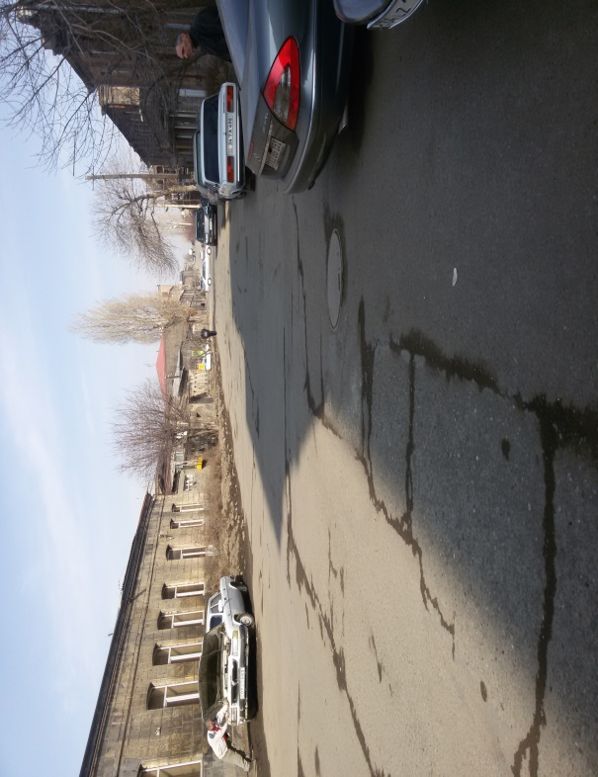

1. 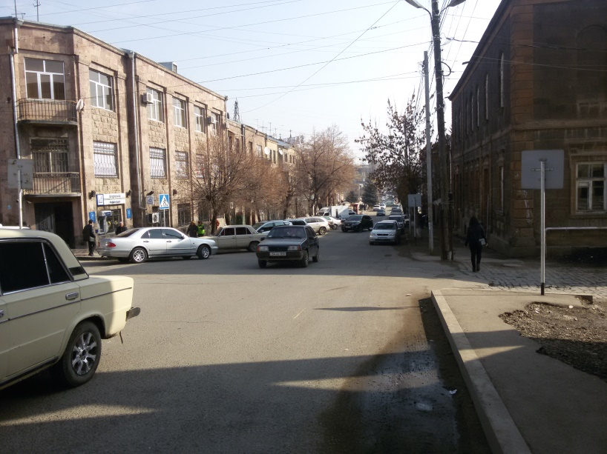 **(b)**

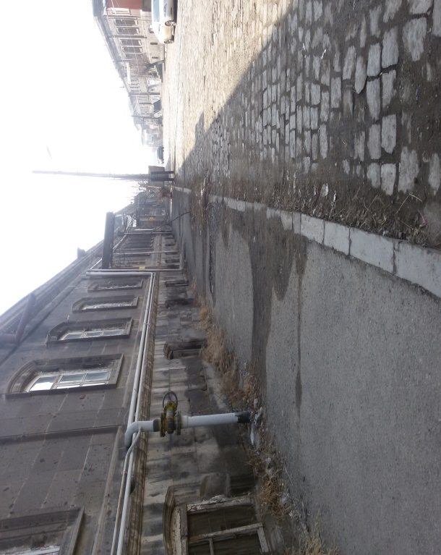**(c) (d)**

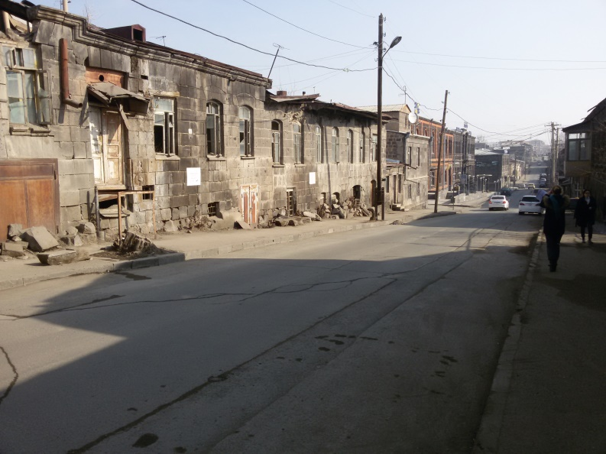

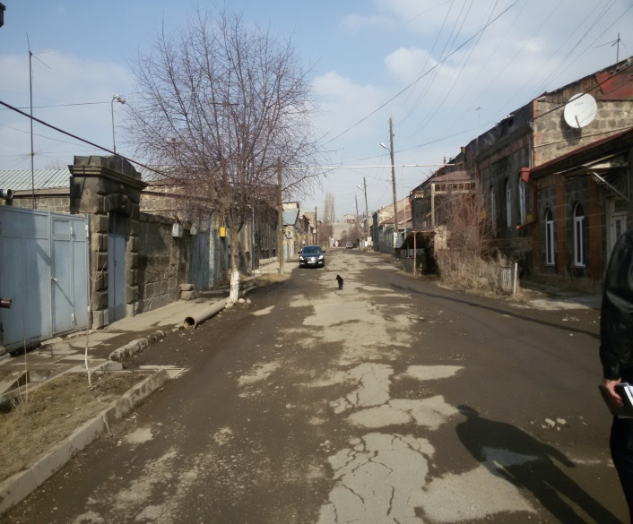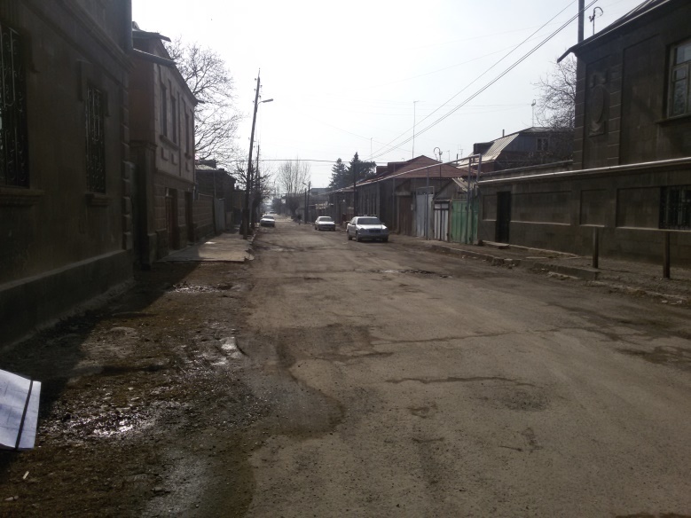**(e) (f)**

**1.2 Photos of the squares envisaged to rehabilitate: (a) Vardanants Square; (b) Jivani Square**

1. 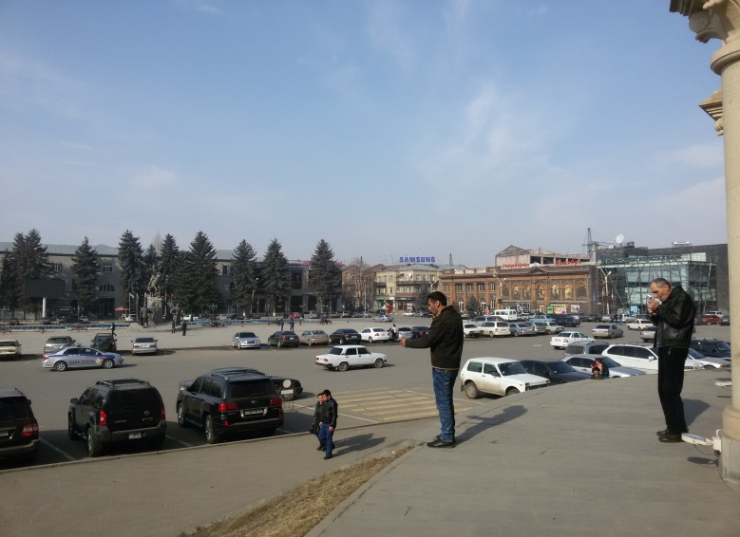 **(b)**

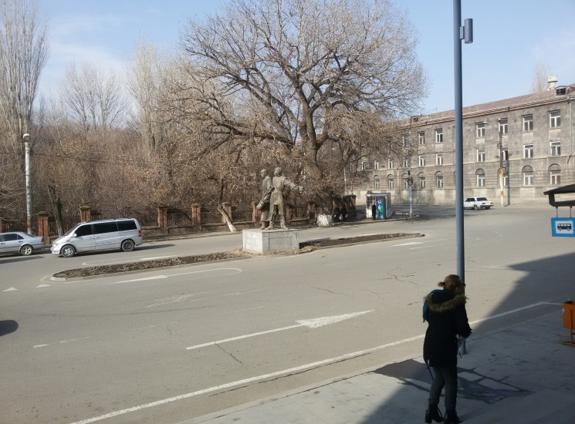

**1.2 Map illustrating sub-project location in Kumayri district:** *The bold-black lines on the map show the sections of the streets envisaged to rehabilitate.*

G:\Publica\1-ՓՈՐՁԱՔՆՆՈՒԹՅՈՒՆ-1\Տուրիզմի ծրագրեր\Gyumri\Untitled-1.tif

**Attachment 2: Agreement for construction waste disposal**

**Unofficial translation**: Earth and asphalt generated from the construction activities under the subproject for Streets Rehabilitation in Kumayri Historical Centerin Gyumri will be transferred and used for covering the waste accumulated in the proximity of Mayisyan-Hazik road which is in 9 km distance from the construction site.

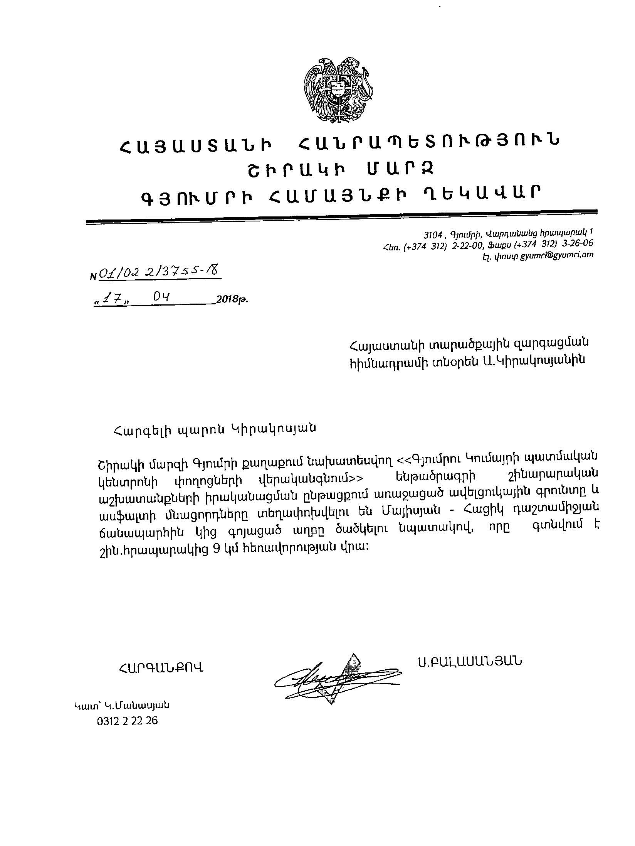

**Attachment 3. Minutes of Public Consultation Meeting**

**MINUTES OF PUBLIC CONSULTATION MEETING**

**On Environmental and Social Management Plan**

**of “Streets Rehabilitation in Kumayri Historical Center in Gyumri” Sub-project**

**Gyumri, August 28, 2018**

A public consultation meeting was held in Gyumri Municipality of Shirak Marz on August 28, 2018 at 12:00pm on Environmental and Social Management Plan of “Streets Rehabilitation in Kumayri Historical Center in Gyumri” to be implemented within the framework of “Local Economy and Infrastructure Development” Project.

The agenda of public consultation meeting was the following:

* Introduction of Local Economy and Infrastructure Development Project to the stakeholders
* Introduction of Environmental and Social safeguard policies and Environmental and Social Management Plan Document
* Introduction of Grievance Redress Mechanisms under the Program
* Q&A session with stakeholders

Information on the meeting day and time was posted on information boards of Gyumri Municipality, in addition the Municipality conducted telephone calls to ensure participants’ attendance. The announcement for the meeting in Armenian and English languages, including its date and time, and Environmental and Social Management Plan was disclosed on the ATDF web page on August 19, 2018(http://atdf.am/en/Reports).

The public consultation was carried out by ATDF Environmental Specialist Lusine Gevorgyan and ATDF Social Specialist Sonya Msryan. The meeting was attended by representatives of Gyumri including 13 participants were present at the meeting.

Deputy Head of Municipality Mr. Sanoyan welcomed the participants, introduced ATDF Specialists and introduced the purpose of the meeting and encouraged them to provide feedbacks on the topics discussed further.

ATDF Environmental Specialist Lusine Gevorgyan introduced Local Economy and Infrastructure Development Project among which “Streets Rehabilitation in Kumayri Historical Center in Gyumri” sub-project was presented to the participants. L. Gevorgyan outlined that development of Environmental and Social Management Plan document is required according to the WB Operational Policy while local legislation requires development and approval of Environmental Impact Assessment which is completed at the moment. The categories of the sub-project according to the WB categorization and local laws were also introduced to the participants. L. Gevorgyan introduced the procedure of environmental and social expertise, description of the sub-project, including the list of the roads to be rehabilitated, traffic safety measures and etc.

L. Gevorgyan introduced Environmental and Social Management Plan Document of the sub-project including the purpose of the document, structure, and key aspects covered by the document. She described baseline environmental conditions of the site. She duly introduced likely negative environmental impacts related to the sub-project implementation including construction and operation phases. L. Gevorgyan outlined anticipated negative impacts including the generation of construction related waste, dust emissions and localized atmospheric air pollution, wastewater discharge which could cause minor contamination of soil and water bodies, increase of noise and vibration level during the construction machinery movement, temporary disruption of some parts of public access roads during construction activities and temporary distortion of landscape due to construction activities.

L. Grigoryan introduced key measures to be undertaken to mitigate adverse environmental impacts and outlined that technical supervisions on monthly basis will keep under control the fulfillment of all the environmental mitigation measures included in ESMP. She highlighted that all sub-project related documents, including ESMP is available on ATDF Web-page and explained where participants can find the documents. She emphasized that long-terms impacts of the Project are positive as rehabilitation of the road will promote flow of tourists and will be beneficial for the town.

S. Msryan presented the main provisions of the ESMP concerning to the social aspects of the Project. She emphasized that the project does not involve any resettlement as all activities will be implemented in public roads. S. Msryan specified that the roads will be accessible for pedestrians and cars during construction activities and total closure of the road during construction activities is not anticipated.

Ms. Msryan explained mechanisms of public engagement and Grievance Redress Mechanism (GRM) to be applied during project implementation. S. Msryan introduced that Grievance Redress Mechanism includes selection of local focal point and explained key activities and responsibilities of FP. She welcomed participants to nominate and select FP. Mr. Samvel Yengoyan was selected as grievance focal point at the community level. S. Msryan introduced that in case of questions/feedback or grievances concerning to the project implementation community member can apply to Mr. Yengoyan.

S. Msryan informed the beneficiaries that they also have the option to contact ATDF directly to communicate their grievance if they are unable to, or do not wish to, go through local focal point. S. Msryan explained all the cannels of grievance submission involving the e-mail address, hot line telephone number, postal address and web-site link and outlined that ATDF contact information is reflected on the booklets delivered to the participants, as well as on the information desk posted in public visible places in the Community, including Municipality building. S. Msryan introduced that information on sub-project details permanently will be available on the information desks, as well as on-going announcements and references. She outlined that these will support to raising public awareness and early identification, assessment and resolution of complaints on Project activities.

The participants were welcomed to raise questions regarding to the presented information. There were question about the start dates and duration of the sub-project which were answered by the specialists.

The list of participants and photos are attached.

**Photos of public consultation meeting**

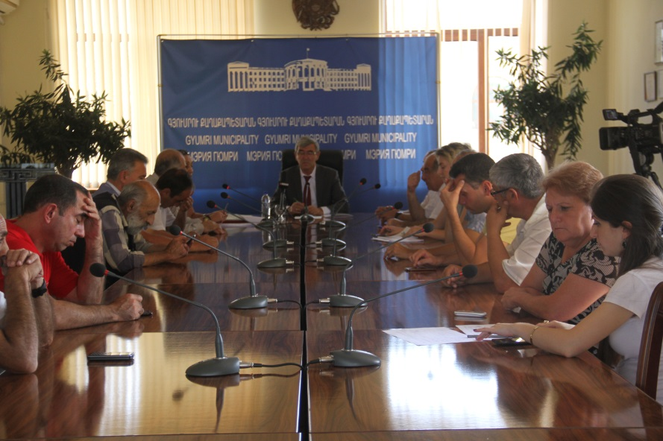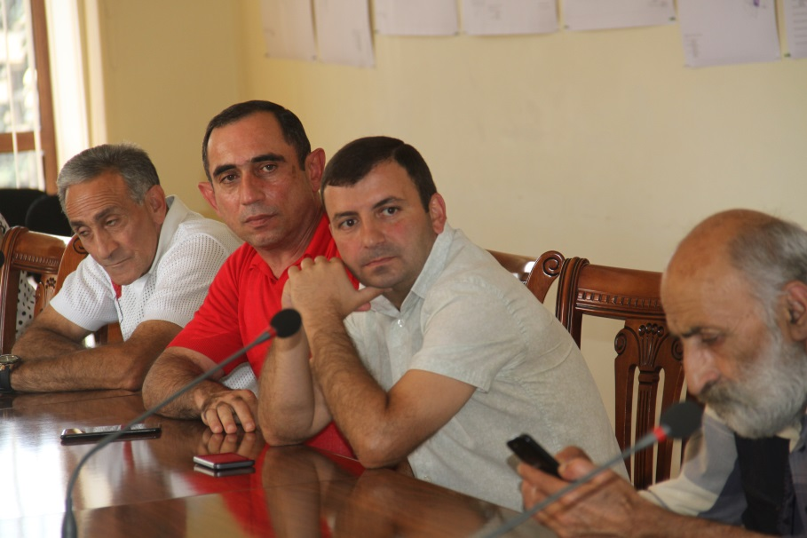

**List of Participants**

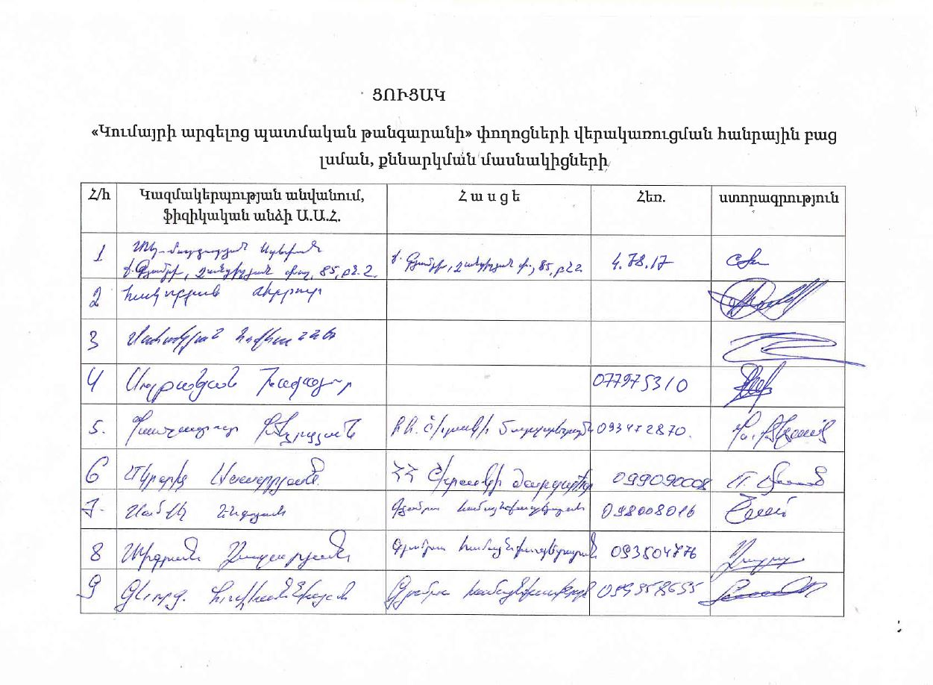

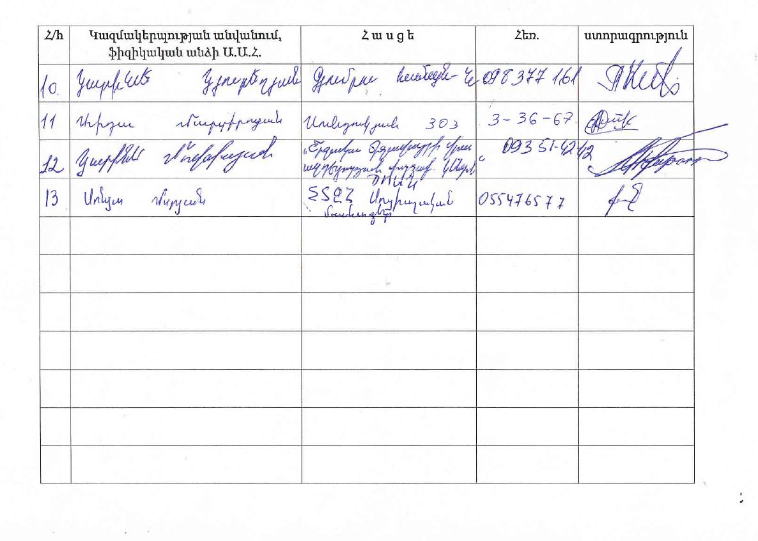

**Attachment 4: Positive conclusion of state environmental expertise**

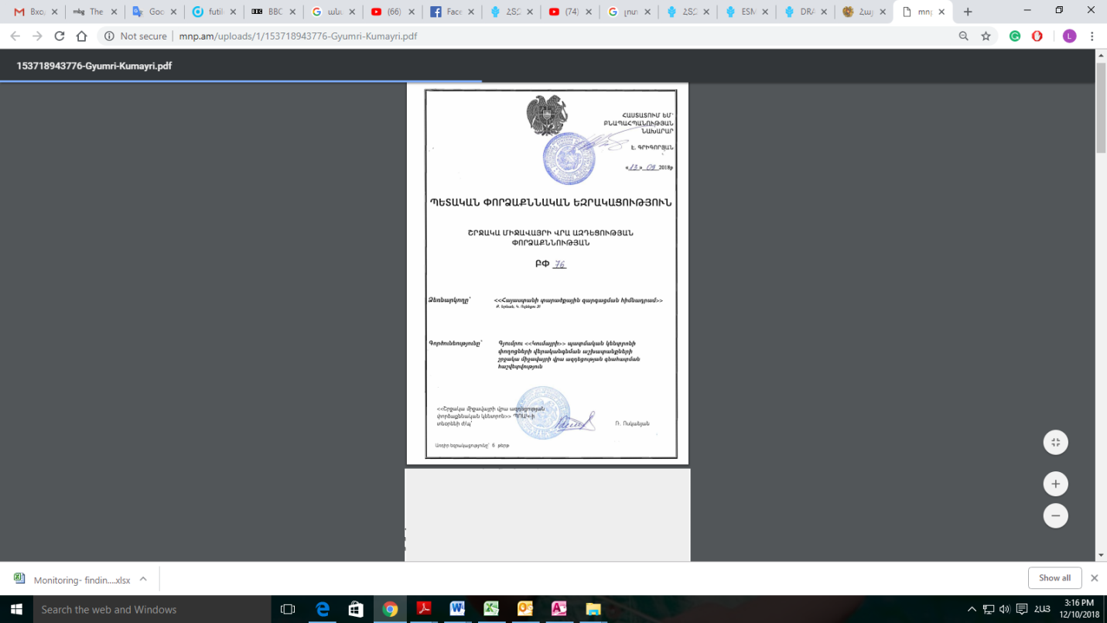

**Attachment 5: Construction permits**

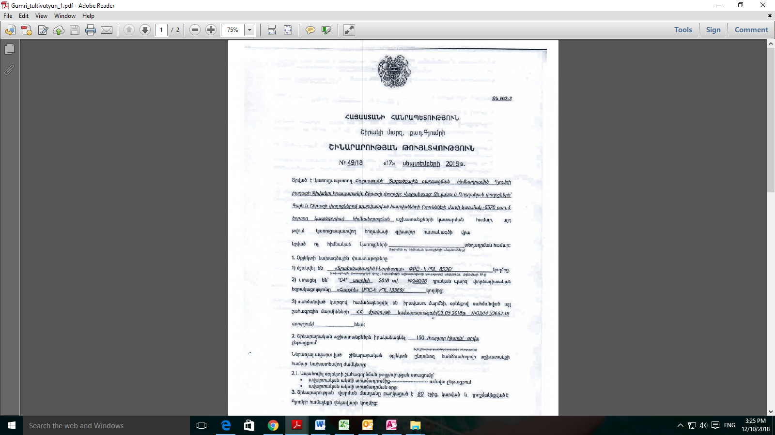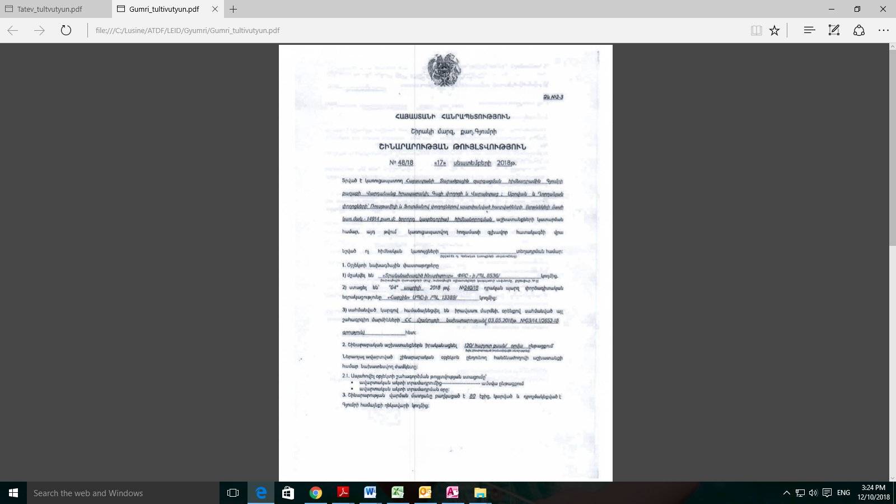

1. Land acquisitions includes displacement of people, change of livelihood encroachment on private property this is to land that is purchased/transferred and affects people who are living and/or squatters and/or operate a business (kiosks) on land that is being acquired.
2. Toxic / hazardous material includes but is not limited to asbestos, toxic paints, noxious solvents, removal of lead paint, etc.