**REPUBLIC OF ARMENIA**

**LOCAL ECONOMY AND INFRASTRUCTURE DEVELOPMENT PROJECT**

**ENVIRONMENTAL AND SOCIAL MANAGEMENT PLAN**

**“Rehabilitation and improvement of Mashtots street in Jermuk city”**

**FEBRUARY 2021**

**PART A: General Project and Site Information**

|  |  |  |  |  |
| --- | --- | --- | --- | --- |
| **INSTITUTIONAL & ADMINISTRATIVE** | | | | |
| Project title | **LOCAL ECONOMY AND INFRASTRUCTURE DEVELOPMENT (LEID)** | | | |
| Subproject number and title | ТUR-11.3, Rehabilitation and improvement of Mashtots street | | | |
| Municipality, community | Jermuk Community, Vayots Dzor marz | | | |
| Scope of site-specific activity | Scope of rehabilitation works at Mashtots Street includes the section between the ropeway and the multi-story building on that street (about 2.3 km). It is also planned to rehabilitate 0.5 km Azatamartikneri Street (near the newly built church), which starts at the end of Mashtots Street.  The following works are planned:  - Complete rehabilitation of 2.3 km long and 7.7 m wide asphalted part of the road;  - Restoration of existing sidewalks, construction of new sidewalks (Azatamartikneri street);  - Restoration of the retaining wall of Mashtots street (2.4 km);  - Marking the bike path along the road;  - Improvement of lighting system along the road;  - Installation of the road drainage system;  - Improvement of lawns and landscaping, planting new trees and lawns;  - Installation of benches and trash bins;  - Installation of road posters and 55 road signs. | | | |
| Institutional arrangements (WB) | Task Team Leader:  Tafadzwa Dube | | Safeguards Specialists:  Hmayak Avagyan (Environment)  Vera Dugandzic (Social) | |
| Implementation arrangements (RoA) | Implementing entity:  ATDF  Asya Osipova (Environment)  Knarik Grigoryan (Social) | Works supervisor:  Haldi Consult LLC | | Works contractor:  Arhovshin LLC |
| **SITE DESCRIPTION** | | | | |
| Name of institution whose premises are to be rehabilitated | Jermuk community | | | |
| Address and site location of institution whose premises are to be rehabilitated | Jermuk City, Mashtots street and Azamartikneri street | | | |
| Who owns the land?  Who uses the land (formal/informal)? | The roads to be rehabilitated are community property. No private land will be used for the implementation of the sub-project. The sub-project will not result in the temporary or permanent loss of crops, fruit trees, and/or household infrastructure. The land is not used for business or other purposes by any individual. | | | |
| Description of physical and natural environment around the site | The roads to be rehabilitated are administratively owned by Jermuk community. There are several trees along the road. There are no kiosks, shops or other businesses, as well as houses on the street. No shops, kiosks or other private objects could be affected. This subproject is expected to improve the quality and reliability of public infrastructure, support tourism and agribusiness development, and create conditions for attracting private sector investment. It is expected that this subproject will improve the quality and reliability of community infrastructure, support the development of tourism and agribusiness, and create conditions for attracting private sector investments. The increase in tourist flow will directly affect the local community through increased income from the tourism sector and improved infrastructure. Short-term benefits are also expected from the participation of local residents in the rehabilitation/construction works. | | | |
| **LEGISLATION** | | | | |
| National & local legislation & permits that apply to sub-project activity | The following Armenian legislation defines a legal framework applicable to project activities:  - Law on Atmospheric Air Protection of RoA (1994)  The purpose of Law on Atmospheric Air Protection is to define main principles of the RoA, directed to provision of purity of atmospheric air and improvement of air quality, prevention and mitigation of the chemical, physical, biological and other impacts on air quality and regulation of public relation. This Law also regulates the emission licenses and provides maximum allowed loads / concentrations for atmospheric air pollution, etc.  *According to this law, contractor shall undertake construction activities as well as transportation and temporary storage of waste the way to minimize dust and other emissions.*  - Law on Waste of RoA (2004)  The law provides the legal and economic basis for collection, transportation, disposal, treatment, re-use of wastes as well as prevention of negative impacts of waste on natural resources, human life and health. The law defines the roles and responsibilities of the state authorized bodies as well as of waste generator organizations in waste management operations.  *According to this law, the waste generated from construction activities should be recycled as appropriate or disposed of in designated locations.*  *Disposal of the construction waste and excess material in selected locations must be approved by local municipality in writing.*  - Law on Environmental Impact Assessment and Expertise of RoA (2014)  The law defines the type of activities that are subject to environmental impact assessment and environmental expertise.  *According to this law, the proposed construction works are not subject to environmental impact assessment and expert examination.*  - Law on Urban Development of RoA (1998) *According to this law, planned works require obtaining the construction permit.* | | | |
| **PUBLIC CONSULTATION** | | | | |
| When / where the public consultation process will take /took place | The draft ESMP was disclosed and discussed at the virtual meeting held via Zoom with the participants from the municipality of Jermuk and local communities on February 12, 2021.  Draft ESMP was disclosed in Armenian and English languages on the ATDF website (atdf.am) and in Armenian language on the beneficiary's website (jermuk.am). Brief information on the planned works and contact information for addressing questions and grievances will be placed at the worksite, on the information board of the Jermuk municipality office and/or in its immediate surroundings. | | | |
| **ATTACHMENTS** | | | | |
| Attachment 1: Site map/photo  Attachment 2: Permission for construction waste disposal  Attachment 3 : Minutes of public consultation on the draft Environmental and Social Management Plan  Attachment 4: Construction permit (to be provided) | | | | |

*Information on works supervisor, works provider (contractor), and the attachments will be provided later, prior to mobilization of a selected works provider to a work site.

**The construction permit will be obtained before commencement of works.

**PART B: safeguards information**

|  |  |  |  |
| --- | --- | --- | --- |
| **ENVIRONMENTAL /SOCIAL SCREENING** | | | |
| Will the site activity include/involve any of the following? | **Activity/Issue** | **Status** | **Triggered Actions** |
| 1. Building rehabilitation | [ ] Yes [x] No | If “Yes”, See Section **A** below |
| 1. Road rehabilitation | [x] Yes [ ] No | If “Yes”, see Section A below |
| 1. New construction | [ ] Yes [x] No | If “Yes”, See Section **A** below |
| 1. Individual wastewater treatment system | [ ] Yes [x] No | If “Yes”, See Section **B** below |
| 1. Historic building(s) and districts | [] Yes [x] No | If “Yes”, See Section **C** below |
| 1. Unexpected need for land take | [ ] Yes [x] No | If “Yes”, See Section **D** below |
| 1. Hazardous or toxic materials[1] | [ ] Yes [x] No | If “Yes”, See Section **E** below |
| 1. Impacts on forests and/or protected areas | [ ] Yes [x] No | If “Yes”, See Section **F** below |
| 1. Handling / management of medical waste | [ ] Yes [ x] No | If “Yes”, See Section **G** below |
| 1. Traffic and pedestrian safety | [x] Yes [ ] No | If “Yes”, See Section **H** below |
| 1. Social risk management | [x] Yes [ ] No | If “Yes”, See Section **I** below |

**PART C: Mitigation measures**

|  |  |  |
| --- | --- | --- |
| **ACTIVITY** | **PARAMETER** | **MITIGATION MEASURES** |
| **0**. General Conditions | Notification and Worker Safety | 1. The local construction and environment inspectorates and communities are notified of upcoming activities 2. The public is notified of the works through appropriate notification in the media and/or at publicly accessible sites (including the site of the works) 3. All legally required permits are acquired for construction and/or rehabilitation 4. The Contractor formally agrees that all work will be carried out in a safe and disciplined manner designed to minimize impacts on neighboring residents and environment. 5. Workers’ personal protection equipment complies with international good practice (always hardhats, as needed masks and safety glasses, harnesses and safety boots) 6. Appropriate signposting of the sites informs workers of key rules and regulations to follow. |
| **A.** General Rehabilitation and /or construction activities | Air Quality | 1. During earth works, dust is suppressed by ongoing water spraying and/or installing dust screen enclosures at site. 2. The surrounding environment (sidewalks, roads) is kept free of debris to minimize dust. 3. There is no open burning of construction / waste material at the site. 4. There is no excessive idling of construction vehicles at sites. |
| Noise | 1. Construction noise is limited to restricted times agreed to in the permit. 2. During operations, the engine covers of generators, air compressors and other powered mechanical equipment are closed, and equipment placed as far away from residential areas as possible. |
| Water Quality | 1. Appropriate erosion and sediment control measures are applied such as e.g. hay bales and / or silt fences to prevent sediment from moving off site and causing excessive turbidity in nearby streams and rivers. 2. Rainwater is removed from the construction site using a rainwater drainage system, and then into the Vararakn River. |
| Waste Management | 1. Waste collection and disposal pathways and sites are identified for all major waste types expected from demolition and construction activities. 2. Mineral construction and demolition wastes are separated from general refuse, organic, liquid and chemical wastes by on-site sorting and stored in appropriate containers. 3. Construction waste is being collected and disposed properly by licensed collectors. 4. Whenever feasible, appropriate and viable materials (except asbestos) are reused or recycled. |
| **B**. Individual wastewater treatment system | Water Quality | 1. The approach to handling sanitary wastes and wastewater from building sites (installation or reconstruction) is approved by the local authorities. 2. Before being discharged into receiving waters, effluents from individual wastewater systems are treated in order to meet the minimal quality criteria set out by national guidelines on effluent quality and wastewater treatment. 3. Monitoring of new wastewater systems (before/after) is carried out. 4. Construction vehicles and machinery are washed only in designated areas where runoff will not pollute natural surface water bodies. |
| **C**. Historic building(s) | Cultural Heritage | 1. If the building is a designated historic structure, very close to such a structure, or located in a designated historic district, notification is made, and approvals/permits be obtained from local authorities and all construction activities planned and carried out in line with local and national legislation. 2. Provisions are put in place so that artifacts or other possible chance finds encountered in excavation or construction are noted and registered, responsible officials contacted, and works activities delayed or modified to account for such finds. |
| **D**. Unexpected need for land take | Private land ownership/use | 1. If expropriation of land was not expected but is required, or if loss of access or income of legal or illegal users of land was not expected but may occur, do not enter site and promptly notify the employer 2. Do not commence works requiring land take prior to official notice of employer on the completion of involuntary resettlement and full provision of compensation to the affected people |
| **E**. Toxic materials | Asbestos management | 1. If asbestos is located on the project site, it is marked clearly as hazardous material. 2. When possible, the asbestos is appropriately contained and sealed to minimize exposure. 3. Prior to removal (if removal is necessary), the asbestos is treated with a wetting agent to minimize asbestos dust. 4. Asbestos is handled and disposed by skilled & experienced professionals 5. If asbestos material is stored temporarily, the wastes are securely enclosed inside closed containments and marked appropriately. Security measures are taken against unauthorized removal from the site. 6. The removed asbestos is not reused. |
| Toxic / hazardous waste management | 1. Temporarily storage on site of all hazardous or toxic substances is in safe containers labeled with details of composition, properties and handling information. 2. The containers of hazardous substances are placed in a leak-proof container to prevent spillage and leaching. 3. The wastes are transported by specially licensed carriers and disposed in a licensed facility. 4. Paints with toxic ingredients or solvents or lead-based paints are not used. |
| **F**. Affected forests, wetlands and/or protected areas | Protection | 1. All recognized natural habitats, wetlands and protected areas in the immediate vicinity of the activity are not damaged or exploited; all staff is strictly prohibited from hunting, foraging, logging or other damaging activities. 2. A survey and an inventory are made of large trees in the vicinity of the construction activity, large trees are marked and cordoned off with fencing; their root system protected, and any damage to the trees avoided. 3. Adjacent wetlands and streams are protected from construction site run-off with appropriate erosion and sediment control feature to include by not limited to hay bales and silt fences. 4. There is no unlicensed borrow pits, quarries or waste dumps in adjacent areas, especially not in protected areas. |
| **G**. Disposal of medical waste | Infrastructure for medical waste management | In compliance with national regulations, the newly constructed and/or rehabilitated health care facilities include sufficient infrastructure for medical waste handling and disposal; this includes and not limited to:   * Special facilities for segregated healthcare waste (including soiled instruments “sharps”, and human tissue or fluids) from other waste disposal; * Appropriate storage facilities for medical waste are in place; and * If the activity includes facility-based treatment, appropriate disposal options are in place and operational |
| **H**. Traffic and pedestrian safety | Direct or indirect hazards to public traffic and pedestrians by construction  activities | In compliance with national regulations, the construction site is properly secured, and construction related traffic regulated. This includes but is not limited to   * Signposting, warning signs, barriers and traffic diversions: site will be clearly visible, and the public warned of all potential hazards. * Traffic management system and staff training, especially for site access and near-site heavy traffic. Provision of safe passages and crossings for pedestrians where construction traffic interferes. * Adjustment of working hours to local traffic patterns, e.g. avoiding major transport activities during rush hours or times of livestock movement. * Active traffic management by trained and visible staff at the site, if required for safe and convenient passage for the public. * Ensuring safe and continuous access to office facilities, shops and residences during renovation activities, if the buildings stay open for the public. |
| **I.** Social risk management | Public relationship management | 1. Assign local liaison person in charge of communication with and receiving requests/ complaints from local population. 2. Consulted local communities to identify and pro-proactively manage potential conflicts between an external workforce and local people. 3. Rise local community awareness about sexually disease risks associated with the presence of an external workforce and include local communities in awareness activities. 4. Inform population about construction and work schedules, interruption of the services, traffic detour routes and provisional bus routes, blasting and demolition, as appropriate. 5. Limit construction activities at night. When necessary, carefully schedule night-time works and inform affected community so they can take necessary measures. 6. At least five days in advance of any service interruption (including water, electricity, telephone, bus routes), advise affected community through postings at the project site, at bus stops, and in affected homes/businesses. |
| Labor management | 1. To the extent possible, locate work camps away from local communities. 2. Undertake sitting and operation of worker camps in consultation with neighboring communities. 3. Recruit unskilled or semi-skilled workers from local communities to the extent possible. Where and when feasible, provide worker skills training to enhance participation of local people. 4. Provide adequate lavatory facilities (toilets and washing areas) in the work site with adequate supplies of hot and cold running water, soap, and hand drying devices. Establish temporary septic tanks for any residential labor camp and without causing pollution of nearby watercourses. 5. Raise awareness of workers on overall relationship management with local population, establish the code of conduct in line with international practice 6. and strictly enforce them, including the dismissal of workers and financial penalties of adequate scale. |

**PART D: Monitoring Plan**

|  |  |  |  |  |  |  |
| --- | --- | --- | --- | --- | --- | --- |
| **Activity** | **What**  (Is the parameter to be monitored?) | **Where**  (Is the parameter to be monitored?) | **How**  (Is the parameter to be monitored?) | **When**  (Define the frequency / or continuous?) | **Why**  (Is the parameter being monitored?) | **Who**  (Is responsible for monitoring?) |
| **CONSTRUCTION PHASE** | | | | | |
| Supply of construction materials | Purchase of construction materials from the licensed suppliers | In supplier’s office or warehouse | Verification of labels of the materials and/or certificates if any | During conclusion of supply contracts | Ensure reliability of construction materials and their safety for human health | ATDF  Technical Supervisor |
| Transportation of construction materials and waste;  Movement of construction vehicles and machinery | * Technical condition of construction vehicles and machinery; * Confinement and protection of truck loads with lining * Movement of construction vehicles and machinery according to predefined traffic routes and within working hours: 9AM-6PM. | -Construction site  -Routes of transportation of construction materials and wastes | Inspection of pre-defined movement routes, entrances and exits of construction sites | Unannounced monthly inspection during work hours and beyond | -Limit pollution of soil and air from emissions;  -Limit nuisance to local communities;  -Minimize traffic disruption, ensure pedestrian safety and prevent accidents | ATDF  Technical Supervisor |
| Maintenance of construction equipment | * Washing of cars and construction equipment outside the construction site or on maximum distance from natural streams * Refueling or lubrication of construction equipment outside the construction site or at the predetermined confined area | Construction site | Inspection of activities | Selective inspections during work hours | -Avoid pollution of water and soil with oil products due to operation of equipment;  -Timely localize and decrease expected damage in case of fire | ATDF  Technical Supervisor |
| Generation of construction waste | * Temporary storage of waste at the pre-defined areas of construction site; * Timely disposal of waste to the formally designated locations | Construction site  Waste disposal site | Inspection of site | Unannounced monthly inspection during entire construction phase | -Prevent pollution of soil, surface water and ground water,  - Avoid accidents at the construction site due to scattered fragments of construction materials and debris,  - Retain esthetic appearance of the construction site and its surroundings | ATDF  Technical Supervisor |
| Deploying manpower for construction | * Provision of uniforms and safety gears to workers and enforcement of their use by the constructor; * Provision of work-site safety instruction to contractor’s personnel and instructions proper recording; * Installation of fencing; * Provisions of nuisance activities within working hours from 9AM-6PM and in accordance with allowed norms of noise and vibrations | Construction site | Inspection | Periodically during construction and upon its completion | -Minimize probability of accidents  -Protect workers’ health;  -Limit nuisance to local communities from noise and vibration. | ATDF  Technical Supervisor |
| Works near privately-owned land plots and other property | * Avoid trespassing or incidentally damaging of private property (using small-size machinery or manual labor near walls and fences, stockpiling of construction material and waste away from private property; etc.); * In case of unintended damage to private property, quickly restore it to the original or better status; * In case of expected temporary impact on privately-owned property, inform owners upfront and guarantee restoration, acquire written consent of owners for intervention, and promptly restore the damage to the original or better status. | Works near privately-owned land, buildings and other assets | Monitoring and inspection | Entire period of construction | -Reduce the probability of damages on private property  -Exclude temporary or permanent violation of ownership and/or user rights on the private property | ATDF  Technical Supervisor |
| Construction site re-cultivation and landscaping | Final cleaning of the rehabilitation site and permanent access roads and landscaping-greening of the area as required | Construction site and access roads | Inspection of activities | Final period of construction | Reduce loss of aesthetical value of the landscape due to construction activities | ATDF  Technical Supervisor |
| Solid waste management | Trash bins placement and arrangement on periodically transportation of waste | Construction site | Inspection | Total period of works | - Prevent pollution of soil, surface water and ground water;  - Retain esthetic appearance of the sites area and its surroundings | ATDF  Technical Supervisor  Jermuk municipality |
| Dust generation | Dust suppression at worksites | Construction site and access roads | Visual inspection | Recurrent | Reduce risks for the workers and neighboring communities | ATDF  Technical Supervisor |
| Handling of chance finds | * Stoppage of works promptly upon encountering of change finds; * Formal communication with Agency for the Protection of Monuments and Historical Sites of RA on chance finds; * Timely arrangements made for the conduct of required excavation and site conservation | Construction site | -Inspection of chance find sites;  - Inspection of filed documentation | Entire period of construction | Ensure cultural heritage is not damaged by the construction works | ATDF  Technical Supervisor  Agency for the Protection of Monuments and Historical Sites |
| Earth work | * Temporary storage of excavated soil at determined places; * Backfilling of the excavated ground as needed and disposal of the excess mass to the places, approved in writing; * Marking and fencing of large trees, protection of their root system; * Limitation of tree cutting wherever feasible. | Construction site | Inspection of activities | During earth works | -Limit pollution with contaminated soil of surface and ground waters;  -Limit loss of trees | ATDF  Technical Supervisor |
| Operation of Grievance Redress Mechanism | * Public right to complaints or questions about the project. * Appeal to the head of local government (community authorities) * The appointment by the authorities of the Coordinator for the consideration of complaints (receiving complaints, reviewing and explaining, registering complaints in the logbook and trying to resolve them on the spot. * Appeal to ATDF by hot-line (010 24 01 59), postal letter (Yerevan 0037, K.Ulnetsi 31), official web page (<http://atdf.am/hy/Home/ContactUs>), e-mail ([support@atdf.am](mailto:support@atdf.am)). | Construction site | Inspection of activities | Entire period of construction | -Monitor compliance with project aspects;  -Timely resolve questions and complaints in the field. | ATDF  Technical Supervisor |
| Traffic and pedestrian safety | * Signposting, warning signs, barriers and traffic diversions; * Provision of safe passages and crossings for pedestrians where construction traffic interferes | Construction site | Inspection of activities | During the works | Reduce probability of accidents to constructors and local population | ATDF  Technical Supervisor |
| COVID-19 preparedness in the work site | * Provision of hand wash facilities in the work site with adequate supplies of running water, hand soap, alcohol-based hand sanitizer and hand drying devices; * Worksite entrance procedure and medical checks; * Regular disinfection of public rooms, equipment, tools, and waste; * Work practices to reduce or minimize contact between workers; * Provision of face masks and other relevant PPE to all project workers at the entrance to the project site. | Construction site | Inspection of activities | Total period of works | Reduce the COVID-19 infection risk at worksites | ATDF  Technical Supervisor |
| **OPERATION PHASE** | | | | | | |
| 1.Operation and maintenance of outdoor lighting system | Regular servicing of the lighting system is being undertaken | Street lighting network | Periodic Inspection | Total period of operation | Maintenance of lighting system in safe and operable condition | Local  municipality |
| 2.Exploitation and maintenance of road | * Cleaning road surface and shoulders from litter deposited out of moving vehicles and from bodies of animals accidentally overrun by vehicles; * Timely confinement, deactivation, and removal of liquid or powder spills of cargo in case of road accidents; * Collection and timely disposal of waste from road maintenance works to a designated landfill. | Carriageway of the road | Visual inspection | As required in response to an accident  Regular, to be determined by local municipality | -Ensure safety of traffic and prevent environmental pollution;  -Ensure aesthetic appearance of the road | Local  municipality |
| 3.Maintenance of drainage system | Keeping road drainage system operational | Carriageway of the road | Visual inspection | Regular, to be determined by local municipality | Ensure safety of traffic and decrease frequency and costs of road rehabilitation | Local  municipality |

**Attachment 1: Sites maps and photos**

Picture 1 : Map of the site, Jermuk city

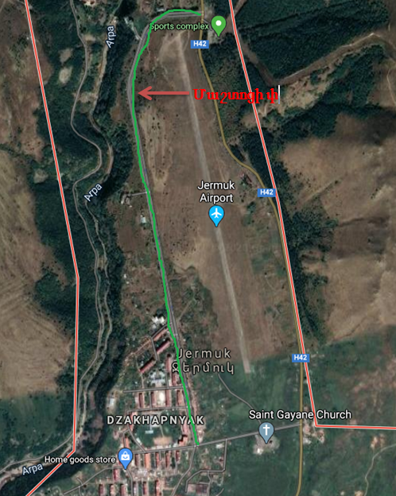 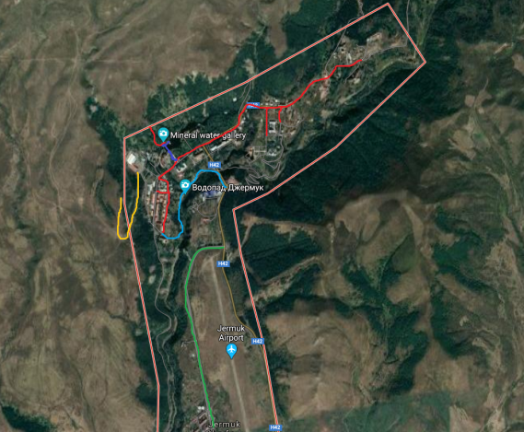

Picture 2. Mashtots Street

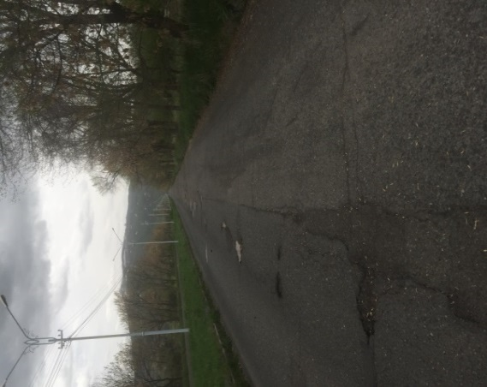 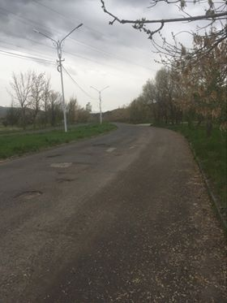

**Attachment 2: Permission for construction waste disposal**



Non-official translation of the above attached document:

Construction waste generated during the construction works under the “Rehabilitation and improvement of Mashtots street” sub-project should be transported to the Ziraki landfill located 5 km far from the construction site of city of Jermuk and 15 km far from the construction site of Gndevaz.

Head of community Sealed/Signed V.Hovhannisyan

**Attachment 3: Minutes of the public consultation on the draft Environmental and Social Management Plan**

On February 12, at 11.00 am, a public consultation was held by Zoom online platform on the Environmental and Social Management Plan of the “Rehabilitation and improvement of Mashtots street” sub-project.

The announcement of the public consultation was posted on the ATDF website (atdf.am), on the Jermuk community social network page and the municipality's information board on February 2, 2021.

During the public consultation period from February 2 to February 12, 2021, no feedback, questions or comments have been received from stakeholders, beneficiaries or other interested parties.

The public consultation meeting was carried out by ATDF Social Specialist Knarik Grigoryan. The meeting was joined by the designer Torosyan Jirair; overall 7 participants participated in the meeting, among which 3 women.

Knarik Grigoryan presented the main purpose of the discussion and the agenda. The representative of the design company presented the planned construction works.

Possible environmental impacts and the mitigation measures were presented. The anticipated environmental impacts, especially accumulation of construction waste, which must be transported to a place permitted by the local government, noise and dust were mentioned. The health and safety measures and working hours were presented; also the frequency of monitoring visits and the procedures of monitoring of the implementation of environmental and social impacts mitigation measures were presented.

Knarik Grigoryan noted that no negative social impacts are expected, as any use of private land or business interruption is not predicted. Closure of the road during construction works is not planned.

The GRM procedures were presented. Knarik Grigoryan introduced the local focal point Garnikyan Arsen to the participants of the meeting. All the contact information of the GRM was presented.

K. Grigoryan asked participants to raise questions and concerns relating to the sub-project and no questions were raised.

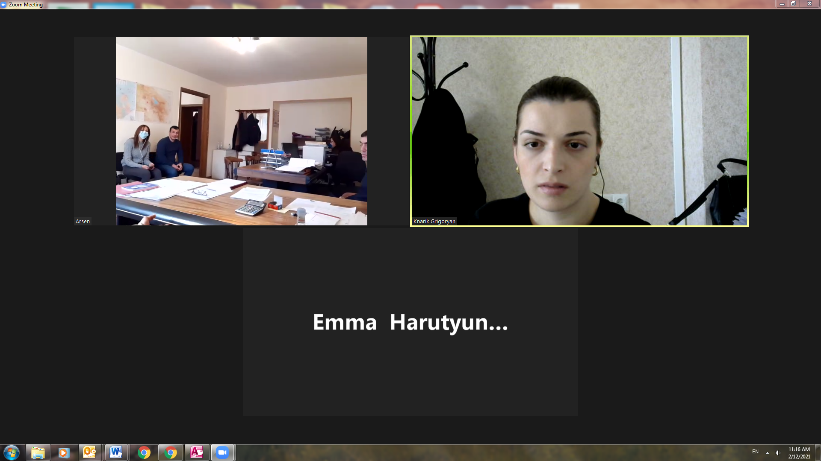

**List of participants**

|  |  |
| --- | --- |
| **Name/surname** | **Community/ organization** |
| Margaryan Arman | Jermuk municipality, chief architecht |
| Garnikyan Arsen | Jermuk municipality office, specialist |
| Zorabyan Lilit | Jermuk municipality office, specialist |
| Manukyan Vaginak | Jermuk municipality office, specialist |
| Gevorgyan Aksanna | Jermuk municipality office, specialist |
| Torosyan Jirayr | Designer |
| Grigoryan Knarik | ATDF, social specialist |

**Attachment 4: Construction permits (to be provided)**

1. Toxic / hazardous material includes but is not limited to asbestos, toxic paints, noxious solvents, removal of lead paint, etc.