**REPUBLIC OF ARMENIA**

**LOCAL ECONOMY AND INFRASTRUCTURE DEVELOPMENT PROJECT**

**ENVIRONMENTAL AND SOCIAL MANAGEMENT PLAN**

**“Improvement of the** **TERRITORY NEAR the Garni temple’’**

**Subproject**

**FEBRUARY 2021**

**PART A: General Project and Site Information**

|  |  |  |  |
| --- | --- | --- | --- |
| **INSTITUTIONAL & ADMINISTRATIVE** | | | |
| Project title | LOCAL ECONOMY AND INFRASTRUCTURE DEVELOPMENT | | |
| Sub-project title | TUR 10.1 Improvement of the territory near the Garni temple | | |
| Municipality, community | Kotayk region, Garni community, Garni village | | |
| Scope of site-specific activity | Within the scope of the subproject, the following is proposed:  1. Rehabilitation of the following roads (and sidewalks):   * the Alekyan street starting from the H3 highway to the Garni municipality office (800 m); * the Marzpetuni street (600 m); * Shahumyan street starting from the municipality office to Charents street (145 m); * Charents street starting from Shahumyan and Charents crossroad to Marzpetuni street (400 m).   The following activities are to be carried out:   * Two-layer asphalting of streets. The total length of the roads is 1.945 km; the width of the roads is 5.4-10.0 m; * Sidewalk rehabilitation with basalt curbs and concrete decorative stones; * Renovation of the water and sewage systems for 70 households of Alekyan and Marzpetuni streets, including the replacement of 1930m sewer pipeline and replacement of 2294 m water pipeline.   2. Installation of 10 sales kiosks;  3. Installation of the ticket office;  4. Construction of parking area for the cars;  5. Installation of the lighting system. | | |
| Institutional arrangements (WB) | Task Team Leader:  Tafadzwa Dube | Safeguards Specialists:  Hmayak Avagyan (Environment)  Vera Dugandzic (Social) | |
| Implementation arrangements (RoA) | Implementing entity:  ATDF  Environmental specialist - Asya Osipova  Social specialist - Knarik Grigoryan | Works supervisor:  ‘’Haldi Consult’’ LLC | Works contractor:  ‘’Beelder’’ Construction LLC |
| **SITE DESCRIPTION** | | | |
| Name of institution whose premises are to be rehabilitated | Garni Community, Garni village | | |
| Address and site location of institution whose premises are to be rehabilitated | Garni village | | |
| Who owns the land?  Who uses the land (formal/informal)? | The roads, sidewalks and the area adjacent to the Garni temple to be rehabilitated are community property and no private land will be used for the implementation of the subproject. The water supply and sanitation network to be renovated under the sub-project is located on the public land. The sub-project will not result in the temporary or permanent loss of private lands, crops, fruit trees, and/or household infrastructure. Residents of houses located along the road will be notified in advance of all planned works, including possible water cuts.  There are two currently not operating kiosks located on the right side of Marzpetuni street leading to the Garni temple. Safe and continuous access will be provided to the kiosks during the construction works. Closure of the roads during the construction works is not anticipated.  On the square near the entrance of Garni temple sale points were operating on renting bases before COVID-19 pandemic, the sale points have not operated for six months; the contracts were terminated on the initiative of the renters. | | |
| Description of physical and natural environment around the site | There are occasional trees along the roadsides from the main square of Garni to the Garni temple that should be avoided during construction activities.  There are two kiosks located on the right side of Marzpetuni street leading to the Garni temple, which will not be affected by construction works, and continuous access will be provided to the kiosks during the construction works. Road closure during the asphalting works is not planed.  It is expected that this subproject will improve the quality and reliability of community infrastructure, support the development of tourism and agribusiness, and create conditions for attracting private sector investments. The increase in tourist flow will directly affect the local community through increased income from the tourism sector and improved infrastructure. Short-term benefits are also expected from the participation of local residents in the rehabilitation/construction works. | | |
| **LEGISLATION** | | | |
| National & local legislation & permits that apply to sub-project activity | The following Armenian legislation defines a legal framework applicable to project activities:   * Law on Atmospheric Air Protection of RoA (1994)   The purpose of Law on Atmospheric Air Protection is to define the main principles of the RoA, directed to the provision of purity of atmospheric air and improvement of air quality, prevention, and mitigation of the chemical, physical, biological and other impacts on air quality and regulation of public relation. This Law also regulates the emission licenses and provides maximum allowed loads/concentrations for atmospheric air pollution, etc.  *According to this law, the contractor shall undertake construction activities as well as transportation and temporary storage of waste the way to minimize dust and other emissions.*   * Law on Waste of RoA (2004)   The law provides the legal and economic basis for the collection, transportation, disposal, treatment, re-use of wastes as well as prevention of negative impacts of waste on natural resources, human life, and health. The law defines the roles and responsibilities of the state authorized bodies as well as of waste generator organizations in waste management operations.  *According to this law, the waste generated from construction activities should be recycled as appropriate or disposed of in designated locations.*  *Disposal of the construction waste and excess material in selected locations must be approved by the local municipality in writing.*   * Law on Environmental Impact Assessment and Expertise of RoA (2014)   The law defines the type of activities that are subject to environmental impact assessment and environmental expertise. *According to this law, the proposed construction works are not subject to environmental impact assessment and expertise, since works will be carried out outside the territory of the cultural monument.*  Law on Urban Development of RoA (1998)   * *According to this law, planned works require obtaining a construction permit.* | | |
| **PUBLIC CONSULTATION** | | | |
| When / where the public consultation process will take /took place | The draft ESMP was disclosed and discussed at the virtual meeting held via Zoom with the participants from the municipality of Garni and local communities on February 11, 2021.  Draft ESMP was disclosed in Armenian and English languages on the ATDF website (atdf.am) and in Armenian language on the beneficiary's website (garni.am). Brief information on the planned works and contact information for addressing questions and grievances will be placed at the worksite, on the information board of the Garni municipality office and/or in its immediate surroundings. | | |
| **ATTACHMENTS** | | | |
| Attachment 1: Site map/photo  Attachment 2: Agreement for construction waste disposal  Attachment 3: Minutes of the Public consultation on the draft ESMP  Attachment 4: Construction Permit | | | |

*Information on works supervisor, works provider (contractor), and the attachments will be provided later, prior to mobilization of a selected works provider to a work site.

**The construction permit will be obtained before the launch of construction activities.

**PART B: safeguards information**

|  |  |  |  |
| --- | --- | --- | --- |
| **ENVIRONMENTAL /SOCIAL SCREENING** | | | |
| Will the site activity include/involve any of the following? | **Activity/Issue** | **Status** | **Triggered Actions** |
| 1. Road rehabilitation | [x] Yes [ ] No | If “Yes”, see Section A below |
| 1. New construction | [ ] Yes [x] No | If “Yes”, see Section **A** below |
| 1. Individual wastewater treatment system | [ ] Yes [x] No | If “Yes”, see Section **B** below |
| 1. Historic building(s) and districts | [ ] Yes [x] No | If “Yes”, see Section **C** below |
| 1. Acquisition of land[1] | [ ] Yes [x ] No | If “Yes”, see Section **D** below |
| 1. Hazardous or toxic materials[2] | [ ] Yes [ x] No | If “Yes”, see Section **E** below |
| 1. Impacts on forests and/or protected areas | [ ] Yes [x] No | If “Yes”, see Section **F** below |
| 1. Handling / management of medical waste | [ ] Yes [ x] No | If “Yes”, see Section **G** below |
| 1. Traffic and pedestrian safety | [x ] Yes [ ] No | If “Yes”, see Section **H** below |
| 1. Social risk management | [x ] Yes [ ] No | If “Yes”, see Section **I** below |

**PART C: Mitigation measures**

|  |  |  |
| --- | --- | --- |
| **ACTIVITY** | **PARAMETER** | **MITIGATION MEASURES** |
| **0**. General Conditions | Notification and Worker Safety | 1. The local construction and environment inspectorates and communities are notified of upcoming activities 2. The public is notified of the works through appropriate notification in the media and/or at publicly accessible sites (including the site of the works) 3. All legally required permits are acquired for construction and/or rehabilitation 4. The Contractor formally agrees that all work will be carried out in a safe and disciplined manner designed to minimize impacts on neighboring residents and environment. 5. Workers’ personal protection equipment complies with international good practice (always hardhats, as needed masks and safety glasses, harnesses and safety boots) 6. Appropriate signposting of the sites informs workers of key rules and regulations to follow. |
| **A.** General Rehabilitation and /or construction activities | Air Quality | 1. During earth works, dust is suppressed by ongoing water spraying and/or installing dust screen enclosures at site. 2. The surrounding environment (sidewalks, roads) is kept free of debris to minimize dust. 3. There is no open burning of construction / waste material at the site. 4. There is no excessive idling of construction vehicles at sites. |
| Noise | 1. Construction noise is limited to restricted times agreed to in the permit. 2. During operations, the engine covers of generators, air compressors and other powered mechanical equipment are closed, and equipment placed as far away from residential areas as possible. |
| Water Quality | 1. Appropriate erosion and sediment control measures are applied such as e.g. hay bales and / or silt fences to prevent sediment from moving off site and causing excessive turbidity in nearby streams and rivers. 2. Rainwater is removed from the construction site using a rainwater drainage system. |
| Waste Management | 1. Waste collection and disposal pathways and sites are identified for all major waste types expected from demolition and construction activities. 2. Mineral construction and demolition wastes are separated from general refuse, organic, liquid and chemical wastes by on-site sorting and stored in appropriate containers. 3. Construction waste is being collected and disposed properly by licensed collectors. 4. Whenever feasible, appropriate and viable materials (except asbestos) are reused or recycled. |
| **B**. Individual wastewater treatment system | Water Quality | 1. The approach to handling sanitary wastes and wastewater from building sites (installation or reconstruction) is approved by the local authorities. 2. Before being discharged into receiving waters, effluents from individual wastewater systems are treated in order to meet the minimal quality criteria set out by national guidelines on effluent quality and wastewater treatment. 3. Monitoring of new wastewater systems (before/after) is carried out. 4. Construction vehicles and machinery are washed only in designated areas where runoff will not pollute natural surface water bodies. |
| **C**. Historic building(s) | Cultural Heritage | 1. If the building is a designated historic structure, very close to such a structure, or located in a designated historic district, notification is made, and approvals/permits be obtained from local authorities and all construction activities planned and carried out in line with local and national legislation. 2. Provisions are put in place so that artifacts or other possible chance finds encountered in excavation or construction are noted and registered, responsible officials contacted, and works activities delayed or modified to account for such finds. |
| **D**. Unexpected need for land take | Private land ownership/use | 1. If expropriation of land was not expected but is required, or if loss of access or income of legal or illegal users of land was not expected but may occur, do not enter site and promptly notify the employer 2. Do not commence works requiring land take prior to official notice of employer on the completion of involuntary resettlement and full provision of compensation to the affected people |
| **E**. Toxic materials | Asbestos management | 1. If asbestos is located on the project site, it is marked clearly as hazardous material. 2. When possible, the asbestos is appropriately contained and sealed to minimize exposure. 3. Prior to removal (if removal is necessary), the asbestos is treated with a wetting agent to minimize asbestos dust. 4. Asbestos is handled and disposed by skilled & experienced professionals 5. If asbestos material is stored temporarily, the wastes are securely enclosed inside closed containments and marked appropriately. Security measures are taken against unauthorized removal from the site. 6. The removed asbestos is not reused. |
| Toxic / hazardous waste management | 1. Temporarily storage on site of all hazardous or toxic substances is in safe containers labeled with details of composition, properties and handling information. 2. The containers of hazardous substances are placed in a leak-proof container to prevent spillage and leaching. 3. The wastes are transported by specially licensed carriers and disposed in a licensed facility. 4. Paints with toxic ingredients or solvents or lead-based paints are not used. |
| **F**. Affected forests, wetlands and/or protected areas | Protection | 1. All recognized natural habitats, wetlands and protected areas in the immediate vicinity of the activity are not damaged or exploited; all staff is strictly prohibited from hunting, foraging, logging or other damaging activities. 2. A survey and an inventory are made of large trees in the vicinity of the construction activity, large trees are marked and cordoned off with fencing; their root system protected, and any damage to the trees avoided. 3. Adjacent wetlands and streams are protected from construction site run-off with appropriate erosion and sediment control feature to include by not limited to hay bales and silt fences. 4. There is no unlicensed borrow pits, quarries or waste dumps in adjacent areas, especially not in protected areas. |
| **G**. Disposal of medical waste | Infrastructure for medical waste management | In compliance with national regulations, the newly constructed and/or rehabilitated health care facilities include sufficient infrastructure for medical waste handling and disposal; this includes and not limited to:   * Special facilities for segregated healthcare waste (including soiled instruments “sharps”, and human tissue or fluids) from other waste disposal; * Appropriate storage facilities for medical waste are in place; and * If the activity includes facility-based treatment, appropriate disposal options are in place and operational |
| **H**. Traffic and pedestrian safety | Direct or indirect hazards to public traffic and pedestrians by construction  activities | In compliance with national regulations, the construction site is properly secured, and construction related traffic regulated. This includes but is not limited to   * Signposting, warning signs, barriers and traffic diversions: site will be clearly visible, and the public warned of all potential hazards. * Traffic management system and staff training, especially for site access and near-site heavy traffic. Provision of safe passages and crossings for pedestrians where construction traffic interferes. * Adjustment of working hours to local traffic patterns, e.g. avoiding major transport activities during rush hours or times of livestock movement. * Active traffic management by trained and visible staff at the site, if required for safe and convenient passage for the public. * Ensuring safe and continuous access to office facilities, shops and residences during renovation activities, if the buildings stay open for the public. |
| **I.** Social risk management | Public relationship management | 1. Assign local liaison person in charge of communication with and receiving requests/ complaints from local population. 2. Consulted local communities to identify and pro-proactively manage potential conflicts between an external workforce and local people. 3. Rise local community awareness about sexually disease risks associated with the presence of an external workforce and includes local communities in awareness activities. 4. Inform population about construction and work schedules, interruption of the services, traffic detour routes and provisional bus routes, blasting and demolition, as appropriate. 5. Limit construction activities at night. When necessary, carefully schedule night-time works and inform affected community so they can take necessary measures. 6. At least five days in advance of any service interruption (including water, electricity, telephone, bus routes), advice affected community through postings at the project site, at bus stops, and in affected homes/businesses. |
| Labor management | 1. To the extent possible, locate work camps away from local communities. 2. Undertake sitting and operation of worker camps in consultation with neighbouring communities. 3. Recruit unskilled or semi-skilled workers from local communities to the extent possible. Where and when feasible, provide worker skills training to enhance participation of local people. 4. Provide adequate lavatory facilities (toilets and washing areas) in the work site with adequate supplies of hot and cold running water, soap, and hand drying devices. Establish temporary septic tanks for any residential labour camp and without causing pollution of nearby watercourses. 5. Raise awareness of workers on overall relationship management with local population, establish the code of conduct in line with international practice and strictly enforce them, including the dismissal of workers and financial penalties of adequate scale. |

**PART D: Monitoring Plan**

|  |  |  |  |  |  |  |
| --- | --- | --- | --- | --- | --- | --- |
| **Activity** | **What**  (Is the parameter to be monitored?) | **Where**  (Is the parameter to be monitored?) | **How**  (Is the parameter to be monitored?) | **When**  (Define the frequency / or continuous?) | **Why**  (Is the parameter being monitored?) | **Who**  (Is responsible for monitoring?) |
| **CONSTRUCTION PHASE** | | | | | | |
| 1. Supply of construction materials | Purchase of construction materials from the licensed suppliers | In supplier’s office or warehouse | Verification of labels of the materials and/or certificates if any | During conclusion of supply contracts | Ensure reliability of construction materials and their safety for human health | ATDF  Technical Supervisor |
| 2. Transportation of construction materials and waste;  Movement of construction vehicles and machinery | * Technical condition of vehicles and machinery; * Confinement and protection of truckloads with lining; * Respect of the established hours (9AM-6PM) and routes of transportation. | - Construction site  - Routes of transportation of construction materials and wastes | Inspection of pre-defined movement routes, entrances and exits of construction sites | Unannounced monthly inspection during work hours and beyond | * Limit pollution of soil and air from emissions; * Limit nuisance to local communities from noise and vibration; * Minimize traffic disruption. | ATDF  Technical Supervisor  Traffic Police |
| 3. Maintenance of construction equipment | * Washing of cars and construction equipment outside the construction site or on maximum distance from natural streams; * Refueling or lubrication of construction equipment outside the construction site or at the predetermined confined area. | Construction site | Inspection of activities | Selective inspections during work hours | * Avoid pollution of water and soil with oil products due to operation of equipment; * Timely localize and decrease expected damage in case of fire. | ATDF  Technical Supervisor |
| 4. Generation of construction waste | * Temporary storage of waste at the pre-defined areas of construction site; * Timely disposal of waste to the formally designated locations. | Construction site;  Waste disposal site | Inspection of site | Unannounced monthly inspection during entire construction phase | * Prevent pollution of soil, surface water and ground water; * Avoid accidents at the construction site due to scattered fragments of construction materials and debris; * Retain esthetic appearance of the construction site and its surroundings. | ATDF  Technical Supervisor  Local  municipality |
| 6. Deploying manpower for construction | * Provision of uniforms and safety gears to workers and enforcement of their use by the constructor; * Provision of work-site safety instruction to contractor’s personnel and instructions proper recording; * Strict compliance with national regulations for construction works and the rules of construction equipment operation; * Presence of basic fire extinguishing means at the construction site and construction camp; * Provisions of nuisance activities within working hours from 9AM-6PM and in accordance with allowed norms of noise and vibrations. | Construction site;  Construction camp | Inspection | Periodically during construction and upon its completion | * Reduce probability of traumas and accidents to constructors; * Protect workers’ health; * Limit nuisance to local communities from noise and vibration. | ATDF  Technical Supervisor |
| 7. Construction site re-cultivation and landscaping | Final cleaning of the construction site and landscaping-greening of the area as required | Construction site | Inspection of activities | Final period of construction | Reduce loss of aesthetical value of the landscape due to construction activities | ATDF  Technical Supervisor |
| 8. Solid waste management | Placement of domestic waste collection containers and arrangement on periodic transportation of waste | Construction site | Inspection | Total period of operation | * Prevent pollution of soil and water; * Retain esthetic appearance of the sites area and its surroundings | ATDF  Technical Supervisor  Local  municipality |
| 9. Dust generation | Dust suppression at worksites | Construction site and access roads | Visual inspection | Recurrent | Reduce risks for the staff and neighboring communities | ATDF  Technical Supervisor |
| 10. Handling of chance finds | * Stoppage of works promptly upon encountering of change finds; * Formal communication with Agency for the Protection of Cultural- Historical Monuments of RoA on chance finds; * Timely arrangements made for the conduct of required excavation and site conservation. | Construction site | * Inspection of chance find sites; * Inspection of filed documentation | Period between first encounter of chance finds and resumption of works on site | Ensure cultural-historical monument is not damaged by the construction works | ATDF  Technical Supervisor  Agency for the Protection of Cultural- Historical Monuments of RoA |
| 11. Earth works | * Temporary storage of excavated soil at determined places; * Backfilling of the excavated ground as needed and disposal of the excess mass to the places, approved in writing.; * Marking and fencing of large trees, protection of their root system; * Limitation of tree cutting wherever feasible. | Construction site | Inspection of activities | During earth works | * Limit pollution with contaminated soil of surface and ground waters; * Limit loss of vegetation | ATDF  Technical Supervisor  Local  municipality |
| 12. Traffic and pedestrian safety | * Signposting, warning signs, barriers and traffic diversions; * Provision of safe passages and crossings for pedestrians where construction traffic interferes; * Traffic management by trained and visible staff at the site, if required for safe and convenient passage for the public. | Construction site | Inspection of activities | During the works | Reduce probability of accidents to constructors and local population | ATDF  Technical Supervisor |
| 13. Works near privately-owned land plots and other property | * Avoiding trespassing or incidental damaging of private property (using small-size machinery or manual labour near walls and fences, stockpiling of construction material and waste away from private property; etc.); * In case of unintended damage to private property, quickly restore it to the original or better status; * In case of expected temporary impact on privately-owned property, inform owners upfront and guarantee restoration, acquire written consent of owners for intervention, and promptly restore the damage to the original or better status. | Works near privately-owned land, buildings and other assets | Monitoring and inspection | Entire period of construction | * Reduce the probability of damages to private property; * Exclude temporary or permanent violation of ownership and/or user rights on the private property | ATDF  Technical Supervisor |
| 14. Operation of Grievance Redress Mechanism | * Public right to complaints or questions about the project; * Appeal to the head of local government (community authorities); * The appointment by the authorities of the Coordinator for the consideration of complaints (receiving complaints, reviewing and explaining, registering complaints in the log book and trying to resolve them on the spot. * Appeal to ATDF by hot-line (010 24 01 59), postal letter (Yerevan 0037, K.Ulnetsi 31), official web page (<http://atdf.am/hy/Home/ContactUs>) e-mail ([support@atdf.am](mailto:support@atdf.am)). | Construction site | Inspection of activities | Entire period of construction | * Monitor compliance with project aspects; * Timely resolve questions and complaints in the field. | ATDF  Technical Supervisor |
| 15. COVID-19 preparedness in the work site | * Provision of hand wash facilities in the work site with adequate supplies of running water, hand soap, alcohol-based hand sanitizer and hand drying devices; * Worksite entrance procedure and medical checks; * Regular disinfection of public rooms, equipment, tools, and waste; * Work practices to reduce or minimize contact between workers; * Provision of face masks and other relevant PPE to all project workers at the entrance to the project site. | Construction site | Inspection of activities | Total period of works | * Reduce the COVID-19 infection risk at worksites | ATDF  Technical Supervisor |
| **OPERATION PHASE** | | | | | | |
| 1. Exploitation and maintenance of roads | * Cleaning road surface and shoulders from litter deposited out of moving vehicles and from bodies of animals accidentally overrun by vehicles; * Timely confinement, deactivation, and removal of liquid or powder spills of cargo in case of road accidents; * Collection and timely disposal of waste from road maintenance works to a designated landfill. | Carriageway of the roads | Visual inspection | As required in response to an accident  Regular, to be determined by local municipality | * Ensure safety of traffic and prevent environmental pollution; * Ensure aesthetic appearance of the road corridor. | Local  municipality |
| 2. Maintenance of drainage system | Keeping road drainage system operational | Carriageway of the road | Visual inspection | Regular, to be determined by local municipality | Ensure safety of traffic and decrease frequency and costs of road rehabilitation | Local municipality |
| 3.Operation and maintenance of street lighting system | Regular servicing of the lighting system is being undertaken | Lighting network | Periodic Inspection | Total period of operation | Maintenance of lighting system in safe and operable condition | Local municipality |
| 4.Maintenance and protection of site | Non-authorized construction and land use near the temple | Rehabilitated site | Inspection | Total period of operation | Retain esthetic appearance of the site and its surroundings | Local municipality |

**Attachment 1: Site map, photos**

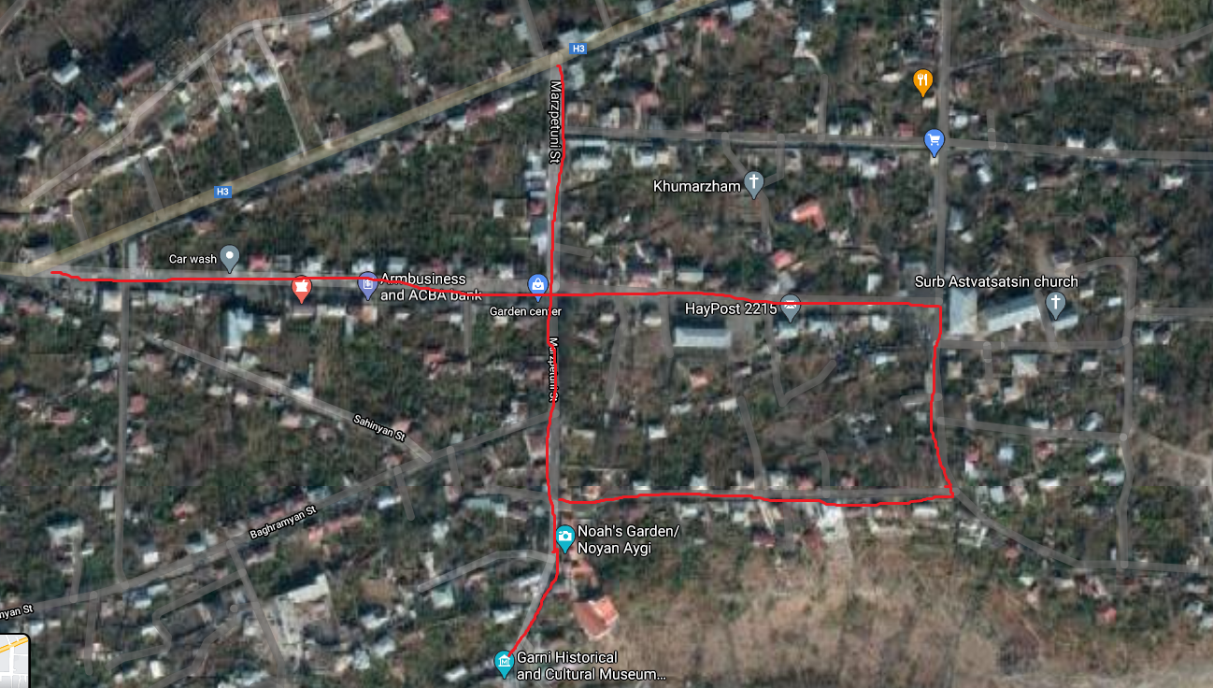

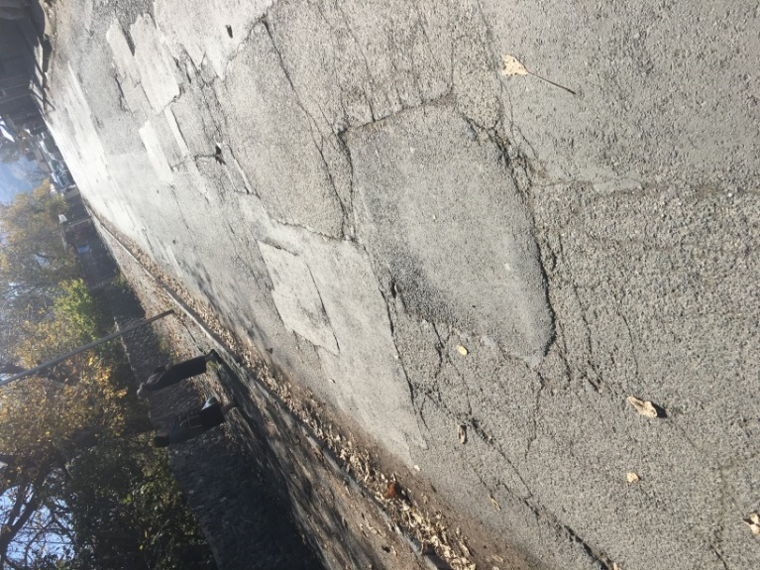 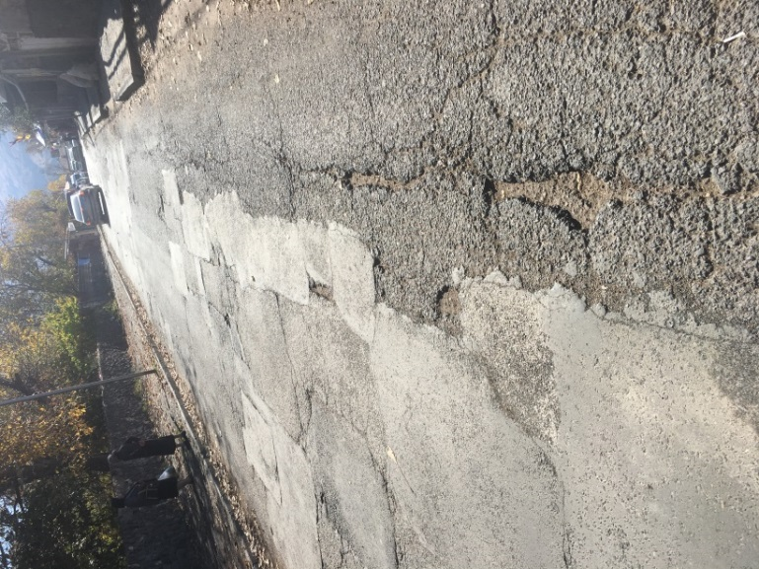

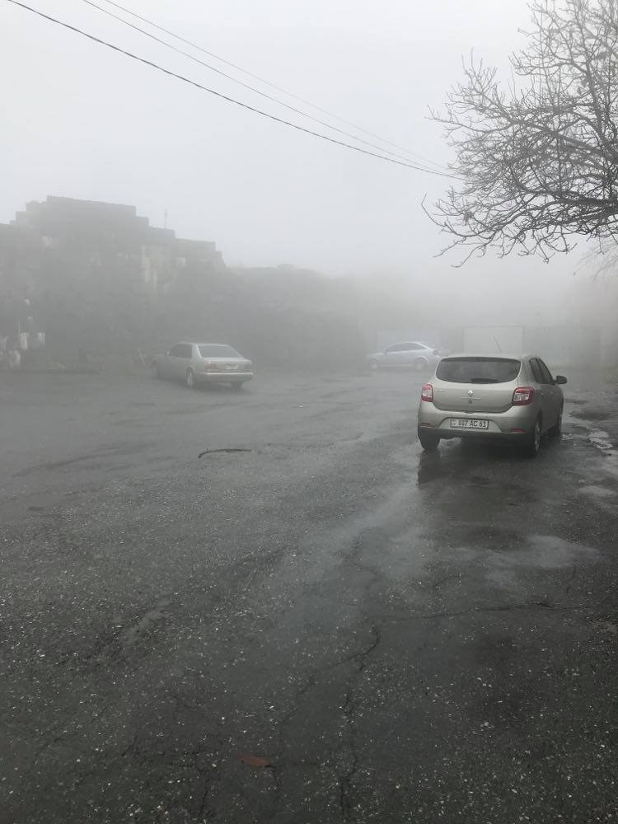 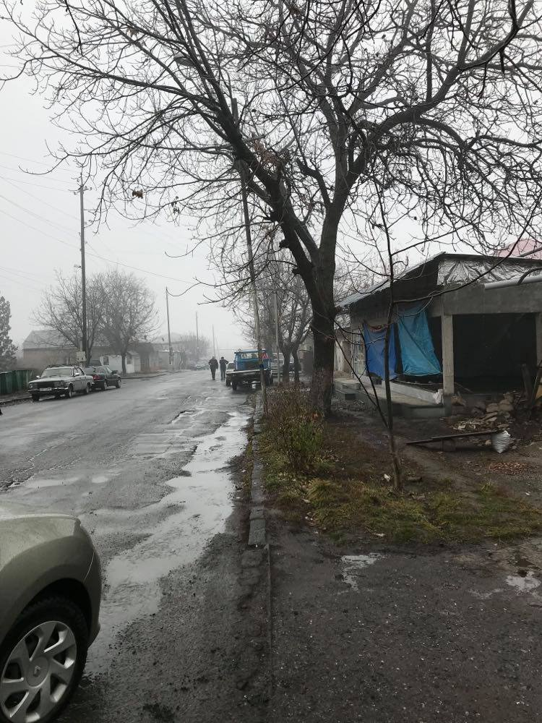

**Attachment 2: Agreement for construction waste disposal**

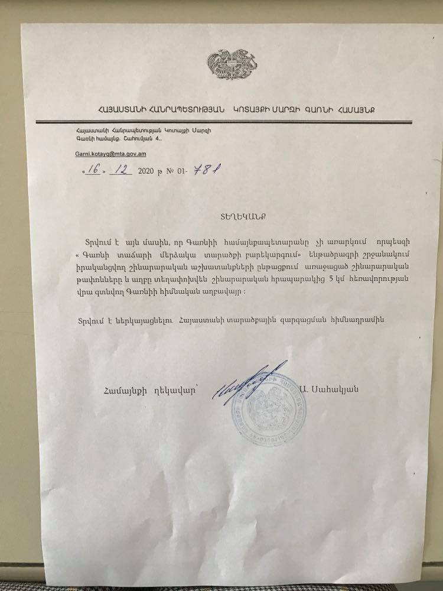

**Non-official translation:**

Garni community has no objection to the disposal of the construction waste generated during the implementation of the “Improvement of the area near Garni temple” subproject to the main landfill of Garni community, located 5 km away from the construction site.

**Attachment 3: Minutes of the Public consultation on the draft ESMP**

On February 11, at 11.00 am, a public consultation was held by Zoom online platform on the Environmental and Social Management Plan of the “Improvement of the territory near the Garni temple” sub-project.

The announcement of the public consultation was posted on the ATDF website (atdf.am), on the Garni community social network page and the municipality's information board on February 2, 2021.

During the public consultation period from February 2 to February 12, 2021, no feedback, questions or comments have been received from stakeholders, beneficiaries or other interested parties.

The public consultation meeting was carried out by ATDF Social Specialist Knarik Grigoryan. The meeting was joined by the designer Gohar Danielyan; overall 9 participants participated in the meeting, among which 6 women.

Knarik Grigoryan presented the main purpose of the discussion and the agenda. The representative of the design company presented the planned construction works.

Possible environmental impacts and the mitigation measures were presented. The anticipated environmental impacts, especially accumulation of construction waste, which must be transported to a place permitted by the local government, noise and dust were mentioned. The health and safety measures and working hours were presented; also the frequency of monitoring visits and the procedures of monitoring of the implementation of environmental and social impacts mitigation measures were presented.

Knarik Grigoryan noted that no negative social impacts are expected, as any use of private land or business interruption is not predicted. Closure of the road during construction works is not planned. The allocation of the sales tables in the square next to the temple was discussed. The representative of the municipality once again clarified that the term of the renting agreements of the sellers has expired, and no new agreements have been signed, in particular, due to the lack of trade in the Quarantine period.

The GRM procedures were presented. Knarik Grigoryan introduced the local focal point Vardan Martirosyan to the participants of the meeting. All the contact information of the GRM was presented.

K. Grigoryan asked participants to raise questions and concerns relating to the sub-project and no questions were raised.

**Attachment 4: Construction Permit**

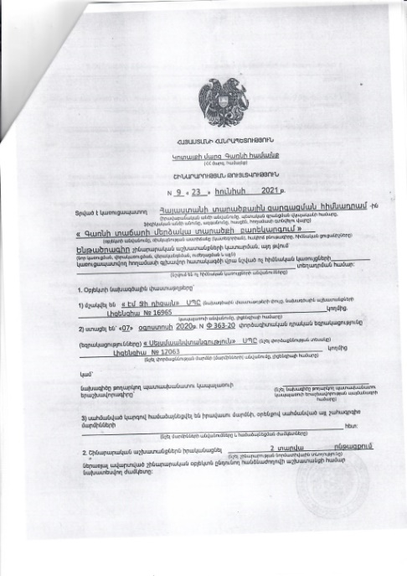 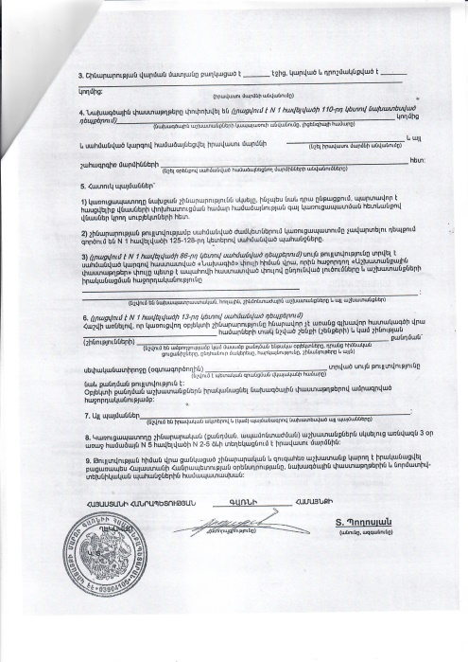

Non-official translation of the above attached document:

Republic of Armenia

Kotayk Region, Garni community

Construction Permit N9, 23.06.2021

This is given for the Improvement of the territory near the Garni temple

The design documents are

1. Developed by “Em Ji Dizayn” LLC, license 16965

2. The reconstruction will be implemented within 2 years.

T. Poghosyan Sealed/Signed

1. Land acquisitions includes displacement of people, change of livelihood encroachment on private property this is to land that is purchased/transferred and affects people who are living and/or squatters and/or operate a business (kiosks) on land that is being acquired.
2. Toxic / hazardous material includes but is not limited to asbestos, toxic paints, noxious solvents, removal of lead paint, etc.