**REPUBLIC OF ARMENIA**

**LOCAL ECONOMY AND INFRASTRUCTURE DEVELOPMENT PROJECT**

**ENVIRONMENTAL AND SOCIAL MANAGEMENT PLAN**

**Improvement of the area near the “Zorats Qarer” Historical and cultural reserve**

**DECEMBER 2020**

**PART A: General Project and Site Information**

|  |  |  |  |  |
| --- | --- | --- | --- | --- |
| **INSTITUTIONAL & ADMINISTRATIVE** | | | | |
| Project title | **LOCAL ECONOMY AND INFRASTRUCTURE DEVELOPMENT (LEID)** | | | |
| Subproject number and title | TUR-05, Improvement of the area near the “Zorats Qarer” historical and cultural reserve | | | |
| Municipality, community | Sisian Community, Syunik region | | | |
| Scope of site-specific activity | The goal of the sub-project is to create tourism infrastructure outside the buffer zone of “Zorats Qarer” historical and cultural reserve to improve the experience of tourists visiting the site. The works will result in improved infrastructure services and institutional capacity to support the development of a tourism-based economy and cultural heritage circuits on the proposed South Corridor circuit. The following works are proposed under this subproject:   * Construction of single-floor tourism service centre building (3.6 x 7m)․ The building will have an office space, toilets, and guardroom. The distance from the tourism service centre to the “Zorats Qarer” monument will be 455 meters. The car access to the monument will be restricted. The road leading to the monument will be paved. * Construction of parking area (663 sq.m). A parking space will be provided for bicycles, cars, and large passenger vehicles. * Rehabilitation of an existing earth road (1900 sq.m) * Construction of drinking water supply network (2582 m) for tourist center. The water will be supplied from Ishkhanasar village; * Installation of lighting poles; * Landscaping and greening of the area; * Installation of ten benches and 7 trash bins. | | | |
| Institutional arrangements (WB) | Task Team Leader:  Tafadzwa Dube | | Safeguards Specialists:  Hmayak Avagyan (Environment)  Vera Dugandzic (Social) | |
| Implementation arrangements (RoA) | Implementing entity:  ATDF  Asya Osipova (Environment)  Knarik Grigoryan (Social) | Works supervisor:  Haldi Consult LLC | | Works contractor:  Vararakn CJSC |
| **SITE DESCRIPTION** | | | | |
| Name of institution whose premises are to be rehabilitated | Sisian Community, Syunik region | | | |
| Address and site location of institution whose premises are to be rehabilitated | Sisian enlarged community’s administrative unit | | | |
| Who owns the land?  Who uses the land (formal/informal)? | The land plot proposed for the construction of the tourism service center and parking area and rehabilitation of an existing earth road belongs to “Zorats Qarer Settlement” reserve. The land proposed for the construction of the water supply pipeline belongs to the Sisian community. The land plot is not used for any private purposes. | | | |
| Description of physical and natural environment around the site | Historical-cultural reserve of “Zorats Qarer" settlement” is located 210 km far from Yerevan - 3km north-east from Sisian town of Syunik region. “Zorats Qarer” (Qarahunj) – is a prehistoric megalithic structure with a circular observatory. The world's oldest observatory, according to researchers, Zorats Qarer was built more than 7500 years ago. The monument consists of a group of separate standing basalt stones with a height ranging from 0.5 to 3 meters and weighs up to 10 tons.  The reserve lacks the necessary tourism infrastructure and is located in a deserted area, the road leading to the monument from the main highway is in poor condition; the preserved rocks face deterioration and loss of valuable pieces. The area of construction has poor vegetation cover.  The implementation of the sub-project will, above all, contribute to the creation of developed, improved tourism infrastructure and the provision of high-quality tourism services. Favorable conditions will be created for business development and investment environment in the historical and cultural area. Since this is an attractive tourist center, the number of domestic and foreign tourists will increase every year.  There are no shops, kiosks, or other small business activities near the construction site. The subproject will not result in the temporary or permanent loss of crops, fruit trees and/or household infrastructure. | | | |
| **LEGISLATION** | | | | |
| National & local legislation & permits that apply to sub-project activity | The following Armenian legislation defines a legal framework applicable to project activities:   * Law on Atmospheric Air Protection of RoA (1994)   The purpose of Law on Atmospheric Air Protection is to define the main principles of the RoA, directed to the provision of purity of atmospheric air and improvement of air quality, prevention, and mitigation of the chemical, physical, biological and other impacts on air quality and regulation of public relation. This Law also regulates the emission licenses and provides maximum allowed loads/concentrations for atmospheric air pollution, etc.  *According to this law, the contractor shall undertake construction activities as well as transportation and temporary storage of waste the way to minimize dust and other emissions.*   * Law on Waste of RoA (2004)   The law provides the legal and economic basis for the collection, transportation, disposal, treatment, re-use of wastes as well as prevention of negative impacts of waste on natural resources, human life, and health. The law defines the roles and responsibilities of the state authorized bodies as well as of waste generator organizations in waste management operations.  *According to this law, the waste generated from construction activities should be recycled as appropriate or disposed of in designated locations.*  *Disposal of the construction waste and excess material in selected locations must be approved by the local municipality in writing.*   * Law on Environmental Impact Assessment and Expertise of RoA (2014)   The law defines the type of activities that are subject to environmental impact assessment and environmental expertise.  *According to this law, the project is not subject to environmental impact assessment and expertise, since construction work will be carried out outside the territory of the historical and cultural reserve.*   * Law on Urban Development of RoA (1998)   *According to this law, planned works require obtaining a construction permit.* | | | |
| **PUBLIC CONSULTATION** | | | | |
| When / where the public consultation process will take /took place | On January 22, at 11.00 am, a public consultation was held by Zoom online platform on the Environmental and Social Management Plan of the "Improvement of the area near the “Zorats Qarer” historical and cultural reserve” sub-project. | | | |
| **ATTACHMENTS** | | | | |
| Attachment 1: Site map/photo  Attachment 2: Permission for construction waste disposal  Attachment 3: Minutes of public consultation on the draft Environmental and Social Management Plan  Attachment 4: Construction permit (to be provided) | | | | |

*Information on works supervisor, works provider (contractor), and the attachments will be provided later, prior to mobilization of a selected works provider to a work site.

**The construction permit will be obtained before commencement of works.

**PART B: safeguards information**

|  |  |  |  |
| --- | --- | --- | --- |
| **ENVIRONMENTAL /SOCIAL SCREENING** | | | |
| Will the site activity include/involve any of the following? | **Activity/Issue** | **Status** | **Triggered Actions** |
| 1. Road rehabilitation | [x] Yes [x] No | If “Yes”, See Section **A** below |
| 1. New construction | [x] Yes [ ] No | If “Yes”, See Section **A** below |
| 1. Individual wastewater treatment system | [x] Yes [ ] No | If “Yes”, See Section **B** below |
| 1. Historic building (s) and districts | [ ] Yes [x] No | If “Yes”, See Section **C** below |
| 1. Unexpected need for land take | [ ] Yes [x] No | If “Yes”, See Section **D** below |
| 1. Hazardous or toxic materials[1] | [ ] Yes [x] No | If “Yes”, See Section **E** below |
| 1. Impacts on forests and/or protected areas | [ ] Yes [x] No | If “Yes”, See Section **F** below |
| 1. Handling / management of medical waste | [ ] Yes [ x] No | If “Yes”, See Section **G** below |
| 1. Traffic and pedestrian safety | [x] Yes [ ] No | If “Yes”, See Section **H** below |
| 1. Social risk management | [x] Yes [ ] No | If “Yes”, See Section **I** below |

**PART C: Mitigation measures**

|  |  |  |
| --- | --- | --- |
| **ACTIVITY** | **PARAMETER** | **MITIGATION MEASURES** |
| **0**. General Conditions | Notification and Worker Safety | 1. The local construction and environment inspectorates and communities are notified of upcoming activities 2. The public is notified of the works through appropriate notification in the media and/or at publicly accessible sites (including the site of the works) 3. All legally required permits are acquired for construction and/or rehabilitation 4. The Contractor formally agrees that all work will be carried out in a safe and disciplined manner designed to minimize impacts on neighboring residents and environment. 5. Workers’ personal protection equipment complies with international good practice (always hardhats, as needed masks and safety glasses, harnesses and safety boots) 6. Appropriate signposting of the sites informs workers of key rules and regulations to follow. |
| **A.** General Rehabilitation and /or construction activities | Air Quality | 1. During earth works, dust is suppressed by ongoing water spraying and/or installing dust screen enclosures at site. 2. The surrounding environment (sidewalks, roads) is kept free of debris to minimize dust. 3. There is no open burning of construction / waste material at the site. 4. There is no excessive idling of construction vehicles at sites. |
| Noise | 1. Construction noise is limited to restricted times agreed to in the permit. 2. During operations, the engine covers of generators, air compressors and other powered mechanical equipment are closed, and equipment placed as far away from residential areas as possible. |
| Water Quality | 1. Appropriate erosion and sediment control measures are applied such as e.g. hay bales and / or silt fences to prevent sediment from moving off site and causing excessive turbidity in nearby streams and rivers. |
| Waste Management | 1. Waste collection and disposal pathways and sites are identified for all major waste types expected from demolition and construction activities. 2. Mineral construction and demolition wastes are separated from general refuse, organic, liquid and chemical wastes by on-site sorting and stored in appropriate containers. 3. Construction waste is being collected and disposed properly by licensed collectors. 4. Whenever feasible, appropriate and viable materials (except asbestos) are reused or recycled. |
| **B**. Individual wastewater treatment system | Water Quality | 1. The approach to handling sanitary wastes and wastewater from building sites (installation or reconstruction) is approved by the local authorities. 2. Before being discharged into receiving waters, effluents from individual wastewater systems are treated in order to meet the minimal quality criteria set out by national guidelines on effluent quality and wastewater treatment. 3. Monitoring of new wastewater systems (before/after) is carried out. 4. Construction vehicles and machinery are washed only in designated areas where runoff will not pollute natural surface water bodies. |
| **C**. Historic building(s) | Cultural Heritage | 1. If the building is a designated historic structure, very close to such a structure, or located in a designated historic district, notification is made, and approvals/permits be obtained from local authorities and all construction activities planned and carried out in line with local and national legislation. 2. Provisions are put in place so that artifacts or other possible chance finds encountered in excavation or construction are noted and registered, responsible officials contacted, and works activities delayed or modified to account for such finds. |
| **D**. Unexpected need for land take | Private land ownership/use | 1. If expropriation of land was not expected but is required, or if loss of access or income of legal or illegal users of land was not expected but may occur, do not enter site and promptly notify the employer 2. Do not commence works requiring land take prior to official notice of employer on the completion of involuntary resettlement and full provision of compensation to the affected people |
| **E**. Toxic materials | Asbestos management | 1. If asbestos is located on the project site, it is marked clearly as hazardous material. 2. When possible, the asbestos is appropriately contained and sealed to minimize exposure. 3. Prior to removal (if removal is necessary), the asbestos is treated with a wetting agent to minimize asbestos dust. 4. Asbestos is handled and disposed by skilled & experienced professionals 5. If asbestos material is stored temporarily, the wastes are securely enclosed inside closed containments and marked appropriately. Security measures are taken against unauthorized removal from the site. 6. The removed asbestos is not reused. |
| Toxic / hazardous waste management | 1. Temporarily storage on site of all hazardous or toxic substances is in safe containers labeled with details of composition, properties and handling information. 2. The containers of hazardous substances are placed in a leak-proof container to prevent spillage and leaching. 3. The wastes are transported by specially licensed carriers and disposed in a licensed facility. 4. Paints with toxic ingredients or solvents or lead-based paints are not used. |
| **F**. Affected forests, wetlands and/or protected areas | Protection | 1. All recognized natural habitats, wetlands and protected areas in the immediate vicinity of the activity are not damaged or exploited; all staff is strictly prohibited from hunting, foraging, logging or other damaging activities. 2. A survey and an inventory are made of large trees in the vicinity of the construction activity, large trees are marked and cordoned off with fencing; their root system protected, and any damage to the trees avoided. 3. Adjacent wetlands and streams are protected from construction site run-off with appropriate erosion and sediment control feature to include by not limited to hay bales and silt fences. 4. There is no unlicensed borrow pits, quarries or waste dumps in adjacent areas, especially not in protected areas. |
| **G**. Disposal of medical waste | Infrastructure for medical waste management | In compliance with national regulations, the newly constructed and/or rehabilitated health care facilities include sufficient infrastructure for medical waste handling and disposal; this includes and not limited to:   * Special facilities for segregated healthcare waste (including soiled instruments “sharps”, and human tissue or fluids) from other waste disposal; * Appropriate storage facilities for medical waste are in place; and * If the activity includes facility-based treatment, appropriate disposal options are in place and operational |
| **H**. Traffic and pedestrian safety | Direct or indirect hazards to public traffic and pedestrians by construction  activities | In compliance with national regulations, the construction site is properly secured, and construction related traffic regulated. This includes but is not limited to   * Signposting, warning signs, barriers and traffic diversions: site will be clearly visible, and the public warned of all potential hazards. * Traffic management system and staff training, especially for site access and near-site heavy traffic. Provision of safe passages and crossings for pedestrians where construction traffic interferes. * Adjustment of working hours to local traffic patterns, e.g. avoiding major transport activities during rush hours or times of livestock movement. * Active traffic management by trained and visible staff at the site, if required for safe and convenient passage for the public. * Ensuring safe and continuous access to office facilities, shops and residences during renovation activities, if the buildings stay open for the public. |
| **I.** Social risk management | Public relationship management | 1. Assign local liaison person in charge of communication with and receiving requests/ complaints from local population. 2. Consulted local communities to identify and pro-proactively manage potential conflicts between an external workforce and local people. 3. Rise local community awareness about sexually disease risks associated with the presence of an external workforce and include local communities in awareness activities. 4. Inform population about construction and work schedules, interruption of the services, traffic detour routes and provisional bus routes, blasting and demolition, as appropriate. 5. Limit construction activities at night. When necessary, carefully schedule night-time works and inform affected community so they can take necessary measures. 6. At least five days in advance of any service interruption (including water, electricity, telephone, bus routes), advise affected community through postings at the project site, at bus stops, and in affected homes/businesses. |
| Labor management | 1. To the extent possible, locate work camps away from local communities. 2. Undertake sitting and operation of worker camps in consultation with neighboring communities. 3. Recruit unskilled or semi-skilled workers from local communities to the extent possible. Where and when feasible, provide worker skills training to enhance participation of local people. 4. Provide adequate lavatory facilities (toilets and washing areas) in the work site with adequate supplies of hot and cold running water, soap, and hand drying devices. Establish temporary septic tanks for any residential labor camp and without causing pollution of nearby watercourses. 5. Raise awareness of workers on overall relationship management with local population, establish the code of conduct in line with international practice and strictly enforce them, including the dismissal of workers and financial penalties of adequate scale. |

**PART D: Monitoring Plan**

|  |  |  |  |  |  |  |
| --- | --- | --- | --- | --- | --- | --- |
| **Activity** | **What**  (Is the parameter to be monitored?) | **Where**  (Is the parameter to be monitored?) | **How**  (Is the parameter to be monitored?) | **When**  (Define the frequency / or continuous?) | **Why**  (Is the parameter being monitored?) | **Who**  (Is responsible for monitoring?) |
| **CONSTRUCTION PHASE** | | | | | | |
| 1.Supply of construction materials | Purchase of construction materials from the licensed suppliers | In supplier’s office or warehouse | Verifications of the documents | In the process of signing the contracts for material supply | To ensure technical quality of construction, human health and environmental quality | ATDF |
| 2.Transportation of construction materials and waste;  Movement of construction vehicles and machinery | * Technical condition of construction vehicles and machinery; * Confinement and protection of truckloads with lining; * Movement of construction vehicles and machinery according to predefined traffic routes and within working hours: 9AM-6PM. | - Construction site  - Routes of transportation of construction materials and wastes | Inspection of pre-defined movement routes, entrances and exits of construction sites | Unannounced monthly inspection during work hours and beyond | * Limit pollution of soil and air from emissions; * Limit nuisance to local communities from noise and vibration; * Minimize traffic disruption. | ATDF  Technical Supervisor |
| 3.Maintenance of construction equipment | * Washing of cars and construction equipment outside the construction site or on maximum distance from natural streams * Refueling or lubrication of construction equipment outside the construction site or at the predetermined confined area | Construction site | Inspection of activities | Selective inspections during work hours | * Avoid pollution of water and soil with oil products due to operation of equipment; * Timely localize and decrease expected damage in case of fire | ATDF  Technical Supervisor |
| 4.Generation of construction waste | * Temporary storage of waste at the pre-defined areas of construction site; * Timely disposal of waste in the permitted dumpsite | Construction site  Waste disposal site | Inspection of site | Unannounced monthly inspection during entire construction phase | * Prevent pollution of soil, surface water and ground water; * Avoid accidents at the construction site due to scattered fragments of construction materials and debris; * Retain esthetic appearance of the construction site and its surroundings. | ATDF  Technical Supervisor |
| 5.Deploying manpower for construction | * Provision of uniforms and safety gears to workers and enforcement of their use by the constructor; * Provision of work-site safety instruction to contractor’s personnel and instructions proper recording; * Strict compliance with national regulations for construction works and the rules of construction equipment operation; * Presence of basic fire extinguishing means at the construction site and construction camp; * Provisions of nuisance activities within working hours from 9AM-6PM and in accordance with allowed norms of noise and vibrations | Construction site | Inspection | Unannounced monthly visits during entire construction phase | * Reduce probability of traumas and accidents to constructors; * Protect workers’ health; * Limit nuisance to local communities from noise and vibration. * Exclude vibration impacts to monument | ATDF  Technical Supervisor |
| 6.Construction site re-cultivation and landscaping | Final cleaning of the construction site and permanent access roads and landscaping-greening of the area as required | Construction site and access roads | Inspection of activities | Final period of construction | Reduce loss of aesthetical value of the landscape due to construction activities | ATDF  Technical Supervisor |
| 7.Solid waste management | Trash bins placement and arrangement on periodic transportation of waste | Construction site | Inspection | Total period of operation | - Prevent pollution of soil, surface water and ground water;  - Retain esthetic appearance of the sites area and its surroundings | ATDF  Technical Supervisor  Sisian community |
| 8.Dust generation | Dust suppression at worksites | Construction site and access roads | Visual inspection | Recurrent | Reduce risks for the staff and neighboring communities | ATDF  Technical Supervisor |
| 9.Handling of chance finds | * Stoppage of works promptly upon encountering of change finds; * Formal communication with Agency for the Protection of Monuments and Historical Sites of RA on chance finds; * Timely arrangements made for the conduct of required excavation and site conservation | Construction site | -Inspection of chance find sites;  - Inspection of filed documentation | Entire period of construction | Ensure cultural heritage is not damaged by the construction works | ATDF  Technical Supervisor  Agency for the Protection of Monuments and Historical Sites |
| 10.Earth work | * Topsoil removal and temporary stockpiling for re-cultivation of the land; * Temporary storage of excavated soil at determined places; * Backfilling of the excavated ground as needed and disposal of the excess mass to the places, approved in writing. | Construction site | Inspection of activities | During earth works | * Limit loss of vegetation due to ground piling and minimization of pollution of surface waters with particles; * Limit pollution with contaminated soil of surface and ground waters. | ATDF  Technical Supervisor |
| 11. COVID-19 preparedness in the work site | * Provision of hand wash facilities in the work site with adequate supplies of running water, hand soap, alcohol-based hand sanitizer and hand drying devices; * Worksite entrance procedure and medical checks; * Regular disinfection of public rooms, equipment, tools, and waste; * Work practices to reduce or minimize contact between workers; * Provision of face masks and other relevant PPE to all project workers at the entrance to the project site. | Construction site | Inspection of activities | Total period of works | * Reduce the COVID-19 infection risk at worksites | ATDF  Technical supervision company |
| 12.Operation of Grievance Redress Mechanism | * Public right to complaints or questions about the project. * Appeal to the head of local government (community authorities) * The appointment by the authorities of the Coordinator for the consideration of complaints (receiving complaints, reviewing and explaining, registering complaints in the logbook and trying to resolve them on the spot. * Appeal to ATDF by hot-line (010 24 01 59), postal letter (Yerevan 0037, K.Ulnetsi 31), official web page (http://atdf.am/hy/Home/ContactUs), e-mail (support@atdf.am). | Construction site | Inspection | Entire period of construction | * Monitor compliance with project aspects; * Timely resolve questions and complaints in the field. | ATDF  Technical Supervisor |
| **OPERATION PHASE** | | | | | | |
| 1.Maintenance and protection of site | * Non-authorized construction and land use in rehabilitated area; * Trash bins placement and arrangement on periodic transportation of waste. | Rehabilitated site | Inspection | During operation phase | Prevent aesthetic view of site and surrounding area | Administration of the Center  Local  municipality |
| 2.Operation and maintenance of outdoor lighting system | * Regular servicing of the lighting system is being undertaken | Lighting network | Periodic Inspection | Total period of operation | Maintenance of lighting system in safe and operable condition | Administration of the Center  Local  municipality |
| 3.Exploitation and maintenance of road | * Cleaning road surface and shoulders from litter deposited out of moving vehicles and from bodies of animals accidentally overrun by vehicles; * Timely confinement, deactivation, and removal of liquid or powder spills of cargo in case of road accidents; * Collection and timely disposal of waste from road maintenance works to a designated landfill. | Carriageway and shoulders of the road section | Visual inspection | As required in response to an accident  Regular, to be determined by local municipality | * Ensure safety of traffic and prevent environmental pollution; * Ensure aesthetic appearance of the road corridor. | Administration of the Center  Local  municipality |
| 4. Operation and maintenance of toilets and wastewater treatment system | * Regular servicing of the system is being undertaken; * Testing of effluents from individual wastewater system is being undertaken; * Compliance with the requirements of local authorities on handling sanitary wastes and wastewater. | Wastewater treatment system  Office building of the Center | Periodic check-ups  Verifications of the documents | Total period of operation of the system | * Maintenance of the system in safe and operable condition * Meet the minimal quality criteria set out by national guidelines on effluent quality and wastewater treatment; * Avoid disruption of Center’s operation and nuisance to staff and visitors | Administration of the Center  Local  municipality |

**Attachment 1: Site map/photo**

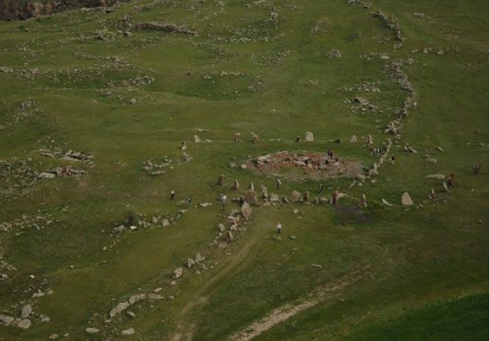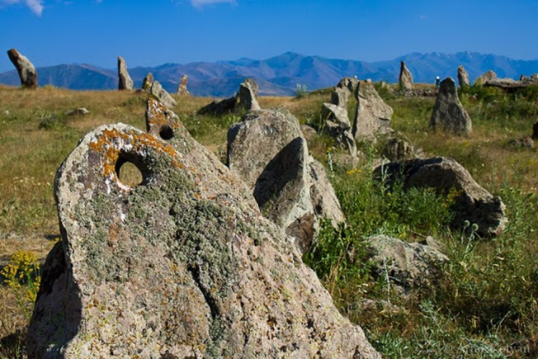

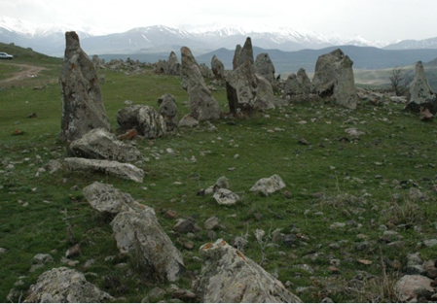

Attachment 2: Permission for construction waste disposal



Non-official translation of the above attached document:

Construction waste generated during the construction works under the “Improvement of the area near the “Zorats Qarer” historical and cultural reserve” sub-project should be transported to the Aghetu landfill located 7,5 km far from the construction site.

Head of community Sealed/Signed S.Hovhannisyan

**Attachment 3: Minutes of public consultation of draft Environmental and Social Management Plan**

On January 22, at 11.00 am, a public consultation was held by Zoom online platform on the Environmental and Social Management Plan of the "Improvement of the area near the “Zorats Qarer” historical and cultural reserve” sub-project.

The announcement of the public consultation was posted on the ATDF website (atdf.am), on the Sisian community social network page and the municipality's information board on January 12, 2021.

The public consultation meeting was carried out by ATDF Social Specialist Knarik Grigoryan and Environmental Specialist Asya Osipova. The meeting was joined by representatives of Sisian community; overall 8 participants were participated in the meeting, among which 3 women.

Knarik Grigoryan presented the main purpose of the discussion, the agenda and the planned construction works.

Asya Osipova presented possible environmental impacts: generation of dust and waste, construction noise, air pollution, etc. and the mitigation measures to be applied. Asya Osipova also presented the frequency of monitoring visits and the procedures of monitoring of the implementation of environmental and social impacts mitigation measures.

Knarik Grigoryan noted that no negative social impacts are expected, as any use of private land or business interaption is not predicted. There are no houses near the site and the area is deserted. The implementation of the sub-project will contribute to the activation of tourist flows to Sisian and the development of the local economy. She introduced the operation of the grievance redress mechanism, the means of contacting ATDF, including hot line, e-mail and the web tool. Simon Hovhannisyan was elected as the grievance local focal point, who was introduced to his main responsibilities and grievance redress procedures.

A. Osipova and K. Grigoryan asked participants to raise questions and concerns relating to the sub-project and social or environmental issues.

A question was raised whether any works will be carried out directly in the area of the monument. Knarik Grigoryan answered, that no construction works will be carried out inside the buffer zone of the monument in the frameworks of the sub-project.

**Photo**

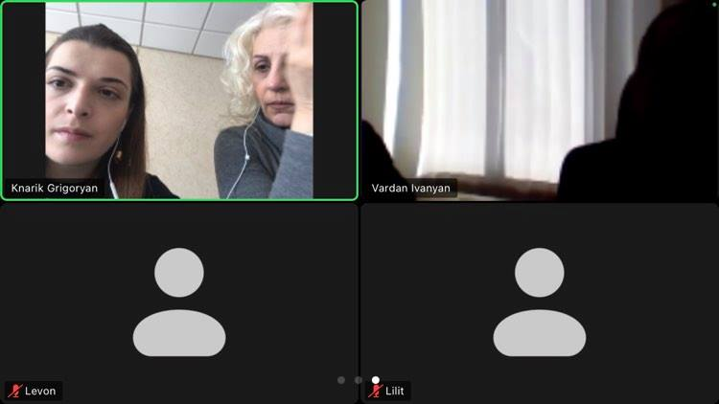

**List of participants**

|  |  |
| --- | --- |
| **Name/surname** | **Community/organization** |
| Vardan Ivanyan | Sisian Municipality office, deputy mayor |
| Simon Hovhannisyan | Sisian Municipality office, chief architect |
| Levon Dolunts | Municipality office, specialist |
| Vigen Manukyan | Municipality office, specialist |
| Lilit Barkhudaryan | Sisian community member |
| Ashot Avetisyan | Sisian community member |
| Asya Osipova | ATDF, environmental specialist |
| Knarik Grigoryan | ATDF, social specialist |

Attachment 4: Construction permits 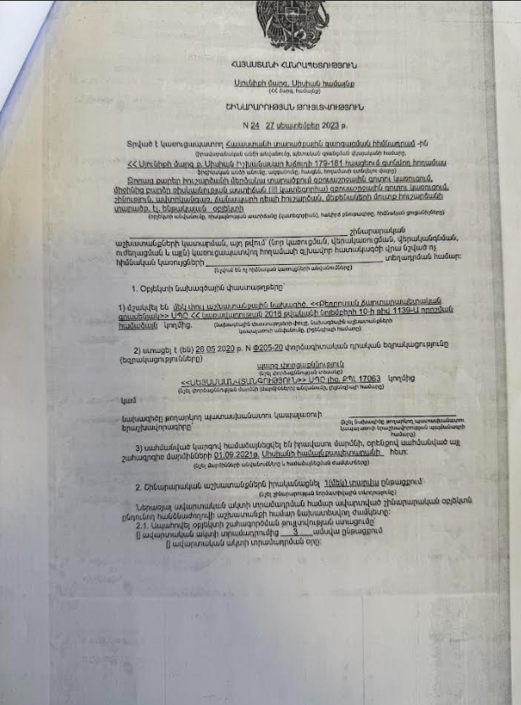 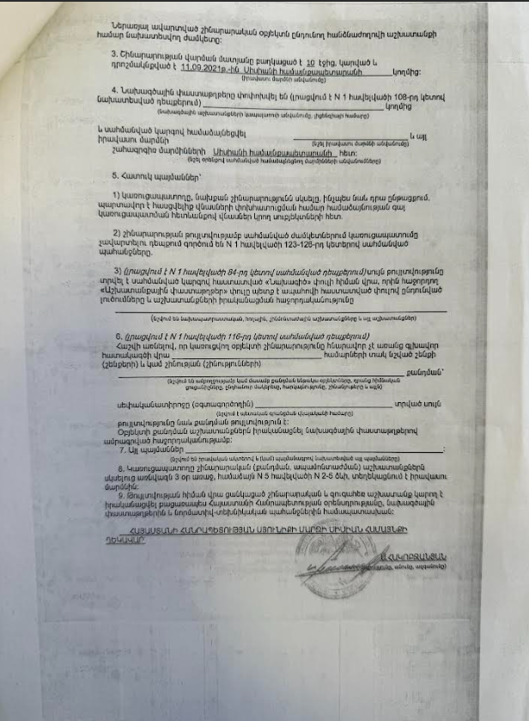

1. Toxic / hazardous material includes but is not limited to asbestos, toxic paints, noxious solvents, removal of lead paint, etc.