***ARMENIA SOCIAL INVESTMENT AND LOCAL DEVELOPMENT PROJECT***

*FINAL ENVIRONMENTAL AND SOCIAL REVIEW CHECKLIST*

Micro-project title: Reconstruction of the Kindergarten in Khashtarak settlement

Micro-project #: AFT-TV-05

Is the Environmental and Social management plan (ESMP) developed?

**Yes +** No -

Does ESMP provide a full list of potential impacts and establish adequate measures for their mitigation?

**Yes +** No -

**Conclusion of the Final Environmental and Social Assessment**

|  |  |
| --- | --- |
| Conclusion | |
| Micro-project rejected | Micro-project approved (environmental assessment completed) |
|  | + |

**PART A: General Project and Site Information**

|  |  |  |  |  |
| --- | --- | --- | --- | --- |
| **INSTITUTIONAL & ADMINISTRATIVE** | | | | |
| Country | Armenia | | | |
| Project title | Social Investment and Local Development Project | | | |
| Micro-project number and title | AFT-TV-05 “Reconstruction of the Kindergarten in Khashtarak settlement ” | | | |
| Municipality, community | Tavush marz, Ijevan community | | | |
| Scope of site-specific activity | The kindergarten was built in 1984. This is a two-story building, consisting of 2 buildings. The roof of the building has been repaired, but the drainage pipes have not been replaced.  The second (left) building, as well as the hot corridor, are in need of repair..  The planned construction works include:  cleaning all the external walls with sandblasting, covering the walls with basalt tiles and installing masonry. For load-bearing walls, it is planned to carry out plastering on the grid. The partition walls are planned to be made with pumice blocks, and the playrooms and bedrooms with plasterboard partitions. The internal walls are planned to be plastered and covered with latex paint.  On the first floor, it is planned to apply a 100-mm-thick floor covering. Inter-floor coverings will be strengthened with a 60-mm-thick reinforced concrete layer. The floors of the bathrooms are planned to be made with ceramic tiles, while in the corridors and in the kitchen - with marble granite. Flooring in bedrooms, playrooms, office rooms and the aid room will be done with vinyl tiles.  The roof is designed to be envelope-shaped, with wood-coal structure and organized drainage. Thermal insulation of the roof is planned.  The internal stairs are planned to be made of reinforced concrete, faced with basalt slabs. The frame will be made of aluminum, with 1.2 m height.  The windows will be made of metalloplast frames (blocks).  The doors will be replaced.  The territory will be landscaped and fenced. Four pavilions will be installed to provide common space for children to play and relax.”  The construction area is 288 square meters.  The water pipeline is laid at a distance of about 400 m, and the gas pipeline is laid at a distance of about 500 m. There is no sewage in this settlement; a bio-purification facility will be installed on the territory of the kindergarten. Two alternative roads lead to the building.  The number of preschool children in Khashtarak is 72 people. The capacity of the new kindergarten will be 90 places.  Taking into account the technical condition of the kindergarten buildings in Khashtarak settlement, Tavush marz, RA identified through the assessment of its structural integrity and based on the requirements of point 10.2 of the "Methodical instructions for surveying and certifying the technical condition of residential public and industrial buildings and structures" approved by the decree No. 282-N of the Minister of Urban Development of the RA dated on December 8, 2009, the left building of the kindergarten buildings belongs to the 2-nd degree of damage. All measures required in the conclusion of the above-mentioned assessment are included in the design package and will be carried out under the Micro-project.  The full document is included in the ESMP as an attachment. | | | |
| Institutional arrangements (WB) | Task Team Leader:  Ivan Drabek | | Safeguards Specialist:  Environment –- Darejan Kapanadze  Social – David Jijelava | |
| Implementation arrangements (RoA) | Implementing entity:  ATDF  Environment - Asya Osipova  Social - Knarik Grigoryan | Works Supervisor: | | Works Contractor: |
| **SITE DESCRIPTION** | | | | |
| Name of site | Kindergarten of Khashtarak settlement | | | |
| Address and site location | Address: Khashtarak settlement, Street 9, Building 11 | | | |
| Who owns the land? | The land plot (Cadastral code: N 11-035-0043-0018) and the building (Cadastral code: N 11-035-0043-0018-001 ) of the kindergarten are the property of the community. The area of the land plot is 0.43392 ha. The land plot and the building to be renovated under the micro-project are not formally or informally used for any private purposes.  No private lands will be used during the construction period for parking of construction machinery or any other purpose.  The Micro-project will not reduce other people’s access to their economic resources, such as land, pasture, water, public services or other resources that they depend on. The Micro-project will not result in the temporary or permanent loss of crops, fruit trees and household infrastructure. | | | |
| Description of physical and natural environment around the site | Khashtarak, a village in the Ijevan region of the Tavush Marz of the Republic of Armenia, about 4 km northeast of the regional center of Ijevan. It is located on the right bank of the Aghstev River; next to it are the settlements of Lusakhovit, Lusadzor, Aknakhbyur and Ditavan.  The existing building of the kindergarten is located in the central part of the village of Khashtarak, surrounded by an old fence. Access to the construction site is from a nearby public road. On the territory of the kindergarten there is enough space for parking construction equipment, as well as for organizing temporary storage of building materials and construction waste. The territory is landscaped, mostly shrubs, there are several large trees that will not interfere with construction work.  There is a one-story building located near the kindergarten, which is the property of the community, but is given for rent for a period of 25 years and is operated as storage. The project provides for a separate entrance (road) to this building, outside the territory (behind the fence) of the kindergarten. The temporary fencing of the construction site will be done in a way not blocking the entrance of the building. | | | |
| **LEGISLATION** | | | | |
| National & local legislation & permits that apply to project activity | The following Armenian legislation defines a legal framework applicable to project activities:  - Law on Atmospheric Air Protection of RoA (1994)  The purpose of Law on Atmospheric Air Protection is to define main principles of the RoA, directed to provision of purity of atmospheric air and improvement of air quality, prevention and mitigation of the chemical, physical, biological and other impacts on air quality and regulation of public relation. This Law also regulates the emission licenses and provides maximum allowed loads / concentrations for atmospheric air pollution, etc.  According to this law, contractor shall undertake construction activities as well as transportation and temporary storage of waste the way to minimize dust and other emissions.  - Law on Waste of RoA (2004)  The law provides the legal and economic basis for collection, transportation, disposal, treatment, re-use of wastes as well as prevention of negative impacts of waste on natural resources, human life and health. The law defines the roles and responsibilities of the state authorized bodies as well as of waste generator organizations in waste management operations.  According to this law, the waste generated from construction activities should be recycled as appropriate or disposed of in designated locations.  Disposal of the construction waste and excess material in selected locations must be approved by local municipality in writing.  - Law on Environmental Impact Assessment and Expertise of RoA (2014)  The law defines the type of activities that are subject to environmental impact assessment and environmental expertise. According to this law, the proposed works are not subject to a state environmental impact expertise.  The following permissions are required for accomplishing the works planned under the sub-project:   * Construction permit; * Land ownership certificate; * Permission for the disposal of construction waste; * Conclusion of seismological expertise / technical condition of the building. | | | |
| **PUBLIC CONSULTATION** | | | | |
| When / where the public consultation process will take /took place | The draft ESMP will be disclosed and discussed at the public consultation meeting to be held in Khashtarak settlement with the participation of representatives from the community administrative office, local population and ATDF.Draft ESMP will be disclosed on the ATDF website (www.atdf.am) and the beneficiary's website (www.ijevan.am). Brief information on the planned works and contact information for addressing questions and grievances will be placed on the information board of the administrative building of Khashtarak settlement, at the worksite and/or in its immediate surroundings | | | |
| **ATTACHMENTS** | | | | |
| Annex 1: Photos and plan of the construction site  Annex 2: Copy of Conclusion of seismological expertise / technical condition of the building  Annex 3: Copy of the land ownership certificate  Annex 4: Copy of an agreement for construction waste disposal  Annex 5: Minutes of Public Consultation on the draft ESMP (to be provided)  Annex 6: Copy of a Construction Permit (to be provided) | | | | |

**PART B: safeguards information**

|  |  |  |  |
| --- | --- | --- | --- |
| **ENVIRONMENTAL /SOCIAL SCREENING** | | | |
| Will the site activity include/involve any of the following? | **Activity/Issue** | **Status** | **Triggered Actions** |
| 1. Building rehabilitation | [+] Yes [ ] No | If “Yes”, See Section **A** below |
| 1. New construction | [ ] Yes [+] No | If “Yes”, See Section A below |
| 1. Individual wastewater treatment system | [ ] Yes [+] No | If “Yes”, See Section **B** below |
| 1. Historic building(s) and districts | [ ] Yes [+] No | If “Yes”, See Section **C** below |
| 1. Acquisition of land[[1]](#footnote-1) | [ ] Yes [+] No | If “Yes”, See Section **D** below |
| 1. Hazardous or toxic materials[[2]](#footnote-2) | [ ] Yes [+] No | If “Yes”, See Section **E** below |
| 1. Impacts on forests and/or protected areas | [ ] Yes [+] No | If “Yes”, See Section **F** below |
| 1. Handling / management of medical waste | [ ] Yes [+] No | If “Yes”, See Section **G** below |
| 1. Traffic and Pedestrian Safety | [+] Yes [ ] No | If “Yes”, See Section **H** below |
|  | 1. Social risk | [+] Yes [ ] No | If “Yes”, See Section **I** below |

**PART C: Mitigation measures**

|  |  |  |
| --- | --- | --- |
| **ACTIVITY** | **PARAMETER** | **MITIGATION MEASURES** (provide costs where applicable) |
| 0. General Conditions | Notification and Worker Safety | 1. The local construction and environment inspectorates and communities have been notified of upcoming activities; 2. The public has been notified of the works through appropriate notification in the media and/or at publicly accessible sites (including the site of the works) 3. All legally required permits have been acquired for construction; 4. The Contractor formally agrees that all work will be carried out in a safe and disciplined manner designed to minimize impacts on neighboring residents and environment; 5. Workers’ PPE will comply with international good practice (always hardhats, as needed masks and safety glasses, harnesses and safety boots); 6. Appropriate signposting of the sites will inform workers of key rules and regulations to follow. |
| A. General Construction Activities | Air Quality | 1. During interior demolition debris-chutes shall be used above the first floor; 2. Demolition debris shall be kept in controlled area and sprayed with water mist to reduce debris dust; 3. During pneumatic drilling/wall destruction dust shall be suppressed by ongoing water spraying and/or installing dust screen enclosures at site; 4. The surrounding environment (sidewalks, roads) shall be kept free of debris to minimize dust; 5. There will be no open burning of construction / waste material at the site; 6. There will be no excessive idling of construction vehicles at sites. |
| Noise | 1. Construction noise will be limited to restricted times agreed to in the permit 2. During operations, the engine covers of generators, air compressors and other powered mechanical equipment shall be closed, and equipment placed as far away from residential areas as possible |
| Water Quality | 1. The site will establish appropriate erosion and sediment control measures such as e.g. hay bales and / or silt fences to prevent sediment from moving off site and causing excessive turbidity in nearby streams and rivers. |
| Waste Management | 1. Waste collection and disposal pathways and sites will be identified for all major waste types expected from demolition and construction activities; 2. Mineral construction and demolition wastes will be separated from general refuse, organic, liquid and chemical wastes by on-site sorting and stored in appropriate containers; 3. Construction waste will be collected and disposed properly by licensed collectors; 4. The records of waste disposal will be maintained as proof for proper management as designed; 5. Whenever feasible the contractor will reuse and recycle appropriate and viable materials (except asbestos). |
| Earth Works | 1. Excess material and topsoil generated from earth works will be stored separately and used for backfilling and site reinstatement 2. Topsoil layer not thicker than 30 m will be stripped separately and temporary piled on-site 3. Stockpile height will not exceed 3.0 m, and the slope angle will not exceed 34o 4. Temporary stockpile will be compacted and covered with a tarp to prevent erosion caused by rain runoff 5. Topsoil will be re-used for backfilling to facilitate re-cultivation of the land plot 6. Excess amount of subsoil will be disposed at the agreed-upon locations. |
| H. Traffic and Pedestrian Safety | Direct or indirect hazards to public traffic and pedestrians by construction  activities | (a) In compliance with national regulations the contractor will insure that the construction site is properly secured and construction related traffic regulated. This includes but is not limited to: Signposting, warning signs, barriers and traffic diversions: site will be clearly visible and the public warned of all potential hazards   * Traffic management system and staff training, especially for site access and near-site heavy traffic. Provision of safe passages and crossings for pedestrians where construction traffic interferes. * Adjustment of working hours to local traffic patterns, e.g. avoiding major transport activities during rush hours or times of livestock movement * Active traffic management by trained and visible staff at the site, if required for safe and convenient passage for the public. * Ensuring safe and continuous access to office facilities, shops and residences during renovation activities, if the buildings stay open for the public. |
| I. Social risk | Public relationship management | 1. Consult local communities to identify and proactively manage potential conflicts between an external workforce and local people; 2. Raise local community awareness about sexually transmitted disease risks associated with the presence of an external workforce and include local communities in awareness activities; 3. Inform the population about construction and work schedules, interruption of services, traffic detour routes and provisional bus routes, blasting and demolition, as appropriate; 4. Limit construction activities at night. When necessary ensure that night work is carefully scheduled, and the community is properly informed, so they can take necessary measures; 5. At least five days in advance of any service interruption (including water, electricity, telephone, and bus routes), advice community through postings at the work site, at bus stops, and in affected homes/businesses; 6. Address concerns raised through Grievance Redress Mechanism established by the Employer within the designated timeline within the scope of Contractor’s liability; 7. To the extent possible, work camps should not be located in close proximity to local communities; 8. Siting and operation of worker camps should be undertaken in consultation with neighboring communities. |
| Labor management | 1. The Contractor will recruit unskilled or semi-skilled workers from local communities to the extent possible. Where and when feasible, worker skills training, should be provided to enhance participation of local people; 2. The Contractor will provide adequate lavatory facilities (toilets and washing areas) in the worksite with adequate supplies of hot and cold running water, soap, and hand drying devices. A temporary septic tank system should be established for any residential labor camp and without causing pollution of nearby watercourses; 3. The Contractor will raise awareness of workers on overall relationship management with local population, establish the code of conduct in line with international practice and strictly enforce them, including the dismissal of workers and financial penalties of adequate scale. |
|  | GRM management | 1. Assign local liaison person within Contractor’s team to be in charge of communication with and receiving requests/ complaints from local population; 2. GRM is established and advertised at the local level. The Contractor is informed of his responsibility to register and communicate to the PIU received verbal and non-verbal grievances; 3. GRM contact information, including local focal points, has been posted at the construction site and the local community’s administrative office; 4. The Contractors' local liaison person receives and registers grievances from the population in the GRM log and communicates the grievances to the PIU regularly. |

**PART D: Environmental and Social Monitoring Plan for construction and operation phases**

|  |  |  |  |  |  |  |
| --- | --- | --- | --- | --- | --- | --- |
| **Activity** | **What**  (Is the parameter to be monitored?) | **Where**  (Is the parameter to be monitored?) | **How**  (Is the parameter to be monitored?) | **When**  (Define the frequency / or continuous?) | **Why**  (Is the parameter being monitored?) | **Who**  (Is responsible for monitoring?) |
| **CONSTRUCTION PHASE** | | | | | | |
| 1. Supply of construction materials | -Purchase of the construction materials from licensed providers | Offices and warehouses of material suppliers | Verification of labels of the materials and/or certificates if any | In the process of signing the agreements for material provision | Ensure quality of construction materials;  Protect human health and environment | ATDF  Technical Supervision Company |
| 2. Transportation of construction materials and waste  Movement of construction machinery | - Technical condition of construction vehicles and machinery;  - Adequacy of the loading trucks for transported types of cargo, and canopy coverage of cargo transported in open trucks;  - Movement of construction vehicles and machinery along pre-defined routes | - Construction site  - Routes for transportation of construction materials and construction wastes | Inspection of roads adjacent to the construction site and included in the agreed-upon routes of transportation | Unannounced checks during the working hours | - Limit pollution of soil and air from emissions;  - Reduce traffic disruption;  - Limit nuisance to local communities from noise and vibration | ATDF  Technical supervision company  Road Police |
| 3. Maintenance of construction equipment | - Washing of cars and construction equipment outside the construction site or on maximum distance from natural streams;  - Refueling or lubrication of construction equipment outside the construction site or at the predetermined confined area. | Construction site | Inspection of activities | Selective inspections during work hours | - Avoid pollution of water and soil with oil products due to operation of equipment;     * Timely localize and decrease expected damage in case of fire | ATDF  Technical supervision company  Khashtarak administrative office |
| 4.Traffic and road safety | * Presence of traffic and road signs as needed; * Construction site is demarcated/fenced, and all the construction activities confined to the site; * No construction materials and waste is piled up or scattered outside the construction site. | Construction site and adjacent area | Inspection of activities | Entire period of construction | -Prevent the violation of interests of the passengers and/or pedestrians because of the construction works | ATDF  Technical supervision company |
| 5. Generation of construction waste | - Temporary storage of construction waste in allocated areas;  - Timely disposal of waste to the formally designated site | Construction site and base (if applicable);  Locations designated for waste disposal | Checking documents;  Visual observation | Entire period of construction | * Prevent pollution of soil, surface water and ground water, * Avoid accidents at the construction site due to scattered fragments of construction materials and debris; * Retain esthetic appearance of the construction site and its surroundings | ATDF  Technical supervision company  Khashtarak administrative office |
| 6. Accumulation of household waste | -Provision of waste containers on-site;  -Agreement with local community for regular out-transporting of waste | Construction site and base (if applicable) | Visual inspection | Entire period of construction | Avoid pollution of soil and water with household waste | ATDF  Technical supervision company  Khashtarak administrative office |
| 7. Safety of labor | - Construction workers wearing uniforms and PPE (hardhats, masks, safety glasses, harnesses and safety boots, etc.);  - Strict compliance with the rules of construction equipment operation and usage of PPE;  - Availability of labor safety training and instruction records;  - First aide medical kits and fire extinguishers availability at work site;  - Contact information for emergency services (medical, fire) posted on the information board at work site | Construction site | Inspection of the activities | Entire period of construction | Reduce the probability of accidents | ATDF  Technical supervision company |
| 8. Earthworks | Topsoil removal and temporary stockpiling for re-cultivation of the land;   * Temporary storage of excavated soil at determined places; * Backfilling of the excavated ground as needed and disposal of the excess mass to the places, approved in writing. | Construction site | Inspection of activities | During earth works | * Limit loss of vegetation due to ground piling and minimization of pollution of surface waters with particles; * Limit pollution with contaminated soil of surface and ground waters | ATDF  Technical supervision company |
| 9.Extraction of inert material | * Purchase of inert materials from the existing suppliers, if there is such opportunity; * Obtaining the license for production of inert materials and strict compliance with the license; * Terracing of quarries, backfilling of exploited areas and harmonization with the landscape; * Excavating gravel outside water flow, arrangement of separating ridges between water flow and excavation area, banning entrance of watery by vehicles and machinery. | Quarries of inert materials | Inspection of documents  Inspection of activities | During excavation and reclamation at quarries | * Limit slope erosion and landscape damage * Limit erosion of riverbanks, pollution of water flow with weighted particles and disturbance of aquatic life | ATDF  Technical supervision company |
| 10. Handling of chance finds | * Stoppage of works promptly upon encountering of chance finds; * Formal communication with Agency for the Protection of Monuments and Historical Sites of RA on chance finds; * Timely arrangements made for the conduct of required excavation and site conservation. | Construction site | -Inspection of chance find sites;  - Inspection of filed document | Entire period of construction | Ensure cultural heritage is not damaged by the construction works | ATDF  Technical supervision company  Agency for the Protection of Monuments and Historical Sites |
| 11. Construction site re-cultivation and landscaping | Final cleaning of the construction site and permanent access roads and landscaping-greening of the area | Construction site, construction base and temporary access roads (if any) | Visual inspection | Final period of construction | Reduce loss of aesthetical value of the landscape due to the renovation works | ATDF  Technical supervision company  Khashtarak administrative office |
| 12. Nuisance to nearby residents caused by improper parking of construction machinery and vehicles, temporary storage of construction material and waste, or littering around the construction site by contractors | - No parking of construction vehicles and machinery outside the construction site;  - No blocking of pedestrian and vehicle movement around the construction site due to stockpiling/dumping of construction materials/waste;  - No trespassing of private land plots and/or other private property around the construction site by contractor’s personnel | In the immediate vicinity of the construction site | Visual inspection | Entire period of construction | Prevent negative impacts on private property, assets or livelihoods of the owners/users | ATDF  Technical supervision company |
| 13. Works within the settlement | - Observation of working hours (9AM-6PM).  - Demarcation and fencing of worksite;  - Warning signs installation and visibility to warn public of all potential hazards;  - Restriction of access to construction site to only authorized personnel involved in implementation of construction works;  - Monitoring of the access to construction site;  - Provision of safe passages for pedestrians. | Construction site | Visual inspection | Entire period of construction | Ensure public safety | ATDF  Technical supervision company |
| 14. Operation of the Grievance Redress Mechanism (GRM) | -ATDF and World Bank GRM information is available and visible to the public;  -The appointment by the authorities of the Coordinator for the consideration of complaints (receiving complaints, reviewing and explaining, registering complaints in the log book and trying to resolve them on the spot);  -Appeal to ATDF by hot-line (010 24 01 59), postal letter (Yerevan 0037, K.Ulnetsi 31), official web page(<http://atdf.am/hy/Home/ContactUs>), e-mail ([support@atdf.am](mailto:support@atdf.am)) | At locations for posting GRM information;  ATDF office | Inspection | Entire period of construction | Provide for all citizens in the community a channel to voice questions, feedback or complaints related to construction works | ATDF  Technical supervision company |
| **OPERATION PHASE** | | | | | | |
| 1.Disposal of household waste and waste from periodic renovation of the building | Regular collection and disposal of household waste generated at the site to the designated landfill site | Premises of the kindergarten | - Inspection of the kindergarten premises;  Timely collection and disposal of household waste | Entire period of construction | - Maintain good sanitary conditions at the site;  - Prevent environmental pollution | Khashtarak administrative office |
| 2. Safe operation and maintenance of the boilers and heating system | Regular servicing of the boilers and entire heating system being undertaken | Premises of the kindergarten | Periodic inspection | Entire period of operation of heating system | Maintenance of boilers in safe and operable condition | Khashtarak administrative office |
| 3. Maintenance of internal communication systems | Electric wiring and water/seage pipes mainitain in good opration condition | Premises of the community center | Inspection of community center area | Total period of operation of community center | Exclude risks of electric shocks, short circuits, and leakage of pipes | Khashtarak administrative office |
| 4. Emergency preparedness | Presence of fire alarm and fire localization system, and emergency back-up systems for power and water supply | Premises of the Kindergarten | Periodic inspection | Entire period of operation of the facility | - Reduce risks for the staff and students;  - Avoid disruption in the provision of utility services to the kindergarten | Khashtarak administrative office  Ministry of Emergency Situations |

**Annex 1: Map and Photos of the construction site**

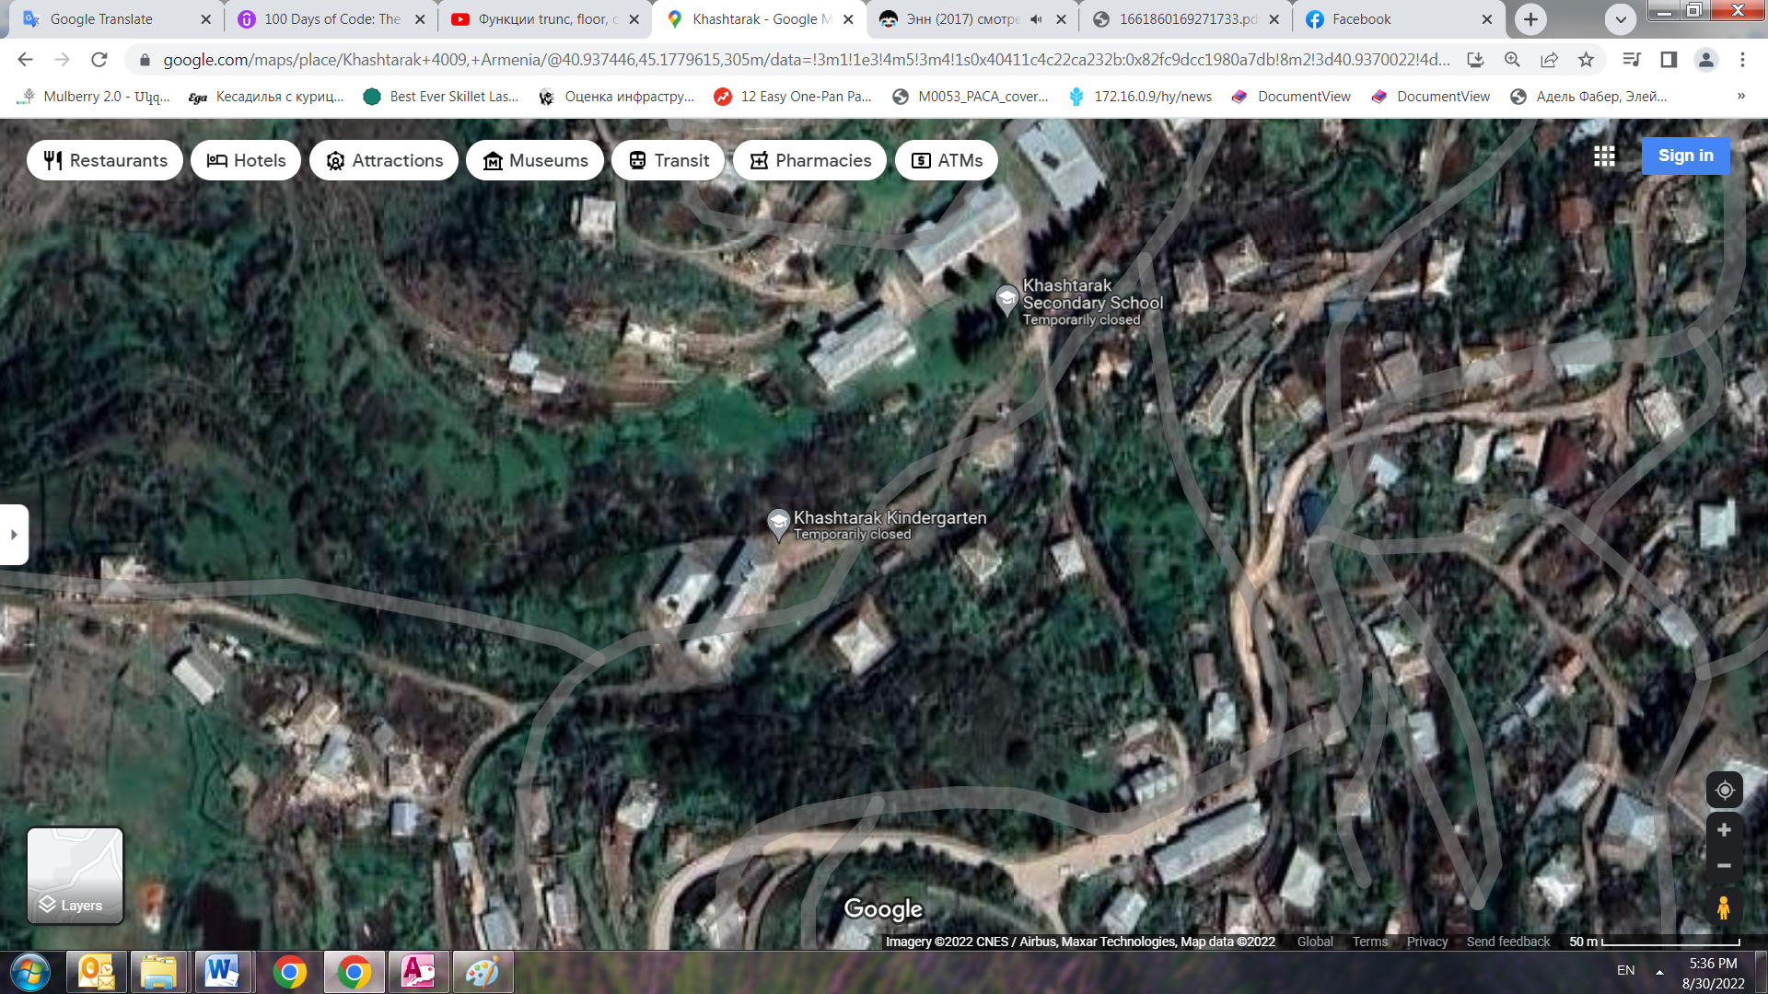

|  |  |
| --- | --- |
| **M:\Alexander\Khashtarak photos\IMG_20210610_125643.jpg** | **M:\Alexander\Khashtarak photos\IMG_20210610_125714.jpg** |
| **M:\Alexander\Khashtarak photos\IMG_20210610_131134.jpg** | **M:\Alexander\Khashtarak photos\IMG_20210610_131353.jpg** |
| **M:\Alexander\Khashtarak photos\IMG_20210610_131400.jpg** | **M:\Alexander\Khashtarak photos\IMG_20210610_131402.jpg** |
| **M:\Alexander\Khashtarak photos\IMG_20210610_131438.jpg** | **M:\Alexander\Khashtarak photos\IMG_20210610_131523.jpg** |

**Annex 2: Copy of the land ownership certificate**

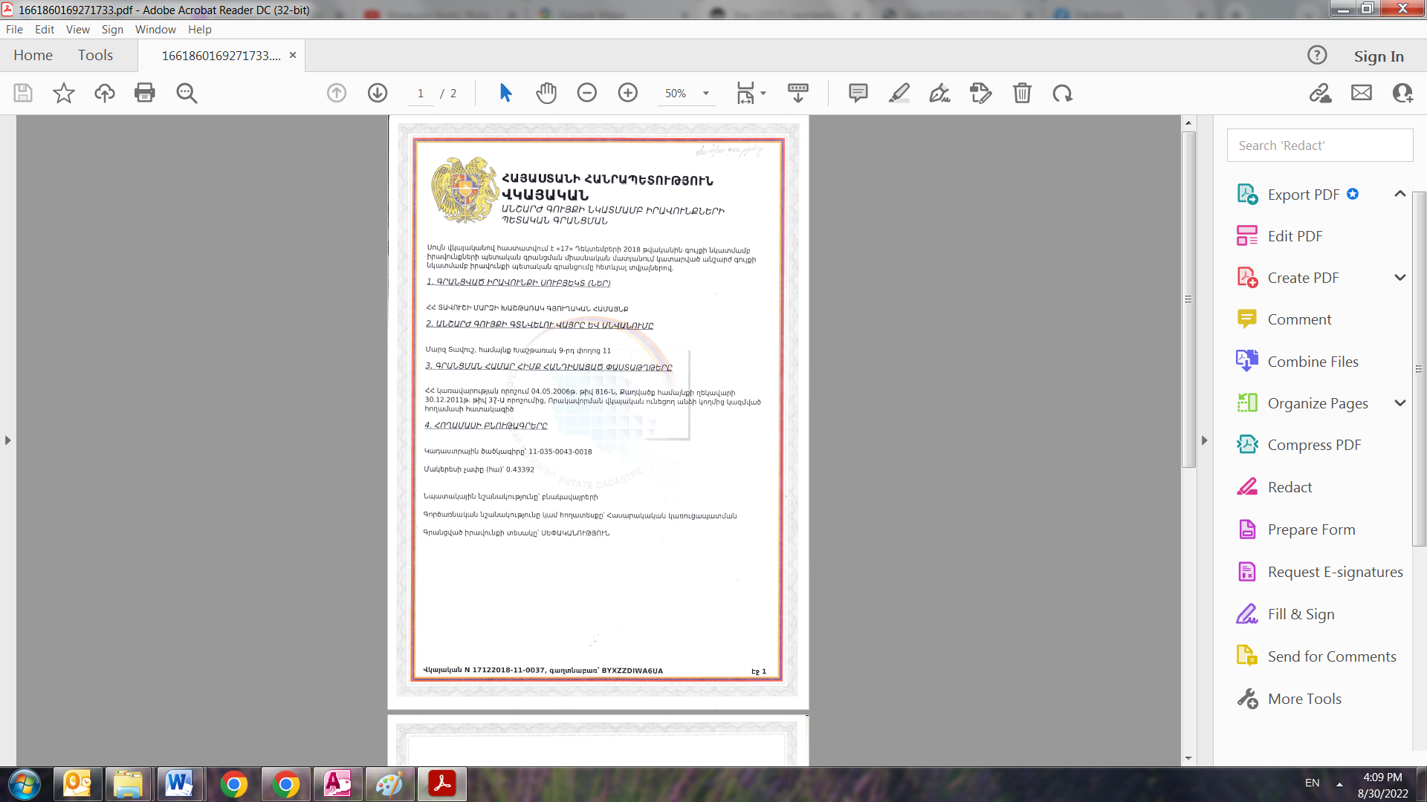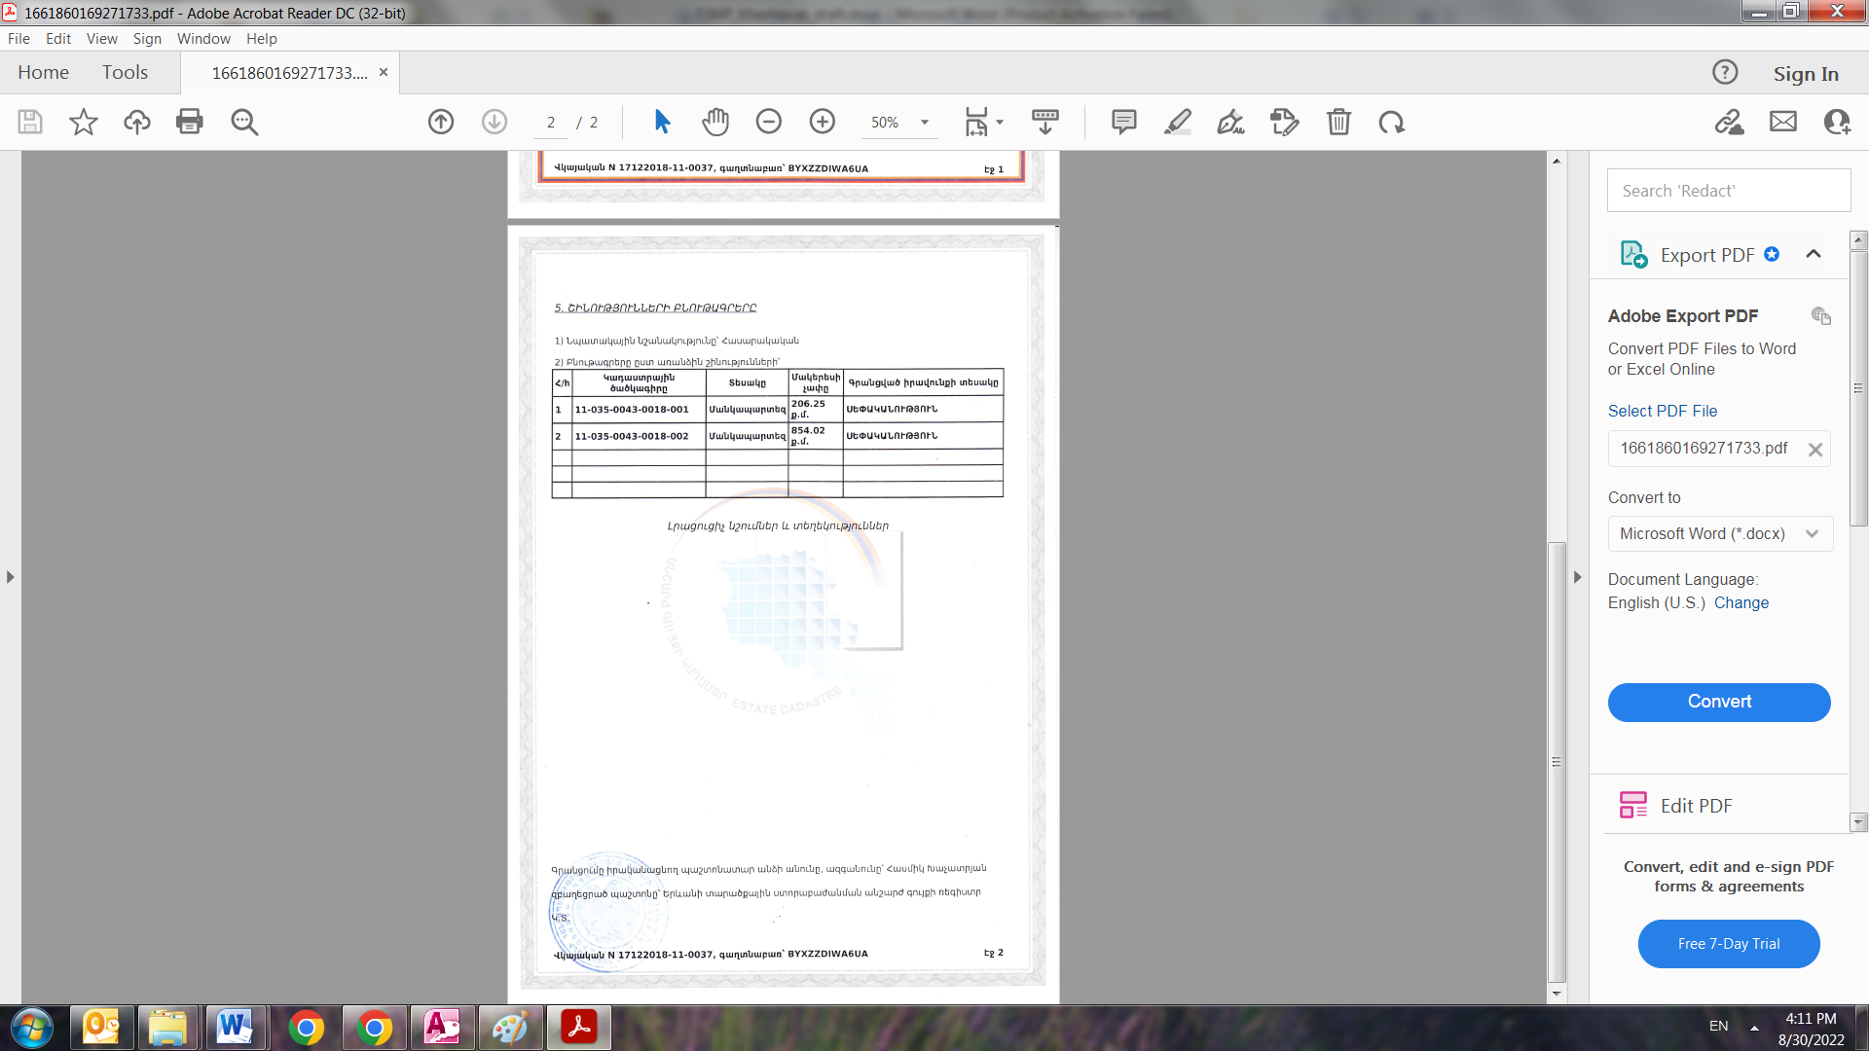

**Non-official translation of the land certificate:**

This certificate confirms the state registration of the rights to immovable property in unified register made on December 17, 2018 with the following data.

The subject of the rights registration - Khashtarak rural community of Tavush marz of RA

Address and name of the property- Tavush marz, Khashtarak community, Street 9, Building 11

The documents that are the basis for registration-Decree of the Government of RA dated on 04.05.2006.

Data on the Land Plot:

Cadastral Number – 11-035-0043-0018

Purpose of the land plot - Residential

Land use – Public construction

The size of land plot – 0.43392 ha

Type of right – ownership

**Annex 3: Copy of an agreement for construction waste disposal**

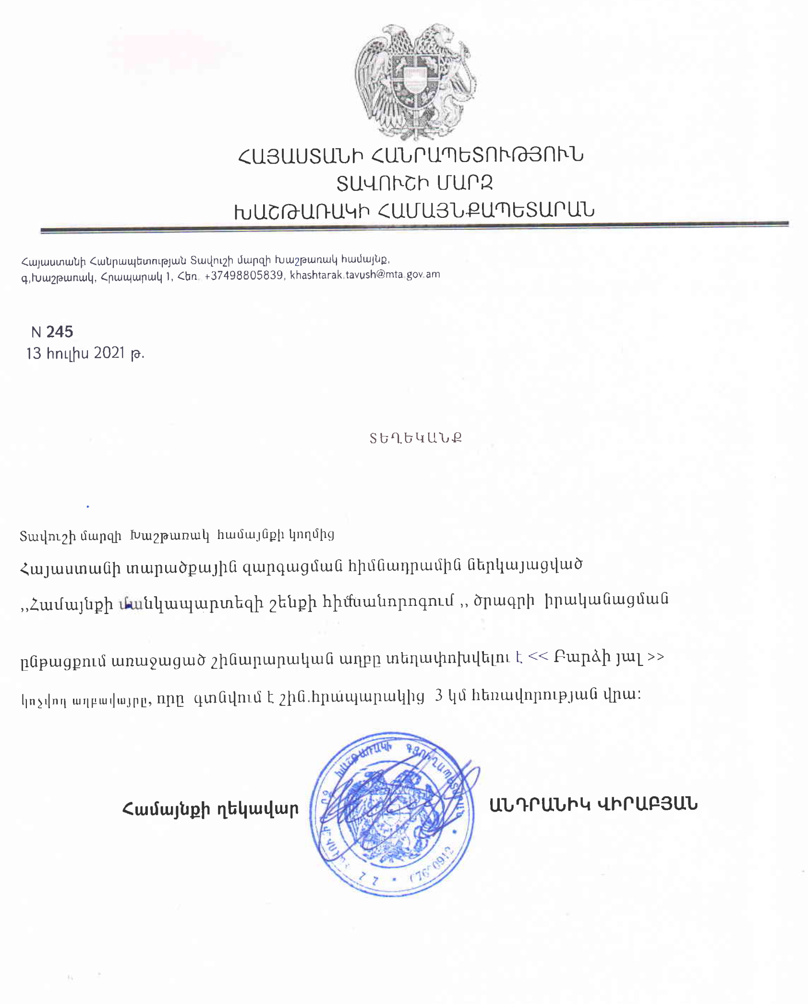

Non-official translation of the above attached document:

Construction waste generated during the reconstruction of the kindergarten in the Khashtarak settlement should be transported to the ‘’Barcr Yal’’ landfill located 3 km far from the construction site.

Head of community Sealed/Signed A.Virabyan

**Annex 4: Copy of Conclusion of seismological expertise / technical condition of the building**

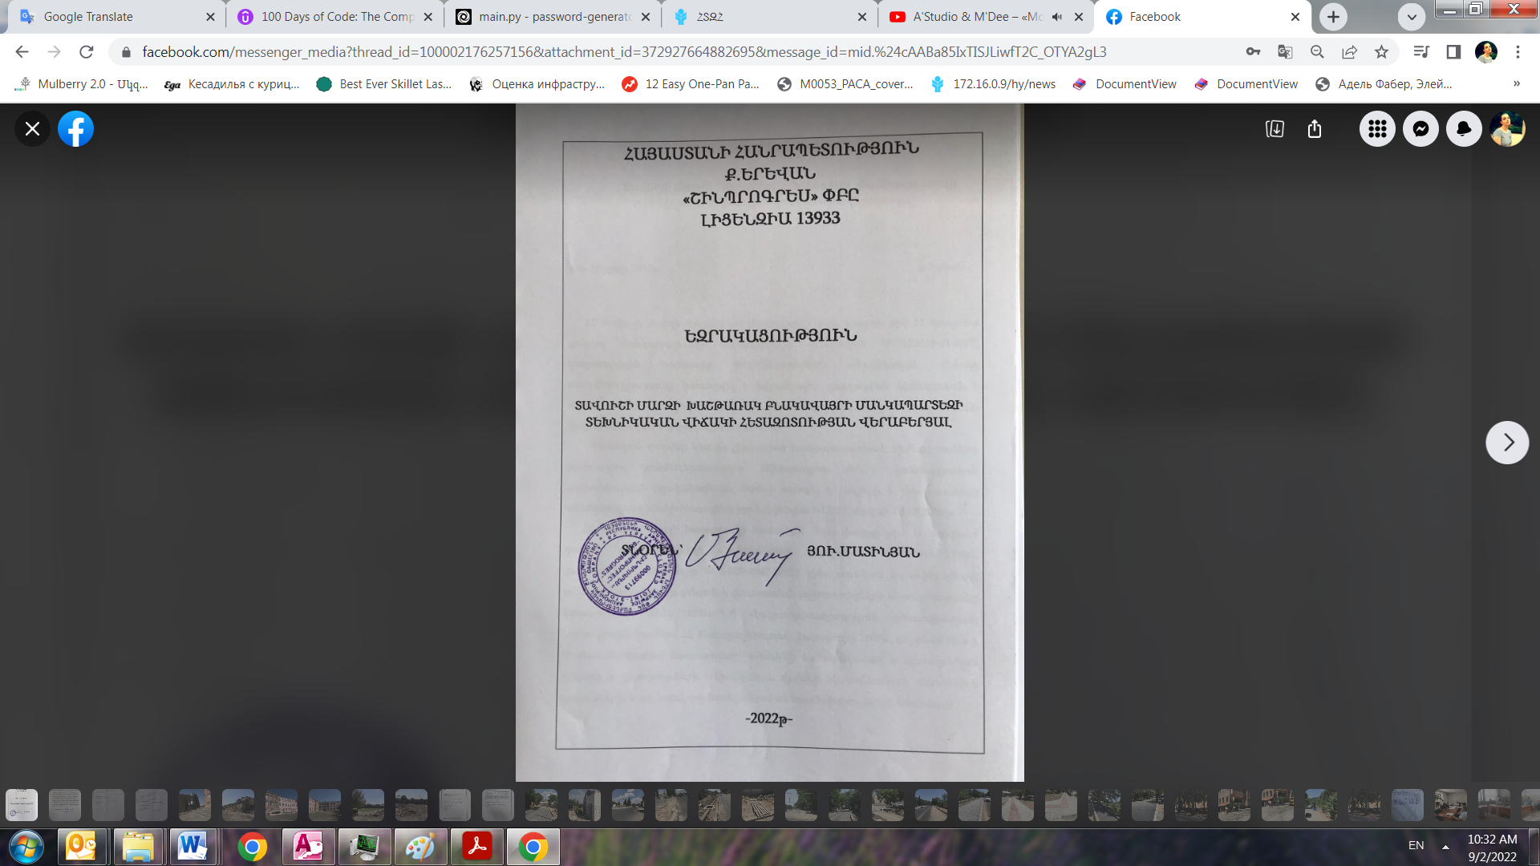 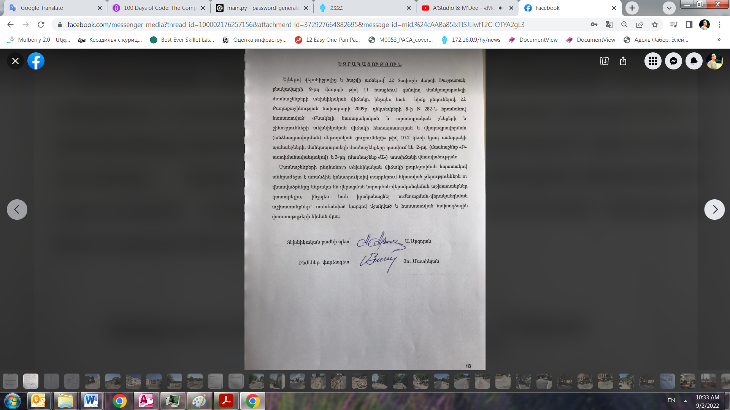

**Non-official translation of above document:**

Taking into account the technical condition of the kindergarten buildings of Khashtarak settlement, Tavush marz, RA, as well as taking as a basis the requirements of point 10.2 of the "Methodical instructions for surveying and certifying the technical condition of residential public and industrial buildings and structures" approved by the decree No. 282-N of the Minister of Urban Development of the RA dated on December 8, 2009, the buildings of the kindergarten are classified as 2nd (Building B) and 3rd (Building A) degree of damage.

In order to improve the general technical condition of the buildings, it is necessary to eliminate the defects and injuries observed in individual structural elements during repair and restoration works, as well as to carry out strengthening and restoration works based on the design documents developed and approved according prescribed procedures.

**Annex 5: Minutes of the Public Consultation on the draft ESMP (to be provided)**

**Annex 6: Copy of a Construction Permit (to be provided)**

1. Land acquisitions includes displacement of people, change of livelihood encroachment on private property this is to land that is purchased/transferred and affects people who are living and/or squatters and/or operate a business (kiosks) on land that is being acquired. [↑](#footnote-ref-1)
2. Toxic / hazardous material includes but is not limited to asbestos, toxic paints, noxious solvents, removal of lead paint, etc. [↑](#footnote-ref-2)