Social Investment and Local Development Project

(Additional Financing)

Component 1

FINAL ENVIRONMENTAL AND SOCIAL REVIEW CHECKLIST

Micro-project title: Reconstruction of the First Floor and Construction

of the Second Floor of the Community Center in Lori Berd

Micro-project #: AFT-LR-01

Is the Environmental and Social management plan (ESMP) developed?
Yes + No _____

Does ESMP provide a full list of potential impacts and establish adequate measures for their mitigation?
Yes + No _____

Conclusion of the Final Environmental and Social Assessment

Conclusion
Micro-project rejected | Micro-project approved (environmental assessment completed)
 | +

PART A: General Project and Site Information
INSTITUTIONAL & ADMINISTRATIVE
Country | Armenia
Project title | Social Investment and Local Development Project
Micro-project number and title | AFT-LR-01, Reconstruction of the First Floor and Construction of the Second Floor of the Community Center in Lori Berd
Municipality, community | Lori region, Lori Berd community
Scope of site-specific activity | The building of Lori Berd Community office is a one-story building of public purpose, which is located on a community-owned land plot of category of “public construction purpose”. It is planned to reconstruct the municipality office building under the micro-project by constructing a new second floor in order to establish a Citizens' Service Office (CSO).  The new CSO will be located on the first floor of the building. Some of the municipality’s existing administrative rooms will be located on the second floor to be constructed. The building will be heated by electric radiators. The construction area is estimated at 302 m².  On the first floor of the community center, all partitions and floor coverings, as well as roof structures and roofing, will be demolished. The bearing walls and side cover will be strengthened; double-sided reinforced concrete cover for the walls and reinforcement of the side cover will be carried out. On the floor to be reconstructed, a transverse frame will be built, and columns will be constructed. The new floor will be built with stone bearing walls. Exterior walls will be plastered and painted. The roof will be four-sloped, with a wooden clapboard construction, and the cover will be made of galvanized colored tiles. The territory will be landscaped and fenced.
Institutional arrangements (WB) | Task Team Leader:  Ivan Drabek | Safeguards Specialist:  Environment – Darejan Kapanadze  Social – David Jijelava
Implementation arrangements (RoA) | Implementing entity:  ATDF  Environment - Asya Osipova  Social - Knarik Grigoryan | Works Supervisor:  (to be provided after supervisor is selected) | Works Contractor:  (to be provided after construction contractor is selected)
SITE DESCRIPTION
Name of institution whose assets are to be rehabilitated | Lori Berd Community
Address and site location | Address: Lori region, Lori Berd community, Lejan village 1 street, N11 building
Who owns the land? | The building of the municipality office (cadastral code: 06-038-0024-0014-001) and the land plot (cadastral code: 06-038-0024-0014) are the property of Lori Berd community. The area of the land plot is 0.056425 ha. The land plot to be used under the micro-project is not formally or informally used for any private purposes.  The municipality office will be temporarily located in the community center (cultural center) building without interruptions of operations during the construction period.
Description of physical and natural environment around the site | The land plot is located at the entrance of the Lori Berd community. There are no buildings on the site. There are no trees and vegetation on the territory Next to the building, there is a parking lot for construction equipment, adjacent to which residential buildings are located.  A conclusion on the reconstruction of the Administrative Building of Lori Berd Municipality of Lori Marz with second floor was provided by the “Expert Center of Urban Planning Projects” CJSC dated on 19.05.2021. Based on the results of the investigation and the requirements of the existing seismic construction norms (Construction norms (CN) of RA II-6-02-06 "Seismic construction: Design norms" and "Methodical instructions for the inspection and certification of the technical condition of residential, public and industrial buildings") as well as according to the requirements of the CN 22-06-2014 “Reconstruction, restoration and strengthening of buildings and structures” the building is located in seismic 3-rd zone and the reconstruction of the Administrative office of Lori Berd community of Lori marz is technically possible. All the measures required in the above mentioned conclusion are included in the design package and will be carried out under the micro-project. The full document is included in the ESMP as an attachment.
LEGISLATION
National & local legislation & permits that apply to project activity | The following Armenian legislation defines a legal framework applicable to project activities:  - Law on Atmospheric Air Protection of RoA (1994)  The purpose of Law on Atmospheric Air Protection is to define the main principles of the RoA, directed to the provision of purity of atmospheric air and improvement of air quality, prevention, and mitigation of the chemical, physical, biological and other impacts on air quality and regulation of public relation. This Law also regulates the emission licenses and provides maximum allowed loads/concentrations for atmospheric air pollution, etc.  According to this law, the contractor shall undertake construction activities as well as transportation and temporary storage of waste the way to minimize dust and other emissions.  - Law on Waste of RoA (2004)  The law provides the legal and economic basis for the collection, transportation, disposal, treatment, re-use of wastes as well as prevention of negative impacts of waste on natural resources, human life, and health. The law defines the roles and responsibilities of the state authorized bodies as well as of waste generator organizations in waste management operations.  According to this law, the waste generated from construction activities should be recycled as appropriate or disposed of in designated locations.  Disposal of the construction waste and excess material in selected locations must be approved by the local municipality in writing.  - Law on Environmental Impact Assessment and Expertise of RoA (2014)  The law defines the type of activities that are subject to environmental impact assessment and environmental expertise.  According to this law, the proposed works are not subject to state environmental impact assessment and expertise.  - Law on Urban Development of RoA (1998)  According to this law, planned works require obtaining a construction permit.
PUBLIC CONSULTATION
When / where the public consultation process will take /took place | The draft ESMP will be disclosed and discussed at the public consultation meeting to be held with the participants from Lori Berd community.  Draft ESMP will be disclosed on the ATDF website (www.atdf.am ) and the beneficiary's website (www.loriberd.am ). Brief information on the planned works and contact information for addressing questions and grievances will be placed on the information board of Lori Berd community, at the worksite and/or in its immediate surroundings.
ATTACHMENTS
Attachment 1: Photos and plan of the construction site
Attachment 2: Copy of an agreement for construction waste disposal
Attachment 3: Preliminary seismic conclusion on the technical condition of the building
Attachment 4: Copy of the ownership certificate
Attachment 5: Minutes of the public consultation of the ESMP (to be provided)
Attachment 6: Copy of the Construction Permit (to be provided)

PART B: safeguards information
ENVIRONMENTAL /SOCIAL SCREENING
Will the site activity include/involve any of the following? | Activity/Issue | Status | Triggered Actions
 | - Reconstruction | [+] Yes [ ] No | If “Yes”, See Section A below
 | - New construction | [+] Yes [ ] No | If “Yes”, See Section A below
 | - Individual wastewater treatment system | [ ] Yes [+] No | If “Yes”, See Section B below
 | - Historic building(s) and districts | [ ] Yes [+] No | If “Yes”, See Section C below
 | - Acquisition of land | [ ] Yes [+] No | If “Yes”, See Section D below
 | - Hazardous or toxic materials | [ ] Yes [+] No | If “Yes”, See Section E below
 | - Impacts on forests and/or protected areas | [ ] Yes [+] No | If “Yes”, See Section F below
 | - Handling / management of medical waste | [ ] Yes [+] No | If “Yes”, See Section G below
 | - Traffic and Pedestrian Safety | [+] Yes [ ] No | If “Yes”, See Section H below
 | - Social risk | [+] Yes [ ] No | If “Yes”, See Section I below
PART C: Mitigation measures
ACTIVITY | PARAMETER | MITIGATION MEASURES (provide costs where applicable)
0. General Conditions | Notification and Worker Safety | - The local construction and environment inspectorates and communities have been notified of upcoming activities  - The public has been notified of the works through appropriate notifications in the media and/or at publicly accessible sites (including the site of the works)  - All legally required permits have been acquired for construction  - The Contractor formally agrees that all work will be carried out in a safe and disciplined manner designed to minimize impacts on neighboring residents and environment.  - Workers’ PPE will comply with international good practice (always hardhats, as needed masks and safety glasses, harnesses and safety boots)  - Appropriate signposting of the sites will inform workers of key rules and regulations to follow.
A. General Construction Activities | Air Quality | - During interior demolition, debris chutes shall be used above the first floor  - Demolition debris shall be kept in controlled area and sprayed with water mist to reduce debris dust  - During pneumatic drilling/wall destruction dust shall be suppressed by ongoing water spraying and/or installing dust screen enclosures at site  - The surrounding environment (sidewalks, roads) shall be kept free of debris to minimize dust  - There will be no open burning of construction / waste material at the site  - There will be no excessive idling of construction vehicles at sites
 | Noise | - Construction noise will be limited to restricted times agreed to in the permit  - During operations the engine covers of generators, air compressors and other powered mechanical equipment shall be closed, and equipment placed as far away from residential areas as possible
 | Water Quality | - The site will establish appropriate erosion and sediment control measures such as e.g. hay bales and / or silt fences to prevent sediment from moving off site and causing excessive turbidity in nearby streams and rivers.
 | Waste Management | - Waste collection and disposal pathways and sites will be identified for all major waste types expected from demolition and construction activities.  - Mineral construction and demolition wastes will be separated from general refuse, organic, liquid and chemical wastes by on-site sorting and stored in appropriate containers.  - Construction waste will be collected and disposed properly by licensed collectors  - The records of waste disposal will be maintained as proof for proper management as designed.  - Whenever feasible the contractor will reuse and recycle appropriate and viable materials (except asbestos)
H. Traffic and pedestrian safety | Direct or indirect hazards to public traffic and pedestrians because of construction  activities | - In compliance with national regulations the Contractor will insure that the construction site is properly secured and construction related traffic is regulated. This includes but is not limited to:  - Signposting, warning signs, barriers and traffic diversions: site will be clearly visible and the public warned of all potential hazards;  - Traffic management system and staff training, especially for site access and near-site heavy traffic;  - Provision of safe passages and crossings for pedestrians where construction traffic interferes;  - Adjustment of working hours to local traffic patterns, e.g. avoiding major transport activities during rush hours or times of livestock movement;  - If required, active traffic management by trained and visible staff at the site for safe passage for the public.  - Ensuring safe and continuous access to all adjacent office facilities, shops and residences during construction.
I. Social risk | Public relationship management | - Consult local communities to identify and proactively manage potential conflicts between an external workforce and local people  - Raise local community awareness about sexually transmitted disease risks associated with the presence of an external workforce and include local communities in awareness activities.  - Inform the population about construction and work schedules, interruption of services, traffic detour routes and provisional bus routes, blasting and demolition, as appropriate.  - Limit construction activities at night. When necessary ensure that night work is carefully scheduled, and the community is properly informed, so they can take necessary measures.  - At least five days in advance of any service interruption (including water, electricity, telephone, bus routes), inform community through postings at the work site, at bus stops, and in affected homes/businesses.  - Address concerns raised through the Grievance Redress Mechanism established by the Employer within the designated timeline within the scope of Contractor’s liability  - To the extent possible, work camps should not be located in close proximity to local communities  - Siting and operation of worker camps should be undertaken in consultation with neighboring communities
 | Labor management | - The Contractor will recruit unskilled or semi-skilled workers from local communities to the extent possible. Where and when feasible, worker skills training, should be provided to enhance participation of local people.  - The Contractor will provide adequate lavatory facilities (toilets and washing areas) in the work site with adequate supplies of hot and cold running water, soap, and hand drying devices. A temporary septic tank system should be established for any residential labor camp and without causing pollution of nearby watercourses  - The Contractor will raise awareness of workers on overall relationship management with local population, establish the code of conduct in line with international practice and strictly enforce them, including the dismissal of workers and financial penalties of adequate scale.
 | GRM management | - Local liaison person within Contractor’s team is assigned to be in charge of communication with and receiving requests/ complaints from local population  - GRM is established and advertised at the local level. The Contractor is informed of his responsibility to register and communicate to the PIU received verbal and non-verbal grievances.  - GRM contact information, including local focal points, has been posted at the construction site and the local community’s administrative office.  - The Contractors' local liaison person receives and registers grievances from the population in the GRM log and communicates the grievances to the PIU regularly.

PART D: Environmental and Social Monitoring Plan for construction and operation phases.

Activity |  | What  (Is the parameter to be monitored?) | Where  (Is the parameter to be monitored?) |  | How  (Is the parameter to be monitored?) |  | When  (Define the frequency / or continuous?) |  | Why  (Is the parameter being monitored?) | Who  (Is responsible for monitoring?)
CONSTRUCTION PHASE
1. Supply of construction materials | Purchase of the construction materials from licensed providers |  | Offices and warehouses of material suppliers |  |  | Verification of labels of the materials and/or certificates if any |  | In the process of signing the agreements for material provision | - Ensure technical quality of construction  - Protect human health and environment | ATDF  Technical supervision company
2. Transportation of construction materials and waste  Movement of construction equipment | - Technical condition of construction vehicles and machinery;  - Adequacy of the loading trucks for transported types of cargo, and canopy coverage of cargo transported in open trucks;  - Movement of construction vehicles and machinery along pre-defined routes |  | Routes for transportation of construction materials and construction wastes |  |  | Inspection of roads adjacent to the construction site and included in the agreed-upon routes of transportation |  | Unannounced checks during the working hours | - Avoid air and road pollution with dust and solid matter;  - Reduce traffic disruption  - Limit nuisance to local communities from noise | ATDF  Technical supervision company  Road Police
3. Maintenance of construction equipment | - Washing of cars and construction equipment outside the construction site or on maximum distance from natural streams;  - Refuelling or lubrication of construction equipment outside the construction site or at the predetermined confined area. |  | Construction site |  |  | Inspection of activities |  | Selective inspections during work hours | - Avoid pollution of water and soil with oil products due to operation of equipment;  - Timely localize and decrease expected damage in case of fire. | ATDF  Technical supervision company
4. Generation of construction waste | - Temporary storage of construction waste in especially allocated areas;  - Temporary storage of inert and hazardous wastes separately at the designated locations;  - Timely disposal of waste to the formally designated landfills |  | Construction site and base (if applicable);  Locations designated for waste disposal |  |  | Checking documents  Visual observation |  | Entire period of construction | - Prevent pollution of soil, surface water and ground water,  - Avoid accidents at the construction site due to scattered fragments of construction materials and debris,  - Retain aesthetic appearance of the construction site and its surroundings | ATDF  Technical supervision company  Lori Berd administrative office
5. Accumulation of household waste | - Provision of waste containers on-site;  - Agreement with local municipality for regular out-transporting of waste |  | Construction site and base (if applicable) |  |  | Visual inspection |  | Entire period of construction | Avoid pollution of soil and water with household waste | ATDF  Technical supervision company  Lori Berd administrative office
6. Safety of labor | - Construction workers wearing uniforms and PPE (hardhats, masks, safety glasses, harnesses and safety boots, etc.);  - Strict compliance with the rules of construction equipment operation and usage of PPE;  - Availability of labor safety training and instruction records;  - First aide medical kits and fire extinguishers are available at work site;  - Contact information for emergency services (medical, fire) posted on the information board at work site. |  | Construction site |  |  | Inspection of the activities |  | Entire period of construction | Reduce the probability of accidents | ATDF  Technical supervision company
7. Earthworks | Topsoil removal and temporary stockpiling for re-cultivation of the land;  - Temporary storage of excavated soil at determined places;  - Backfilling of the excavated ground as needed and disposal of the excess mass to the places, approved in writing |  | Construction site |  |  | Inspection of activities |  | During earth works | - Limit loss of vegetation due to ground piling and minimization of pollution of surface waters with particles;  - Limit pollution with contaminated soil of surface and ground waters | ATDF  Technical supervision company
9.Extraction of inert material | - Purchase of inert materials from the existing suppliers, if there is such opportunity;  - Obtaining the license for production of inert materials and strict compliance with the license;  - Terracing of quarries, backfilling of exploited areas and harmonization with the landscape;  - Excavating gravel outside water flow, arrangement of separating ridges between water flow and excavation area, banning entrance of watery by vehicles and machinery. |  | Quarries of inert materials |  |  | Inspection of documents  Inspection of activities |  | During excavation and reclamation at quarries | - Limit slope erosion and landscape damage  - Limit erosion of riverbanks, pollution of water flow with weighted particles and disturbance of aquatic life | ATDF  Technical Supervision company
11. Handling of chance finds | - Stoppage of works promptly upon encountering of chance finds;  - Formal communication with Agency for the Protection of Monuments and Historical Sites of RA on chance finds;  - Timely arrangements made for the conduct of required excavation and site conservation. |  | Construction site |  |  | -Inspection of chance find sites;  - Inspection of filed document |  | Entire period of construction | Ensure cultural heritage is not damaged by the construction works | ATDF  Technical supervision company  Agency for the Protection of Monuments and Historical Sites
12.Construction site re-cultivation and landscaping | -Final cleaning of the rehabilitated site and permanent access roads and landscaping-greening of the area as required. |  | Construction site and access roads |  |  | Inspection of activities |  | Final period of construction | Reduce loss of aesthetical value of the landscape due to construction activities | ATDF  Technical supervision company
13.Operation of Grievance Redress Mechanism (GRM) | - Public right to complaints or questions about the project;  - Appeal to the head of local government (community authorities);  - The appointment by the authorities of the Coordinator for the consideration of complaints (receiving complaints, reviewing and explaining, registering complaints in the logbook and trying to resolve them on the spot;  - Appeal to ATDF by hot-line (010 24 01 59), postal letter (Yerevan 0037, K.Ulnetsi 31), official web page (http://atdf.am/hy/Home/ContactUs), e-mail (support@atdf.am). |  | At locations for posting GRM information;  ATDF office |  |  | Inspection |  | Monthly visits during construction | Provide all the residents of the community the opportunity to raise questions, feedback or complaints related to construction works;  Timely resolve complaints in the field. | ATDF  Technical supervision company
13.Nuisance to nearby residents caused by improper parking of construction machinery and vehicles, temporary storage of construction material and waste, or littering around the construction site by contractors | - No parking of construction vehicles and machinery outside the construction site;  - No blocking of pedestrian and vehicle movement around the construction site due to stockpiling/ dumping of construction materials/waste;  - No trespassing of private land plots and/or other property around the construction site by contractor’s personnel. |  |  | In the immediate vicinity of the construction site |  | Visual inspection |  | Monthly visits, or if notified by contractor or citizens | Prevent negative impacts on property, assets or livelihoods | ATDF  Technical supervision company
OPERATION PHASE
1.Disposal of household waste |  | -Regular collection and disposal of household waste generated during community center operation is provided;  -Arrangements are in place and operational for removal of household waste from community center | Community center land plot and its immediate surroundings |  | Inspection of community center area |  | During entire period of community center building operation |  | Ensure good sanitary conditions at community center;  Prevent environmental pollution | Lori Berd administrative office
2. Operation and maintenance of the electric radiators |  | - Regular maintenance of all electric radiators is provided and prompt repair is undertaken in case of damage or malfunction | Premises of the community center |  | Inspection of community center area |  | Total period of operation of electric radiators |  | Deliver operation of electric radiators in safe and operable condition | Lori Berd  administrative office
3. Maintenance of internal communication systems |  | Electric wiring nad water/seage pipes mainitain in good opration condition | Premises of the community center |  | Inspection of community center area |  | Total period of operation of community center |  | Exclude risks of electric shocks, short circuits, and leakage of pipes | Lori Berd  administrative office
4. Emergency preparedness |  | -Presence of fire alarm and fire localization system, and emergency back-up systems for power and water supply | Premises of the community center |  | Periodic check-ups |  | Total period of operation of the facility |  | - Reduce risks for the staff and visitors;  - Avoid disruption in the provision of utility services to the community center | Lori Berd administrative office  Ministry of Emergency Situations

Attachment 1: Map and photos of the construction site
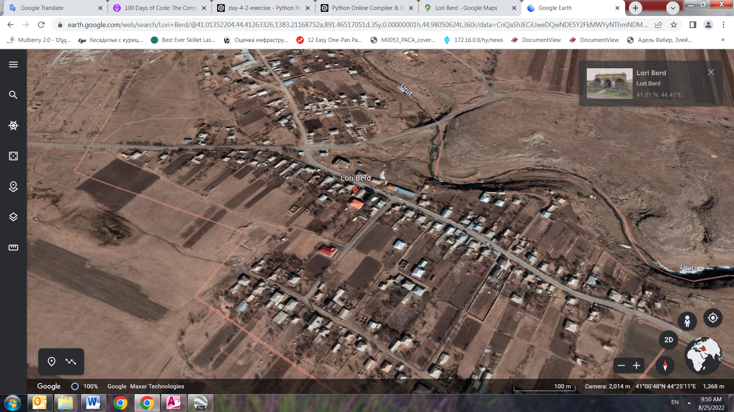

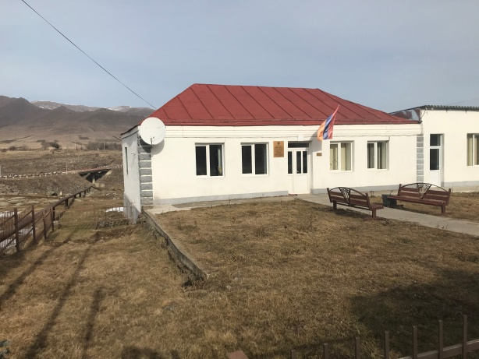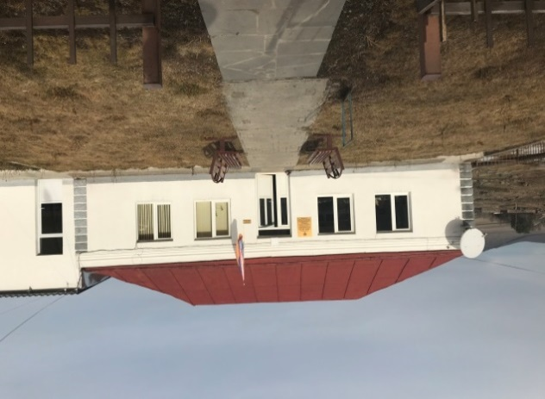

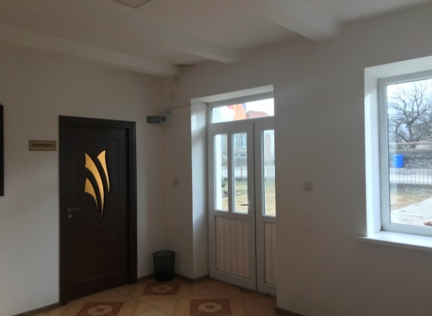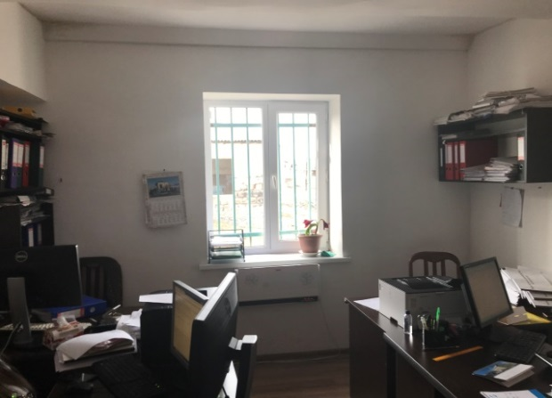

Attachment 2: Copy of an agreement for construction waste disposal

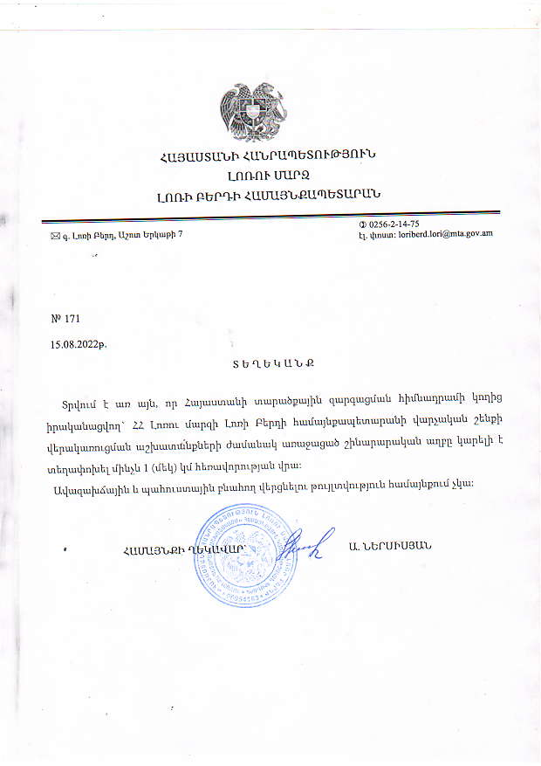

Construction waste generated during the reconstruction will be transported to the disposal site, located 1 km far from the construction site.

Community Head Sealed/Signed A. Nersisyan

15.08.2022

Attachment 3: Preliminary seismic conclusion on the technical condition of the building (to open the PDF document double click on the photo)

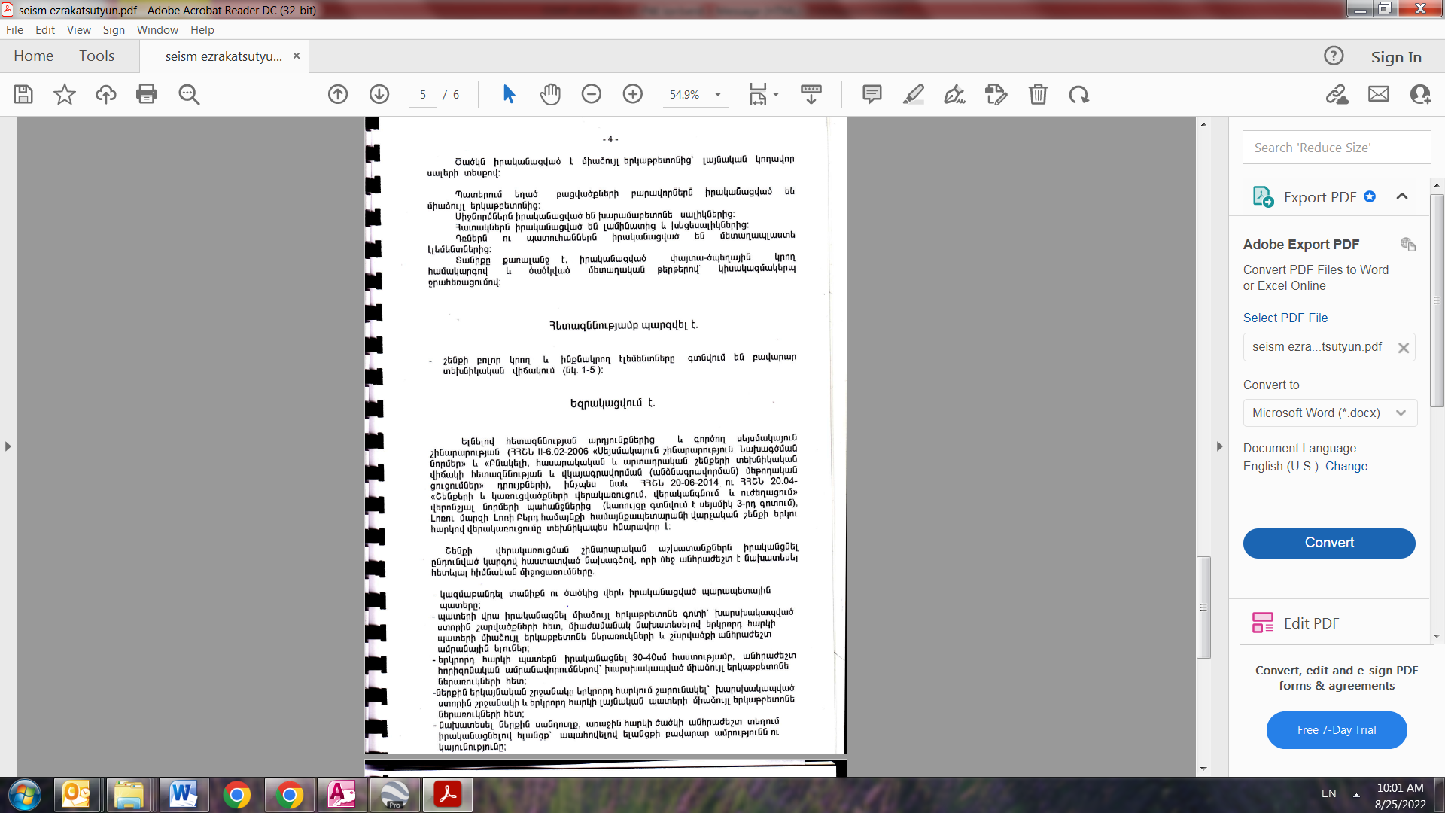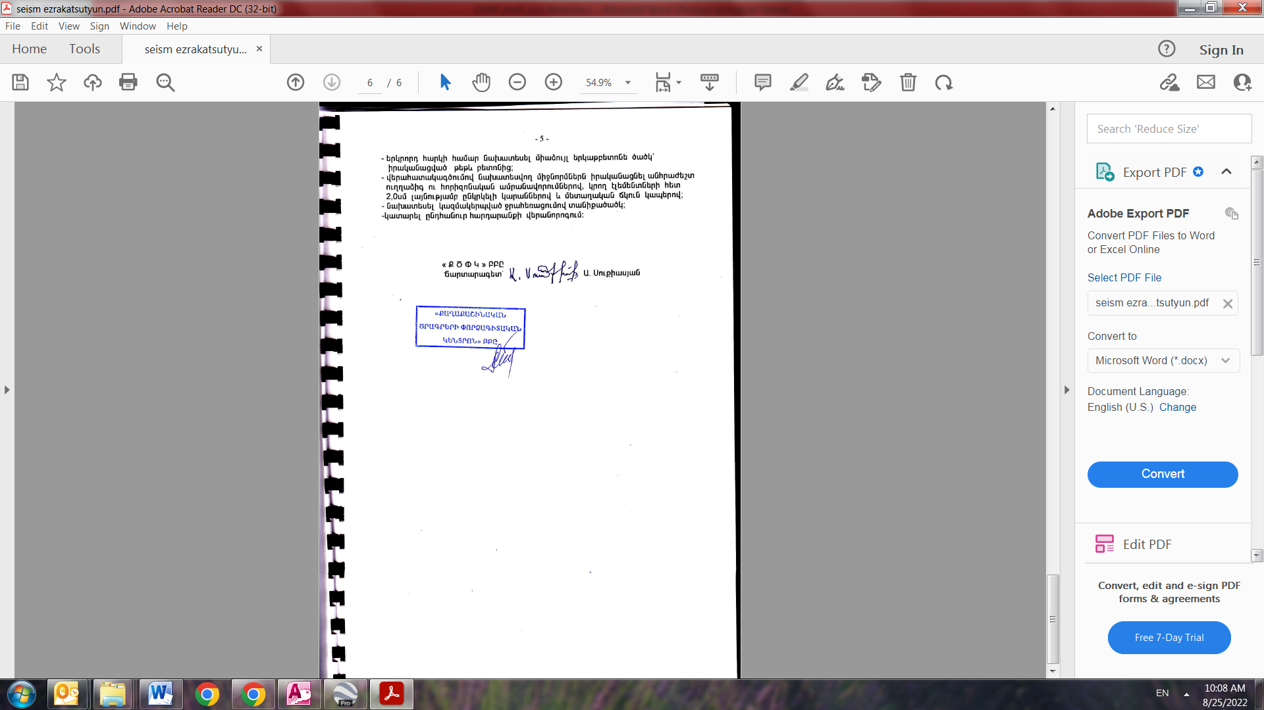
Summary of the above-attached document
The investigation revealed that all supporting and self-supporting elements of the building are in satisfactory technical condition.
Based on the results of the investigation and the requirements of the existing seismic construction norms, the reconstruction of the Administrative office of Lori Berd community of Lori marz is technically possible.

Attachment 4: Copy of the Ownership Certificate
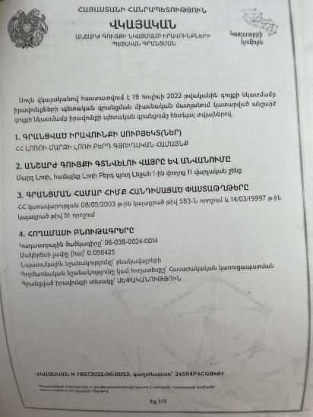
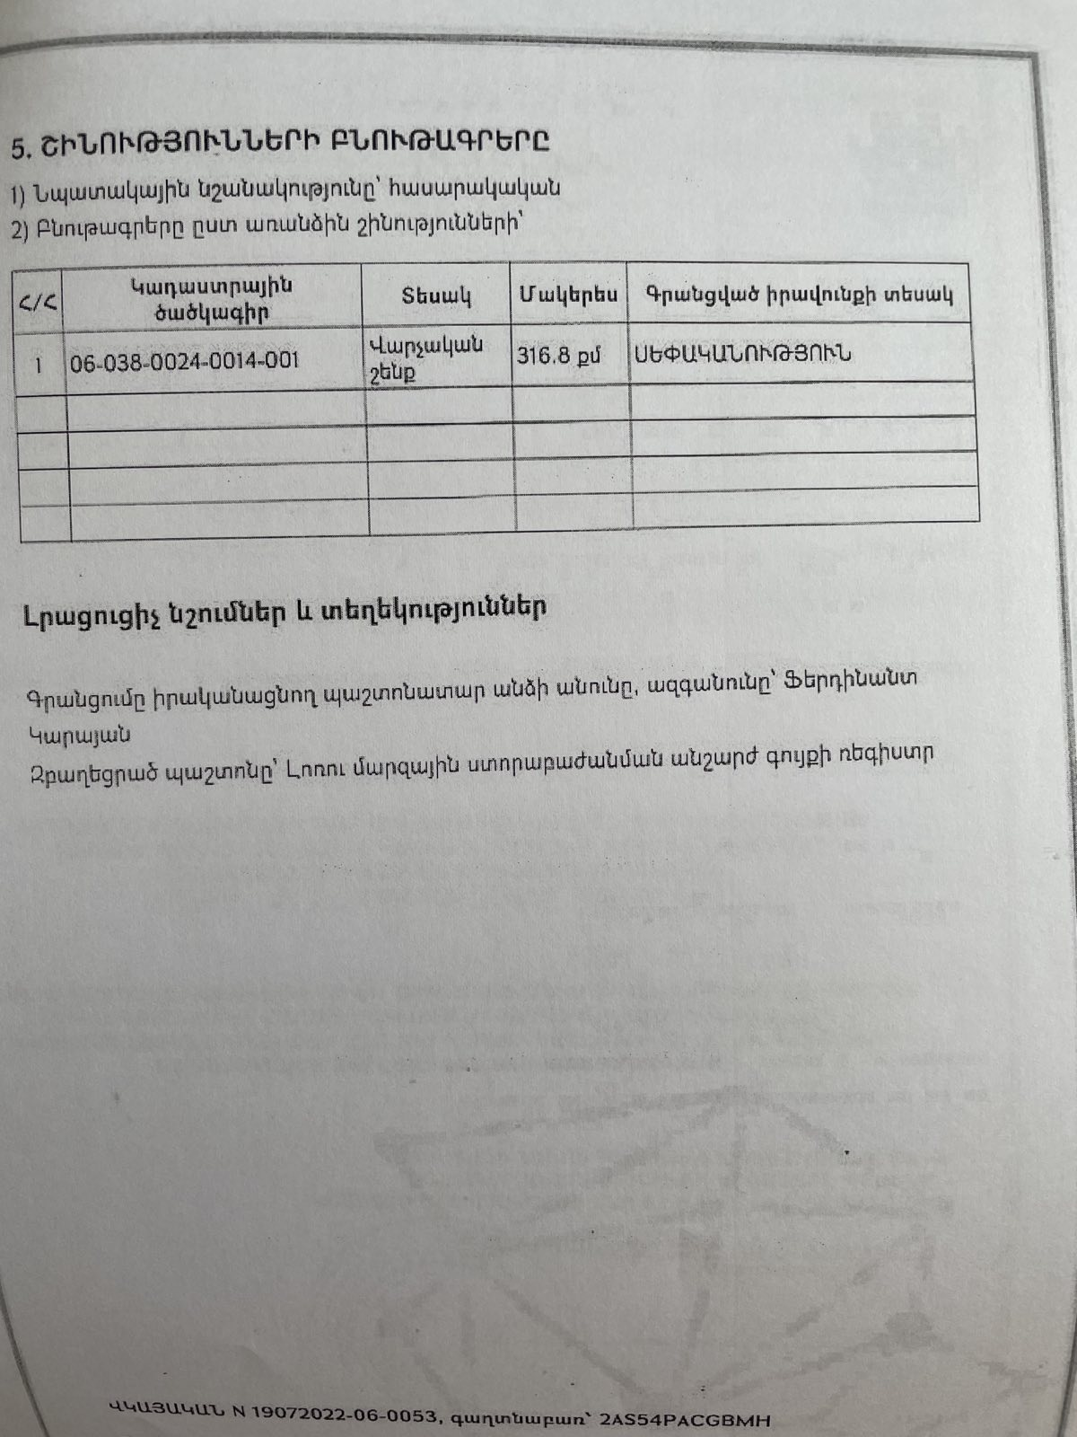

Non-official translation of the land ownership certificate:
Data on Land Plot
Cadastral Number – 06-038-0024-0014
Purpose of the land plot - Residential
Land use – Public construction
The size of land plot – 0.056425 ha
Type of right – Ownership
Data on the building
Cadastral Number – 06-038-0024-0014-001
Purpose of the land plot - Public
Land use –Community Center
The size of building-316.8sq.m
Type of right – Ownership

Attachment 5: Minutes of the public consultation of ESMP (to be provided)
Attachment 6: Copy of Construction Permit (to be provided)

Land acquisitions includes displacement of people, change of livelihood encroachment on private property this is to land that is purchased/transferred and affects people who are living and/or squatters and/or operate a business (kiosks) on land that is being acquired.
Toxic / hazardous material includes but is not limited to asbestos, toxic paints, noxious solvents, removal of lead paint, etc.

