FINAL ENVIRONMENTAL AND SOCIAL REVIEW CHECKLIST

Project location: Tumanyan Consolidated Community, Lori Region

Project name Construction the 6 bus-stops in Tumanyan Consolidated
Community in villages
Atan, Martc, Qarinj, Ahnidzor, Lorut, Shamut

Is the Environmental and Social management plan (ESMP) developed?
Yes + No _____

Does ESMP provide a full list of potential impacts and establish adequate measures for their mitigation?
Yes + No _____

Conclusion of the Final Environmental and Social Assessment

Conclusion
Micro-project rejected | Micro-project approved (environmental assessment completed)
 | +

PART A: General Project and Site Information
INSTITUTIONAL & ADMINISTRATIVE
Project title | Construction the 6 bus-stops in Tumanyan Consolidated Community in villages Atan, Marc, Qarinj, Ahnidzor, Lorut, Shamut.
Municipality, community | Lori Marz, Tumanyan Consolidated Community
Scope of site-specific activity | It is planned to build bus stops in 6 villages of the Tumanyan community. These are small buildings, single-storey bus stops from the reinforced concrete structure with a size of 5 * 3, as well as spaces for advertising and announcements equipped with benches and lighting.  The land plots were chosen taking into account the wishes of the villagers and for general convenience. A metal fence, asphalting of the territory, landscape gardening, a parking with markings, road signs and outdoor lighting with LED lamps are envisaged by the project.
Institutional arrangements (USAID) | Task Team Leader: |  | Safeguard Specialist:  Asya Osipova - Environment
Implementation arrangements (RoA) | Implementing entity:  ATDF | Works Supervisor:  “ALTERNATIV” LTD |  | Works Contractor:  “PRIZMA-VAN” LTD
SITE DESCRIPTION
Name of institution whose premises are to be rehabilitated | Road Department of Tumanyan Consolidated community (regional governor office),
Address and site location | Address: Lori Marz, Tumanyan Consolidated Community
Who owns the land? | The land is the property of the Tumanyan Consolidated Community. For each stops will be allocated a land plot of 30 sq.m. According to the legal decision of land allocation (19.05.2016) the land was allocated for the construction 6 bus stops in the 6 villages of the Tumanyan community.
Description of physical and natural environment around the site (see maps and photo annex 1) | The lands to be used under this project is not used by any private household; there are no structures, crops, trees or business in the proposed sites. During the construction works, no tree removal is intended. Endemic species and plants do not exist across the land plot provided for the construction works. Geological conditions are favourable for construction works. No geo hazards exist in the area. The precipitations in the area generally have surface flood, and only the part of the water penetrate through the minerals and soil. The natural relief and landscape will be recovered after construction works. The project will have modest impact on the village population, as construction works will constrain movement only of those people who reside immediately along the road and this impact will be limited to the rehabilitation phase.
LEGISLATION
National & local legislation & permits that apply to project activity | Construction the 6 bus-stops are not subject to the Environmental Impact Assessment and to the issuance of the expert environmental review conclusion.  According to the Armenian legislation, the following permissions are required for this project:  - Land allocation  - Construction permit  - Waste disposal permit
ATTACHMENTS
Annex 1: Photos and plan of the construction site
Annex 2: Copy of the land allocation document
Annex 3: Copy of an agreement for construction waste disposal
Annex 4: Copy of construction permit

PART B: safeguards information
ENVIRONMENTAL /SOCIAL SCREENING
Will the site activity include/involve any of the following? | Activity/Issue | Status | Triggered Actions
 | - Building rehabilitation | [ ] Yes [+] No | See Section A below
 | - New construction | [+] Yes [ ] No | See Section A below
 | - Individual wastewater treatment system | [ ] Yes [+] No | See Section B below
 | - Historic building(s) and districts | [ ] Yes [+] No | See Section C below
 | - Acquisition of land | [ ] Yes [+] No | See Section D below
 | - Hazardous or toxic materials | [ ] Yes [+] No | See Section E below
 | - Impacts on forests and/or protected areas | [ ] Yes [+] No | See Section F below
 | - Handling / management of medical waste | [ ] Yes [+] No | See Section G below
 | - Traffic and Pedestrian Safety | [+ ] Yes [ ] No | See Section H below
PART C: Mitigation measures
ACTIVITY | PARAMETER | MITIGATION MEASURES (provide costs where applicable)
0. General Conditions | Notification and Worker Safety | - The local construction and environment inspectorates and communities have been notified of upcoming activities  - The public has been notified of the works through appropriate notification in the media and/or at publicly accessible sites (including the site of the works)  - All legally required permits have been acquired for construction  - The Contractor formally agrees that all work will be carried out in a safe and disciplined manner designed to minimize impacts on neighboring residents and environment.  - Workers’ PPE will comply with international good practice (always hardhats, as needed masks and safety glasses, harnesses and safety boots)  - Appropriate signposting of the sites will inform workers of key rules and regulations to follow.
A. General Construction Activities | Air Quality | - During interior demolition debris-chutes shall be used above the first floor  - Demolition debris shall be kept in controlled area and sprayed with water mist to reduce debris dust  - During pneumatic drilling/wall destruction dust shall be suppressed by ongoing water spraying and/or installing dust screen enclosures at site  - The surrounding environment (sidewalks, roads) shall be kept free of debris to minimize dust  - There will be no open burning of construction / waste material at the site  - There will be no excessive idling of construction vehicles at sites
 | Noise | - Construction noise will be limited to restricted times agreed to in the permit  - During operations the engine covers of generators, air compressors and other powered mechanical equipment shall be closed, and equipment placed as far away from residential areas as possible
 | Water Quality | - The site will establish appropriate erosion and sediment control measures such as e.g. hay bales and / or silt fences to prevent sediment from moving off site and causing excessive turbidity in nearby streams and rivers.
 | Waste Management | - Waste collection and disposal pathways and sites will be identified for all major waste types expected from demolition and construction activities.  - Mineral construction and demolition wastes will be separated from general refuse, organic, liquid and chemical wastes by on-site sorting and stored in appropriate containers.  - Construction waste will be collected and disposed properly by licensed collectors  - The records of waste disposal will be maintained as proof for proper management as designed.  - Whenever feasible the contractor will reuse and recycle appropriate and viable materials (except asbestos)
B. Individual wastewater treatment system | Water Quality | - The approach to handling sanitary wastes and wastewater from building sites must be approved by the local authorities  - Before being discharged into receiving waters, effluents from individual wastewater systems must be treated in order to meet the minimal quality criteria set out by national guidelines on effluent quality and wastewater treatment  - Monitoring of new wastewater systems (before/after) will be carried out  - Construction vehicles and machinery will be washed only in designated areas where runoff will not pollute natural surface water bodies.
C. Historic building(s) | Cultural Heritage | - If the building is a designated historic structure, very close to such a structure, or located in a designated historic district, notification shall be made and approvals/permits be obtained from local authorities and all construction activities planned and carried out in line with local and national legislation.  - It shall be ensured that provisions are put in place so that artifacts or other possible “chance finds” encountered in excavation or construction are noted and registered, responsible officials contacted, and works activities delayed or modified to account for such finds.

ACTIVITY | PARAMETER | MITIGATION MEASURES CHECKLIST
D. Acquisition of land | Land Acquisition Plan/Framework | - If expropriation of land was not expected but is required, or if loss of access to income of legal or illegal users of land was not expected but may occur, that the Bank’s Task Team Leader shall be immediately consulted.  - The approved Land Acquisition Plan/Framework (if required by the project) will be implemented
E. Toxic Materials | Asbestos management | - If asbestos is located on the project site, it shall be marked clearly as hazardous material  - When possible the asbestos will be appropriately contained and sealed to minimize exposure  - The asbestos prior to removal (if removal is necessary) will be treated with a wetting agent to minimize asbestos dust  - Asbestos will be handled and disposed by skilled & experienced professionals  - If asbestos material is stored temporarily, the wastes should be securely enclosed inside closed containments and marked appropriately. Security measures will be taken against unauthorized removal from the site.  - The removed asbestos will not be reused
 | Toxic / hazardous waste management | - Temporarily storage on site of all hazardous or toxic substances will be in safe containers labeled with details of composition, properties and handling information  - The containers of hazardous substances shall be placed in an leak-proof container to prevent spillage and leaching  - The wastes shall be transported by specially licensed carriers and disposed in a licensed facility.  - Paints with toxic ingredients or solvents or lead-based paints will not be used
F. Affected forests, wetlands and/or protected areas | Protection | - All recognized natural habitats, wetlands and protected areas in the immediate vicinity of the activity will not be damaged or exploited, all staff will be strictly prohibited from hunting, foraging, logging or other damaging activities.  - A survey and an inventory shall be made of large trees in the vicinity of the construction activity, large trees shall be marked and cordoned off with fencing, their root system protected, and any damage to the trees avoided  - Adjacent wetlands and streams shall be protected from construction site run-off with appropriate erosion and sediment control feature to include by not limited to hay bales and silt fences  - There will be no unlicensed borrow pits, quarries or waste dumps in adjacent areas, especially not in protected areas.
G. Disposal of medical waste | Infrastructure for medical waste management | - In compliance with national regulations the contractor will insure that newly constructed and/or rehabilitated health care facilities include sufficient infrastructure for medical waste handling and disposal; this includes and not limited to:  - Special facilities for segregated healthcare waste (including soiled instruments “sharps”, and human tissue or fluids) from other waste disposal; and  - Appropriate storage facilities for medical waste are in place; and  - If the activity includes facility-based treatment, appropriate disposal options are in place and operational
H Traffic and Pedestrian Safety | Direct or indirect hazards to public traffic and pedestrians by construction  activities | (a) In compliance with national regulations the contractor will insure that the construction site is properly secured and construction related traffic regulated. This includes but is not limited to  - Signposting, warning signs, barriers and traffic diversions: site will be clearly visible and the public warned of all potential hazards  - Traffic management system and staff training, especially for site access and near-site heavy traffic. Provision of safe passages and crossings for pedestrians where construction traffic interferes.  - Adjustment of working hours to local traffic patterns, e.g. avoiding major transport activities during rush hours or times of livestock movement  - Active traffic management by trained and visible staff at the site, if required for safe and convenient passage for the public.  - Ensuring safe and continuous access to office facilities, shops and residences during renovation activities, if the buildings stay open for the public.

Environmental Monitoring Plan for construction and operation phases.

Activity | What  (Is the parameter to be monitored?) | Where  (Is the parameter to be monitored?) | How  (Is the parameter to be monitored?) |  | When  (Define the frequency / or continuous?) | Why  (Is the parameter being monitored?) |  | Who  (Is responsible for monitoring?)
CONSTRUCTION PHASE
1. Supply of construction materials | Purchase of the construction materials from licensed providers | Offices and warehouses of material suppliers, and borrowing sites | Checking documents;  Inspection of material quality |  | In the process of signing the agreements for material provision | Ensure technical quality of construction;  Protect human health and environment |  | ATDF
2. Transportation of construction materials and waste  Movement of construction equipment | Technical condition of construction vehicles and machinery;  Adequacy of the loading trucks for transported types of cargo, and canopy coverage of cargo transported in open trucks;  Movement of construction vehicles and machinery along pre-defined routes | Routes for transportation of construction materials and construction wastes | Inspection of roads adjacent to the construction site and included in the agreed-upon routes of transportation |  | Unannounced checks during the working hours | Avoid air and road pollution with dust and solid matter;  Reduce traffic disruption |  | ATDF, Tumanyan  Community
3. Generation of construction waste | Temporary storage of inert and hazardous wastes separately at the designated locations;  Timely disposal of waste to the formally designated landfills;  Hand-over of hazardous wastes to licensed deactivating and processing companies. | Construction site and base (if applicable);  Locations designated for waste disposal | Checking documents;  Visual observation |  | Entire period of construction | Avoid pollution of the environment |  | ATDF, Tumanyan  Community
4. Generation of liquid waste | Dissolving disinfectant applied for treating newly installed pipes prior to release into nature for decrease concentration of active chlorine to 75 - 100 mg / l. | Construction site |  | Visual inspection  Instrumental measurement of concentration | Upon completion of pipe installation |  | Avoid pollution of water and soil with chlorine | ATDF  Sanitary Epidemiological Service
5. Accumulation of household waste | Provision of waste containers on-site;  Agreement with local municipality for regular out-transporting of waste | Construction site and base (if applicable) | Visual inspection |  | Entire period of construction | Avoid pollution of soil and water with household waste |  | ATDF, Tumanyan Community
6. Safety of labor | - Provision of Special Clothes and protective means for the contractors;  - Consistency with the rules of exploitation of the construction equipment and usage of private safety means | Construction site | Inspection of the activities |  | Entire period of construction | Reduce the probability of accidents |  | ATDF, Tumanyan Community
7. Undertaking works within the settlement | Deparkation and fencing of work site;  No parking of construction vehicles and machinery outside work site the way impeding free passage of traffic and pedestrians;  No piling and no scattering of construction materials and waste outside the work site | Construction site and nearly area | Visual inspection |  | Entire period of construction | Reduce disruption of movement around the work site and decrease probability of accidents |  | ATDF, Tumanyan Community
OPERATION PHASE
1. Rectification works | Keep under general control the disposal of all types of waste | Construction site and nearly area | Visual inspection |  | Entire period of construction and operation phases | Prevent pollution |  | ATDF, Local municipality of the Tumanyan c
3. Landscaping | Protection near trees, shrubs and vegetation cover | Construction site | Inspections |  | Entire period of construction and operation phases | Verification of the sanitary of the green cover |  | ATDF, Local municipality of the Tumanyan

Annex 1: Photos and plan of the construction site

1. Selected area for a stop in the village of Atan

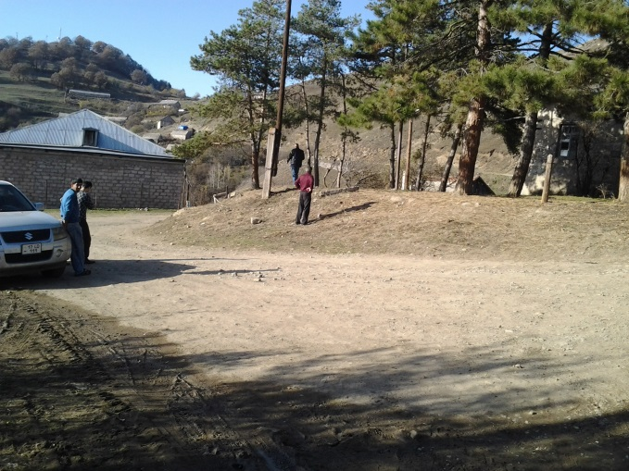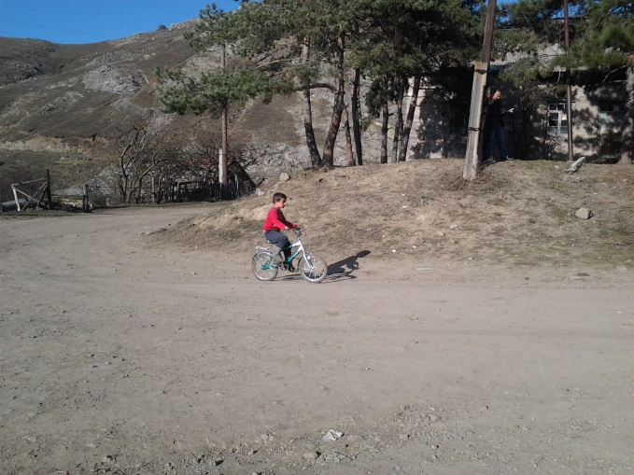

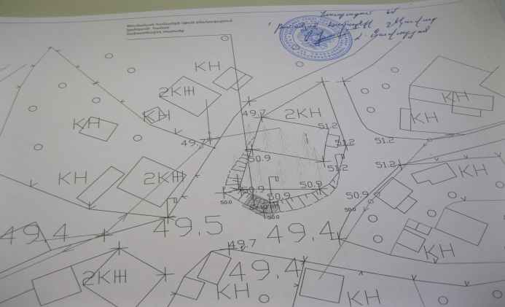

2. Selected area for a stop in the village of Lorut

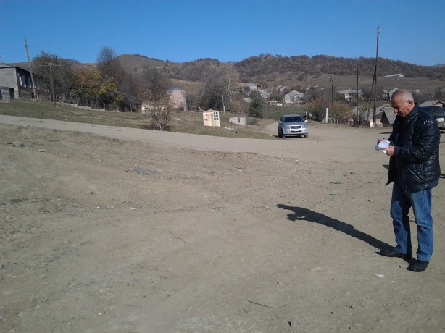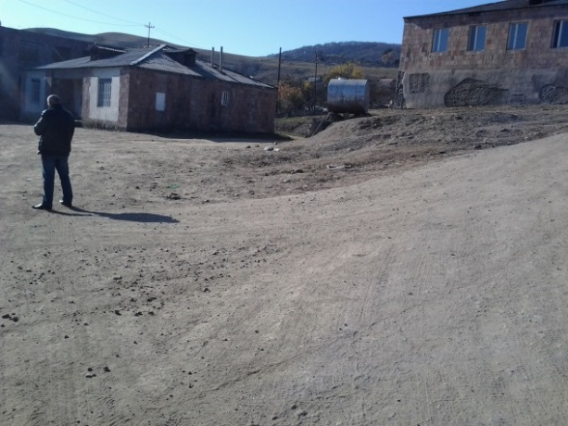

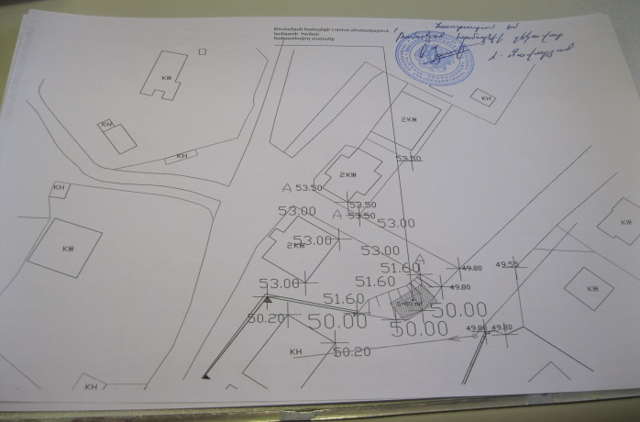

3. Selected area for a stop in the village of Qarinj

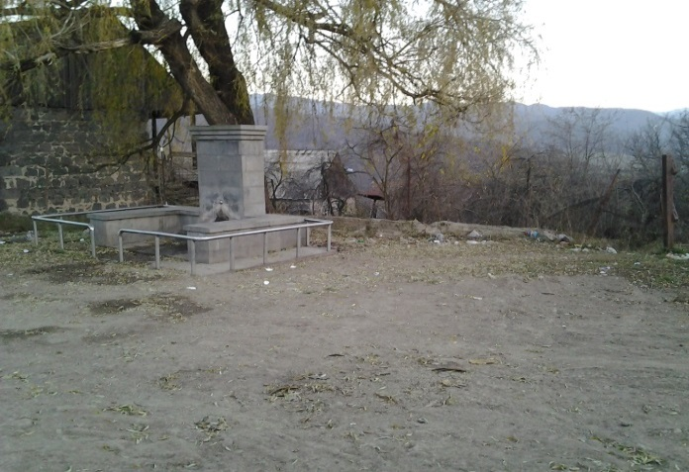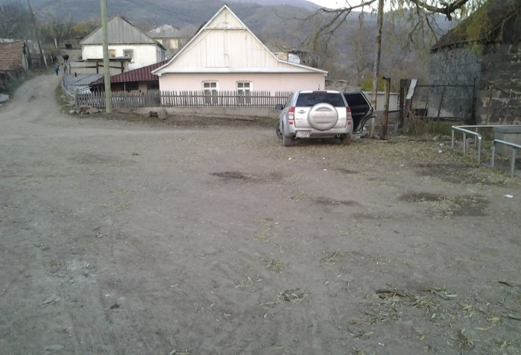
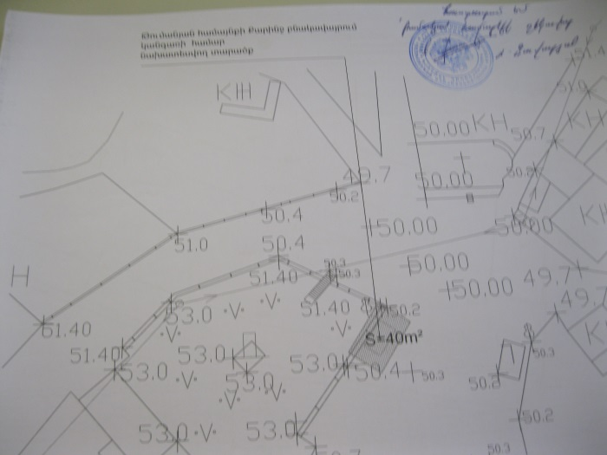
4. Selected area for a stop in the village of Shamut

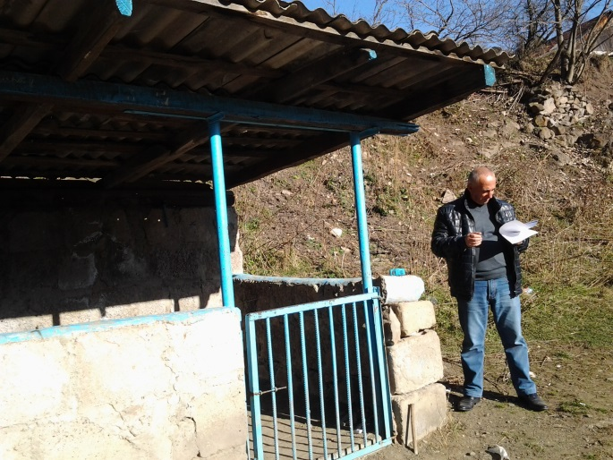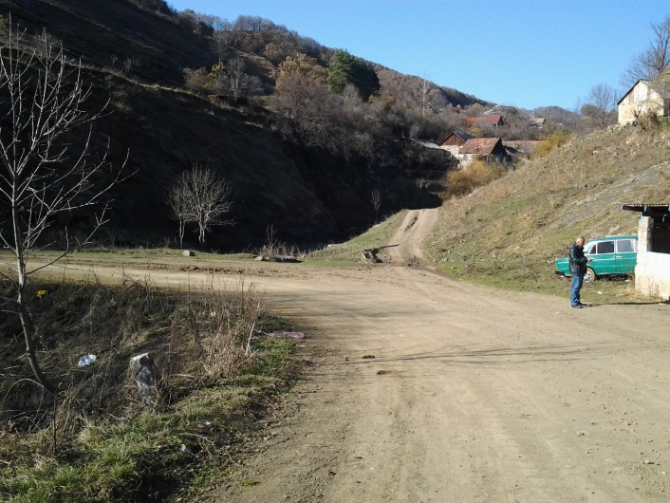

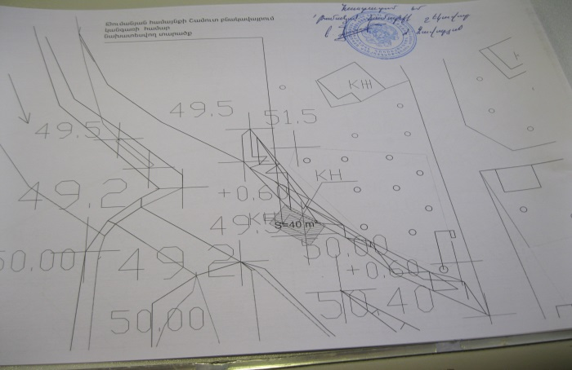

5. Selected area for a stop in the village of Aghnidzor
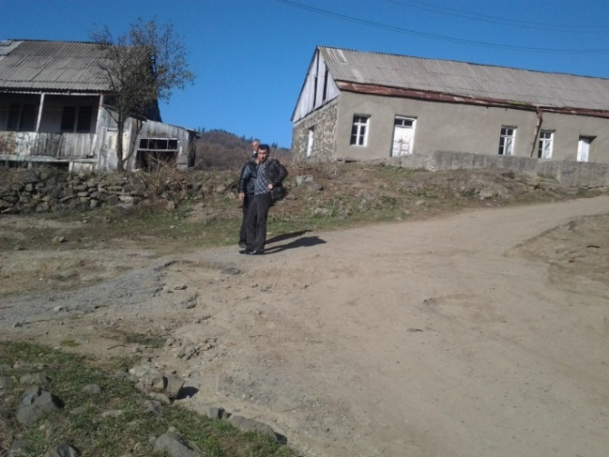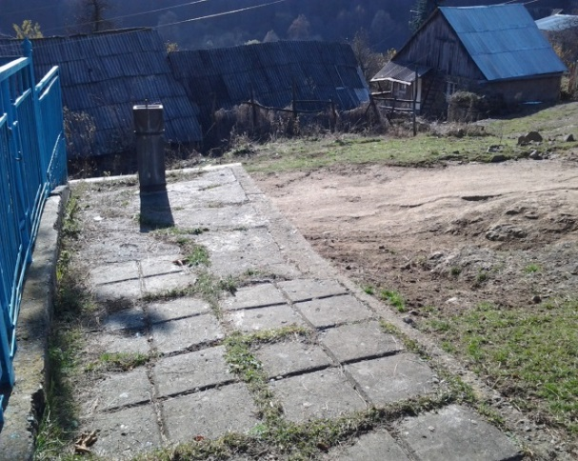
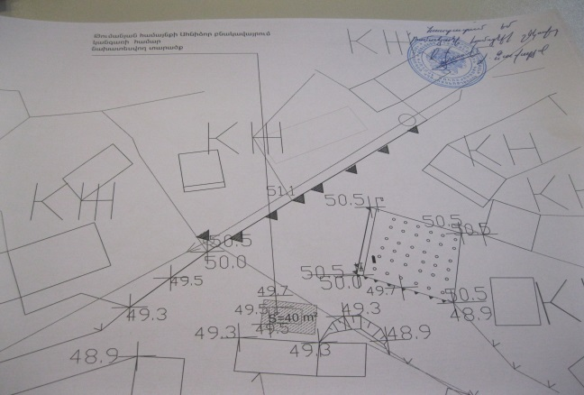

6. Selected area for a stop in the village of Mars
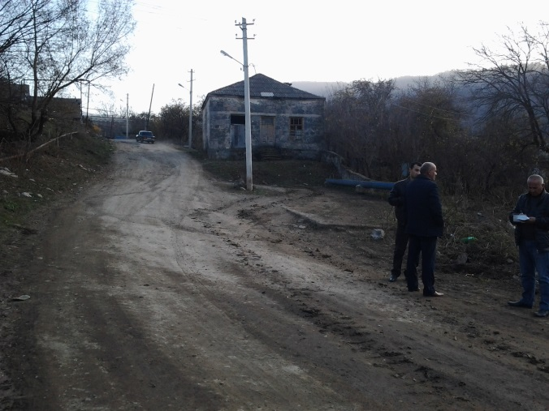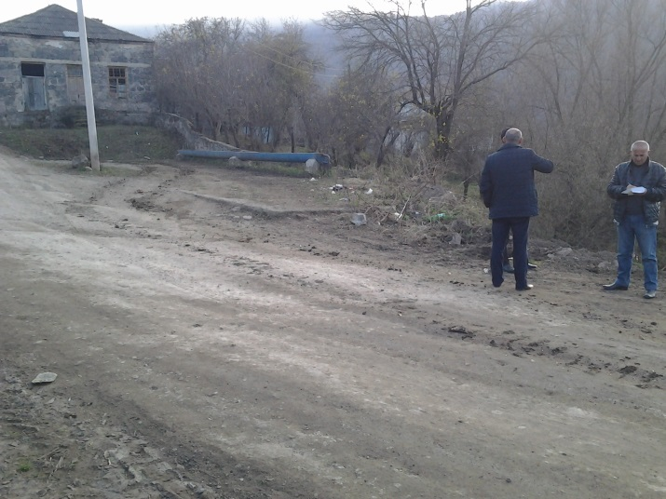

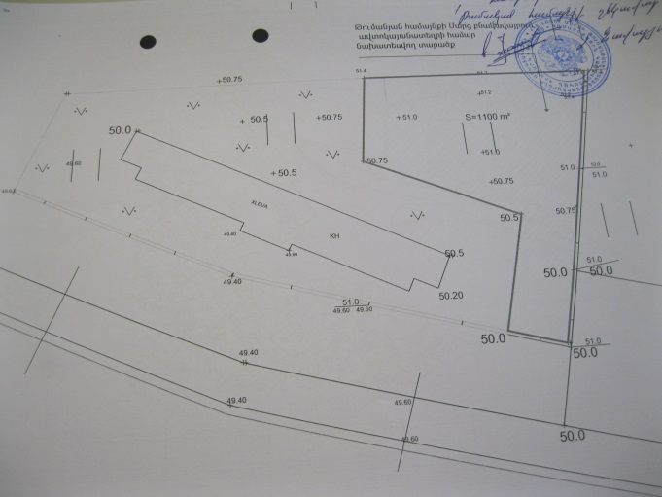

Annex 2: Minutes of Environmental and Social Public Consultations

MINUTES
Of Public Consultations
on Environmental and Social Management Plan
For the Construction the 6 bus-stops in Tumanyan Consolidated
Community in villages Atan, Martc, Qarinj, Ahnidzor, Lorut, Shamut

A stakeholder consultation meeting on the draft Environmental and Social Management Plan (ESMP) for the Construction the 6 bus-stops in Tumanyan Community was held on August 05, 2016 in Marts community, Lori Marz.
The announcement for the meeting in Armenian and English languages, including its date and time, was disclosed on the ATDF web page (www.atdf.am) on 26 July, 2016. Information on the meeting day and time was posted on information boards of Tumanyan Community Administration Office; in addition the ATDF Environmental specialist conducted telephone calls to ensure participants’ attendance.
The public consultation was carried out by ATDF Environmental Specialist Asya Osipova. 28 participants were present at the meeting, among which 12 women (about 50%).
A.Osipova introduced the main purpose as well as Armenian legislation on conducting environmental and social assessment. She reasoned the need to develop ESMP, specifying that the Micro-project involves construction of a new 6 bus-stops. She outlined likely negative environmental impacts related to the Micro-project implementation. These include pollution of air, generation of construction waste and direct or indirect hazards to public traffic and pedestrians by construction activities.
Ms. Osipova explained what measures ATDF will apply to mitigate possible negative impacts, including construction waste materials transportation. It was mentioned that ESMP covers the issue of the transportation and disposal of construction wastes.
A. Osipova talked about safety measures for community members and workers and disturbance to community life due to construction activities. Technical supervisors on monthly basis will keep under control the fulfillment of all the environmental mitigation measures included in ESMP, and report the deviations to ATDF.
A. Osipova presented the main provisions of the ESMF concerning to the social aspects of the Project. She emphasized that the project does not involve any resettlement as proposed area of the construction is public property and building ownership certificate is available issued by Cadaster.
A. Osipova talked also about main socio-economic challenges including engagement of women, youth and vulnerable groups in distribution of benefits. She outlined that these groups should have equal opportunities to be engaged in project benefits.
A. Osipova informed the beneficiaries that they also have the option to contact ATDF directly to communicate their grievance if they are unable to, or do not wish to, go through the PIC grievance focal point. A. Osipova explained all the cannels of grievance submission involving e-mail address, hot line telephone number, postal address and web-site link and outlined that ATDF contact information is reflected on the booklets delivered to the participants, as well as on the information desk already posted in public visible places in the Community, including Community Administrative Office building. A.Osipova introduced that information on Micro-project details permanently will be available on the information desks, as well as on-going announcements and references. She outlined that these will support to raising public awareness and early identification, assessment and resolution of complaints on Project activities.

The list of participants and photos are attached

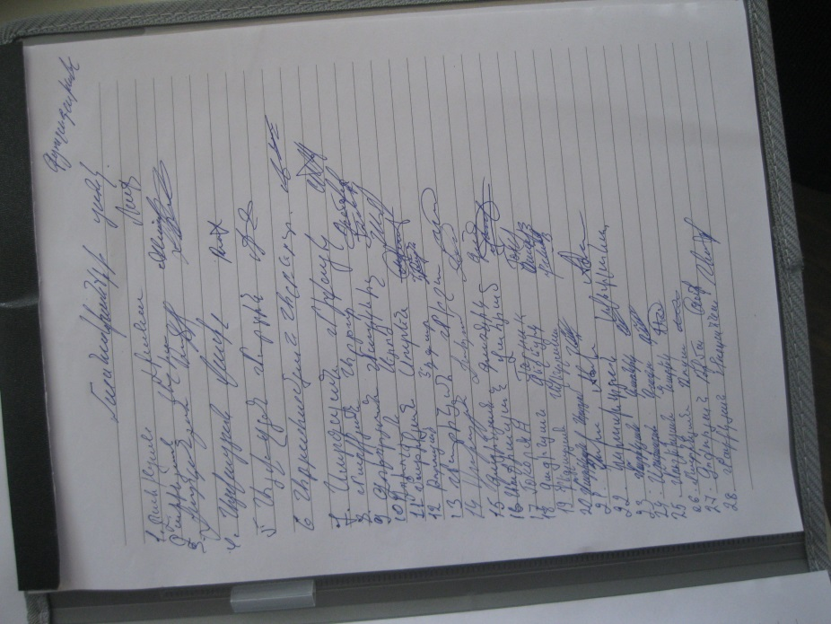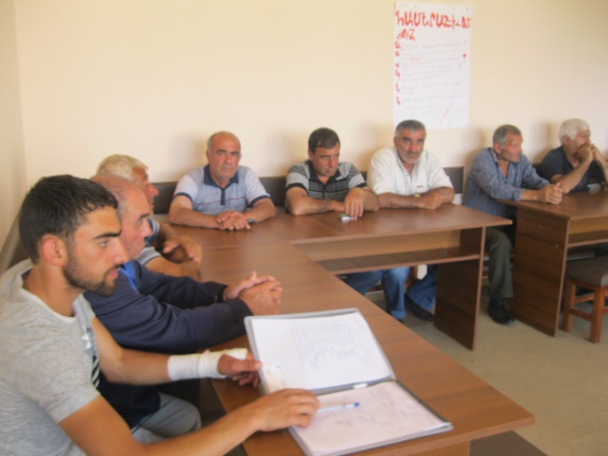

Annex 2: Copy of the land allocation document
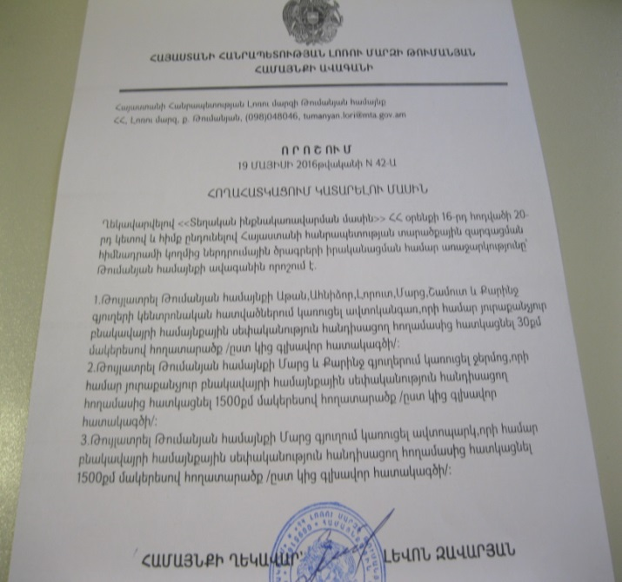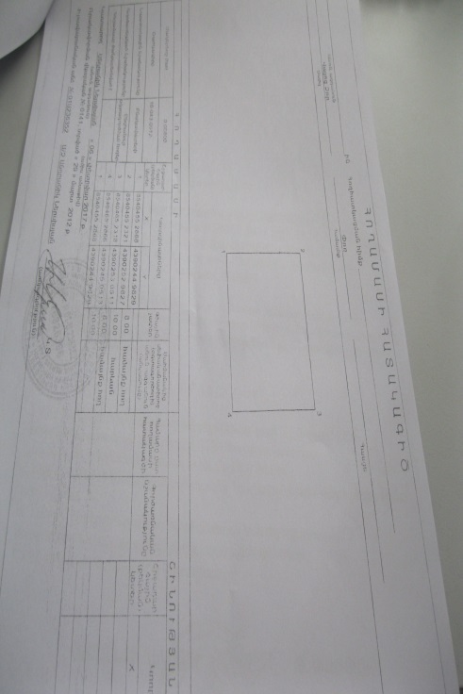
Non Official translation of the document
Reference of Community Council of Tumanyan Consolidated community, Loru Marz
19 May 2016
N 42-A
According to the provisions of 16th point of 20th article of RA Law on “Local Self-Governance” the Community Council decides:
Allocate 30 meter/square land for construction the 6 bus-stops in Tumanyan Consolidated Community in villages Atan, Marc, Qarinj, Ahnidzor, Lorut, Shamut.
Annex 3: Copy of an agreement for construction waste disposal

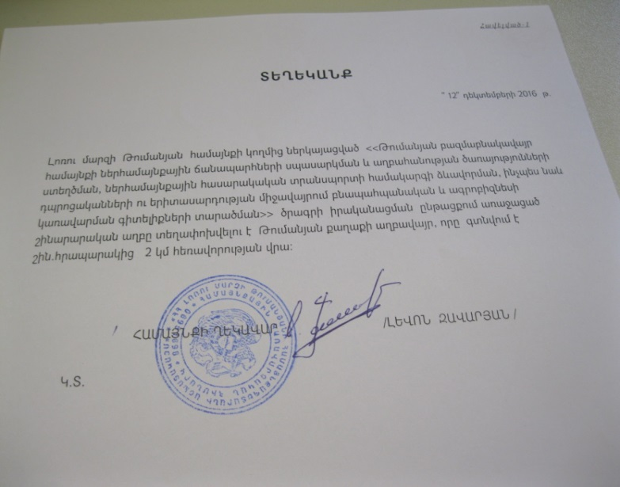

Non Official translation of the document
The construction waste will be transported to the waste dump located 2 km far from the site.

Head of Community (signed) L.Zavaryan

Annex 4: Copy of construction permit

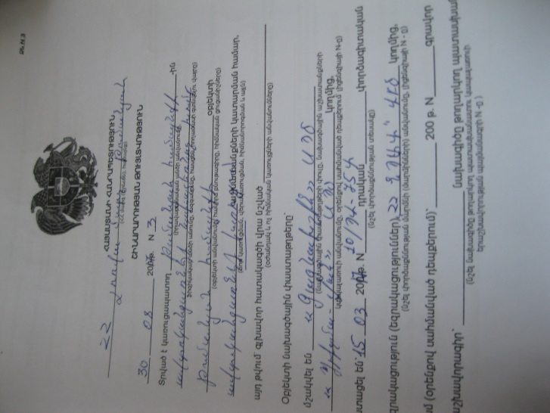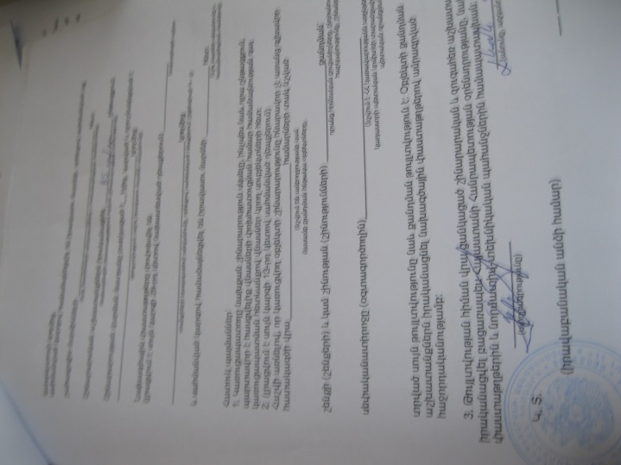

Non-official translation of the above attached document:

Republic of Armenia
Lori Region, Community Tumanyan
Construction Permit N 3, 30.08.2017
This is given for the Construction the 6 bus-stops in Tumanyan Consolidated Community
The design documents are developed by “Gagnakhshin” LTD
The construction will be implemented within 85 days.

ATDF, Environmental specialist Asya Osipova

USAID, Governance Sector Specialist Bella Markarian

USAID, Environment Advisor, Marina Vardanyan
Mission Environmental Officer

Land acquisitions includes displacement of people, change of livelihood encroachment on private property this is to land that is purchased/transferred and affects people who are living and/or squatters and/or operate a business (kiosks) on land that is being acquired.
Toxic / hazardous material includes but is not limited to asbestos, toxic paints, noxious solvents, removal of lead paint, etc.

